Applying Short-term Traffic Prediction Models for Updating
Missing Values of Traffic Counts
By Ming Zhong,¹ Pawan Lingras,² and Satish Sharma³
ABSTRACT: The presence of missing values is an important issue for traffic data programs. The analyses applied to data sets from two highway agencies show that significant portion of data has missing values. Literature review indicates that previous research mainly focused on detecting missing values. There is limited research on data imputation in traffic analysis. In this study, genetically designed neural network models and regression models were applied to six permanent traffic counts (PTCs) from Alberta, Canada to investigate their merits in imputing missing values. These six PTCs belong to different trip-pattern groups and functional classes. A top-down model refinement was used to search for the models with reasonable accuracy for each type of road. Average errors for refined models were lower than 2% and the 95th percentile errors were below 4-5% for counts with stable patterns. Even for counts with relatively unstable patterns, average errors were below 6% in most cases, and the 95th percentile errors were rarely more than 10%. It is believed that the models proposed in this study would be helpful for highway agencies in their traffic data programs.

KEY WORDS: Missing Values, Short-term Traffic Prediction, Traffic Counts, Genetic Algorithms, Neural Network, Regression Analysis
¹Doctoral Student Faculty of Engineering, University of Regina, Regina, SK, Canada, S4S 0A2
Phone: (902) 496-8152 Email: Ming.Zhong@stmarys.ca
²Associate Professor Dept. of Mathematics and Computing Science, Saint Mary’s University, Halifax, NS, Canada, B3H 3C3
Phone: (903) 420-5798 Email: Pawan.Lingras@stmarys.ca
³Professor Faculty of Engineering, University of Regina, Regina, SK, Canada, S4S 0A2
Phone: (306) 585-4553 Email: Satish.Sharma@uregina.ca

INTRODUCTION

Missing values in traffic counts is an important issue for traffic engineers and data analysts, since traffic data programs were established in the 1930’s (Albright 1991ª). Dealing with missing values has significant implications to the limited budgets of traffic data programs. This was particularly true before the advanced data collection tools, such as mechanical detectors and electronic or ultrasonic sensors were applied in the fields, because of the high cost of manual counts (Sharma 1983). Even though scientists and engineers have managed to decrease the cost of data collection, highway agencies still commit a significant portion of their resources to data collection, summarization, and analysis (Sharma et al. 1996). Highway agencies need to use the collected data efficiently.
This study analyzed missing values for the data sets from two highway agencies in North America. First data set was from Alberta Transportation Department and the other was from the Minnesota Department of Transportation. In Alberta, over seven years, more than half of total counts have missing values. As shown in Figure 1, during some years the percentage is as high as 70% to 90%. Minnesota data shows more than 40% counts having missing values. Williams et al. (Williams et al. 1998) also reported that approximately 20 percent of the data in the development and test sets of their study were missing.
For the traffic counts with missing values, highway agencies usually either retake the counts or estimate the missing values. Estimating missing values is known as data imputation. Since sometimes retaking counts is impossible due to limited resource and time, imputing the data has become a popular method (Albright, 1991ª). The experience with data from Alberta Transportation indicates that the agency used data imputation before 1995. The replaced values of missing data were marked with minus signs for some years. Imputing data with reasonable accuracy may help establish more cost-effective traffic data program. The analysis of Alberta data also shows that a significant percent (varied from 10% to 44% from year to year) of traffic counts have missing data for several successive days or months. Usually these PTCs can not be used to calculate AADT or DHV due to the missing data. Such PTCs may be used as seasonal traffic counts (STCs) or short-period traffic counts (SPTCs) or just discarded by highway agencies. However, the information contained in these PTCs is certainly more than that from STCs and SPTCs. If missing data from PTCs can be accurately updated, further analysis could be applied based on AADT or DHV.
There are increasing concerns about data imputation and Base Data Integrity. The principle of Base Data Integrity is an important theme addressed in both American Society for Testing and Materials (ASTM) Standard Practice E1442, Highway Traffic Monitoring Standards (America 1991) and the American Association of State Highway and Transportation Officials (AASHTO) Guidelines for Traffic Data Programs (America 1992). The principle says that traffic measurements must be retained without modification and adjustment. Missing values should not be imputed in the base data. However, this does not prohibit imputing data at analysis stage. In some cases, traffic counts with missing values could be the only data available for certain purpose and data imputation is necessary for further analysis.
A review of literature indicates that little research has been done in this area. Most methods used by transportation practitioners are simple factor approaches or moving average regression analyses. A group of scholars at University of Leeds, England, tried to model outliers and missing values in traffic count time series by employing exponentially weighted moving average, autocorrelation based influence function, and autoregressive integrated moving average (ARIMA) models (Clark 1992; Redfern et al. 1993; Watson et al. 1993). It was found that ARIMA models outperformed other models in detecting missing values and outliers. In this study, genetically designed neural network and regression models for short-term predictions were tested on six permanent traffic counts (PTCs) to investigate their abilities of updating missing values. The six PTCs belong to different groups based on the trip purpose and trip length distributions.
The experiments presented in this paper illustrate how to use proposed techniques to update missing values of traffic counts. The genetic algorithms were used to select final input variables for designing short-term prediction models. These models were trained and tested for short-term traffic predictions. The resulting models were used to estimate the missing values. The techniques used in this study could be applied to not only permanent traffic volume counts, but also to seasonal or short-term traffic volume counts, vehicle classification counts, weight counts, and speed counts.

LITERATURE REVIEW

There is significant amount of research related to missing values (Little and Rubin 1987; Bole et al. 1990; Beveridge 1992; Wright 1993; Gupta and Lam 1996; Singh and Harmancioglu 1996). However, there is limited research on how missing data are handled by transportation practitioners. Southworth et al. (1989) introduced a system called RTMAS for urban population evacuations in times of threat. One subroutine of this system is AUTOBOX, which applies Box-Jenkins time series model to the hourly or daily traffic count data. AUTOBOX allows complete autoregressive integrated moving average (ARIMA) modeling. The example in their study clearly showed that proposed ARIMA model was good at detecting unusual traffic profiles and also good at predicting hourly counts. They used past five days data to predict 24 hourly volumes of the same day of the next week. It was found that 22 hourly volumes were within 95% confidence level of the observed counts. The other two were detected as outliers caused by an evacuation response to the threat of Hurricane Elena. Such system can also be used to predict missing values for traffic counts.
In 1990, New Mexico State Highway and Transportation conducted a survey of traffic monitoring practice (New Mexico 1990) in the United States. It was shown that when portable devices failed, 13 states used some procedure to estimate the missing values and complete the data set. When permanent devices failed, 23 states employed some procedure to estimate the missing values (Albright 1991^{b}). Various methods were used for this purpose. For example, in Alabama, if less than 6 hours are missing, the data are estimated using the previous year or other data from the month. If more than 6 hours are missing, the day is voided. In Delaware, estimate of missing values is based on a straight line using the data from the months before and after the failure. Most of these methods apply simple factors to historical data to estimate missing values. Only in Kentucky, a computer program was used to estimate and fill in the blanks (New Mexico 1990). No research has been done for assessing the accuracy of such imputations.
In England, a survey of practical solutions used by consultancies and local authorities was conducted in 1993 (Redfern et al. 1993). It was reported that there were two broad categories of solutions. One is “by-eye” method and the other is computerized packages (Redfern et al. 1993). Most automated practical solutions to patching were based upon simple, moving or exponentially weighted moving average, or their variants. For example, DOT in London employed an exponentially weighted moving average model to update missing values. The process involved validating new traffic count data against old data from the same site collected over the previous weeks at the same time. Following equation was used to estimate missing or rejected data at time t, 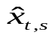:
(1)
where x_{t-1,s}, x_{t-2,s}, …, x_{t-n,s} represent the observations for that particular site and vehicle category at the same times for weeks 1, 2, …, n before the current observation; is a constant such that 0<<1. A value of 0.7 was typically used for parameter .
A series of studies (Clark 1992; Redfern et al. 1993, Waston et al. 1993) were carried out by a group of scholars at University of Leeds, England in the early 1990’s. Redfern et al. (1993) tested four types of models on four traffic time series supplied by DOT in London. These models were exponentially weighted moving average, autocorrelation based influence function, ARIMA model using large residuals, and ARIMA model using the Tsay likelihood ratio diagnostics. It was reported that the estimation of replacement values for both extreme and missing values was most efficiently done using the parametric ARIMA(1,0,0)(0,1,1)₇ model. However, it was also reported that the estimated replacements of the missing values showed considerable variation (Redfern et al. 1993). The study also mentioned concerns about the Base Data Integrity.
Bruce Ratner (2000) reported that there were four popular imputation methods for updating missing values:
- Deductive Imputation. Missing values are deduced with certainty, or with high probability, from other information on the case.
- Hot-deck Imputation. For each imputation class, missing values are replaced with values from “closest matching” individuals.
- Mean-value Imputation. The sample mean of each imputation class is used to fill in the missing values.
- Regression-based Imputation. Missing values are replaced by the predicted values from a regression analysis.
This study investigates the capability of two techniques, namely neural networks and regression analysis, for updating missing values of different traffic counts. The models are designed using genetic algorithms.

REVIEW OF TECHNIQUES

This section provides a brief review of neural networks, genetic algorithms, and statistical technique used in the present study.

Locally Weighted Regression Analysis
A variant of regression analysis called locally weighted regression was used in this study. Locally weighted regression is a form of instance-based (or memory-based) algorithm for learning continuous mappings from real-valued input vectors to real-valued output vectors. Local methods assign a weight to each training observation that regulates its influence on the training process. The weight depends upon the location of the training point in the input variable space relative to that of the point to be predicted. Training observations closer to the prediction point generally receive higher weights (Friedman 1995). The local weighted regression program used in this study can be downloaded from the web site (Locally 2001).
Model-based methods, such as neural networks and the mixture of Gaussians, use the data to build a parameterized model. After training, the model is used for predictions and the data are generally discarded. In contrast, “memory-based” methods are non-parametric approaches that explicitly retain the training data, and use it each time a prediction needs to be made. Locally weighted regression is a memory-based method that performs regression around a point of interest using only training data that are “local” to that point. One recent study demonstrated that locally weighted regression was suitable for real-time control by constructing a locally-weighted-regression-based system that learned a difficult juggling task (Schaal and Atkeson 1994).

Time Delay Neural Networks
The neural networks used in this study consist of three layers: input, hidden, and output. The input layer receives data from the outside world. The input layer neurons send information to the hidden layer neurons. The hidden neurons are all the neurons between the input and output layers. They are part of the internal abstract pattern, which represents the neural network’s solution to the problem. The hidden layer neurons feed their output to the output layer neurons, which provide the neural network’s response to the input data.
The variant of neural network used in this study is called time delay neural network (TDNN) (Hecht-Nielsen 1990). Figure 2 shows an example of a TDNN, which are particularly useful for time series analysis. The neurons in a given layer can receive delayed input from other neurons in the same layer. For example, the network in Figure 2 receives a single input from the external environment. The remaining nodes in the input layer get their input from the neuron on the left delayed by one time interval. The input layer at any time will hold a part of the time series. Such delays can also be incorporated in other layers.
Neurons process input and produce output. Each neuron takes in the output from many other neurons. Actual output from a neuron is calculated using a transfer function. In this study, a sigmoid transfer function is chosen because it produces a continuous value in the range [0,1]. It is necessary to train a neural network model on a set of examples called the training set so that it adapts to the system it is trying to simulate. Supervised learning is the most common form of adaptation. In supervised learning, the correct output for the output layer is known. Output neurons are told what the ideal response to input signals should be. In the training phase, the network constructs an internal representation that captures the regularities of the data in a distributed and generalized way. The network attempts to adjust the weights of connections between neurons to produce the desired output. The backpropagation method is used to adjust the weights, in which errors from the output are fed back through the network, altering weights as it goes, to prevent the repetition of the error.

Genetic Algorithms
The origin of genetic algorithms (GAs) is attributed to Holland’s work (Holland 1975) on cellular automata. There has been significant interest in GAs over the last two decades (Buckles and Petry 1994). The genetic algorithm is a model of machine learning, which derives its behavior from a metaphor of the processes of evolution in nature. This is done by the creation within a machine of a population of individuals represented by chromosomes, in essence a set of character strings that are analogous to the base-4 chromosomes in human DNA. The individuals in the population then go through a process of evolution.
In practice, the evolutionary model of computation can be implemented by having arrays of bits or characters to represent the chromosomes 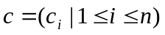, where c_{i} is called a gene. Simple bit manipulation operations allow the implementation of crossover, mutation and other operations. When genetic algorithms are implemented, they are usually done in a manner that involves the following cycle: “Evaluate the fitness of all of the individuals in the population; Create a new population by performing operations such as crossover, fitness-proportionate reproduction and mutation on the individuals whose fitness has just been measured; Discard the old population and iterate using the new population.”
The first generation (generation 0) of this process operates on a population of randomly generated individuals. From there on, the genetic operations, in concert with the fitness measure, operate to improve the population.

Genetic Algorithms for Designing Neural Networks
Many researchers have used GAs to determine neural network architectures. Harp, et al. (1989) and Miller, et al. (1989) used GAs to determine the best connections among network units. Montana and Davis (1989) used GAs for training the neural networks. Chalmers (1991) developed learning rules for neural networks using GAs.
Hansen, et al. (1999) used GAs to design time delay neural networks (TDNN), which included the determination of important features such as number of inputs, the number of hidden layers, and the number of hidden neurons in each hidden layer. Hansen, et al. (1999) applied their networks to model chemical process concentration, chemical process temperatures, and Wolfer sunspot numbers. Their results clearly showed advantages of using TDNN configured by GAs over other techniques including conventional autoregressive integrated moving average (ARIMA) methodology as described by Box and Jenkins (1970).
Hansen et al.’s approach (1999) consisted of building neural networks based on the architectures indicated by the fittest chromosome. The objective of the evolution was to minimize the training error. Such an approach is computationally expensive. Another possibility that is used in this study is to choose the architecture of the input layer using genetic algorithms.
Time series modeling is based on the assumption that the historical values of a variable provide an indication of its value in the future. Based on the available information and pattern analysis, it is possible to make a reasonable assumption about the appropriate length of the history that may be useful for predicting the value of a variable. If all the historical values in the input layer were used in the TDNN calculations, it would lead to an unwieldy network. Such a complex network may hinder the training process. A solution to such a problem is selective pruning of network connections. Lingras and Mountford proposed the maximization of linear correlation between input variables and the output variable as the objective for selecting the connections between input and hidden layers. Since such an optimization is not computationally feasible for large input layers, GAs were used to search for a near optimal solution. It should be noted here that since the input layer has a section of time series, it is not possible to eliminate intermediate input neurons. They are necessary to preserve their time delay connections. However, it is possible to eliminate their feedforward connections. Lingras and Mountford achieved superior performance using the GAs designed neural networks for the prediction of inter-city traffic. The present study uses the same objective function for development of regression and neural network models. The developed models were used to update missing values of traffic counts.
STUDY DATA
Currently, Alberta Transportation employs about 350 permanent traffic counters (PTCs) to monitor its highway networks. Hierarchical grouping method proposed by Sharma and Werner (1981) was used to classify these PTCs into groups. The ratios of monthly average daily traffic (MADT) to annual average daily traffic (AADT) (known as monthly factor MF = MADT/AADT) were used to represent the highway sections monitored by these PTCs during the classification. The errors associated with the successive stages of the grouping process indicated that optimal group number is between 4 and 9. The errors increased dramatically when the group number became smaller than 4. After studying group patterns from 1996 to 2000, five groups seemed appropriate to represent study data. These groups are labeled as commuter, regional commuter, rural long-distance, summer recreational, and winter recreational groups. Figure 3 shows the grouping results. It can be seen that commuter group has a flat yearly pattern due to the stable traffic flows across the year. Regional commuter and rural long-distance groups show higher peaks in the summer and lower troughs in the winter. Recreational group has the sharpest pattern and highest peak in the summer. The largest monthly factor (in August) is about 6 times the smallest monthly factor (in January) for recreational group. Winter recreational group showed an interesting yearly pattern – the peak occurred in winter season (from December to March).
Six counts were selected from 4 out of 5 groups: two from commuter group, two from regional commuter group, one from rural long-distance, and one from recreational group. Due to insufficient data in winter recreational group, no counts were selected from that group. Table 1 shows PTCs selected from different groups, their functional classes, AADT values, and training and test data used in this study.
Figure 4 shows daily patterns for these counts. For commuter group counts (C011145t and C002181t) there are two peaks in a day: one is in the morning, and the other is in the afternoon. Regional commuter count – C022161t also has two peaks in a day, but they are smaller than commuter counts. Even though C003061t was classified into regional commuter group based on its yearly pattern, its daily pattern is very similar to that of rural long-distance count C001025t. The daily patterns of both C003061t and C001025t have two very small peaks. However, the first peak occurred nearly at noon, instead of in the early morning. Recreational count – C093001t only has one peak occurring nearly at noon. Majority of recreational travel took place in a few hours in the afternoon.
For each count, four or five years data was used in the experiments, as shown in Table 1. The data from 1996 to 1999 was used as training set and the data of 2000 was used as test set for counts from the groups other than recreational. Since there were large number of missing values in 1999 data for C093001t, only three years data (from 1996 to 1998) was used for training set and data from 2000 was used as test set. There are no missing values in the experimental data. The data is in the form of hourly traffic volumes for both directions.
STUDY MODELS, RESULTS, AND DISCUSSION
Study Models
The models were trained and tested by assuming that a certain portion of the data was missing. Genetically designed regression and neural network short-term prediction models were applied to estimate missing values from traffic counts. If only one hourly volume is missing, short-term prediction models were only applied once to update that missing value. If there are more than one successive missing values, short-term prediction models were applied recursively for estimating missing values. Figure 5 shows the prototype of models used in this study.
First, assuming there is one or more than one successive missing values in traffic counts, a week-long (7 × 24 = 168) hourly volumes before the first missing values were used as the candidate inputs for short-term prediction models. GAs were used to select 24 input variables, which have the maximum correlation with the traffic volume of next hour. The next hour here is the hour whose volume will be predicted based on GAs selected 24 inputs. The GAs selected variables were used to train the neural network and regression models for traffic prediction of next hour. The trained neural network or regression models were used to estimate missing traffic volume of first hour P1. If there were more than one successive missing values, same techniques would be used to predict second missing value P2. However, at this stage, the candidate pattern presented to GAs for selecting final inputs included estimated volume of first hour P1, as shown in Figure 5. P1 may or may not be chosen as final input because there are different input selection schemas for different models. Figure 6 shows a TDNN model with inputs selected from a week-long hourly-volume time series. Corresponding regression model also used same inputs for prediction.
In order to find out the models with adequate accuracy (e.g., the 95th percentile error below 10%) for updating missing values, a top-down model design was used. First 24-hour universal models were established to test their ability, then they were further split into 12-hour universal models, single-hour models, seasonal single-hour models, and day-hour models. The characteristics of these models are as follows:
- 24-hour universal models: This approach involved a single TDNN and a single regression model for all the hours across the year. The advantage of such models is the simplicity of implementation during the operational phase.
- 12-hour universal models: In order to improve models’ accuracy, 12-hour universal models were built based on 12-hour (from 8:00 a.m. to 8:00 p.m.) observations. In other words, the observations from late evenings and early mornings were eliminated from the models.
- Single-hour models: 12-hour universal models were further split into 12 single-hour models. That is, every hour had a separate model.
- Seasonal single-hour models: Seasons have definite impact on the travel. So further dividing single-hour models into seasonal models may improve models’ accuracy. In this study, yearly single-hour models were further split into May-August single-hour models and July-August single-hour models.
- Day-hour models: Travel patterns also vary by the day of the week. Further classification of observations into groups for different days (e.g., Wednesday or Saturday) may improve models’ accuracy.
- Seasonal day-hour models. Day-hour models were further split into July-August day-hour models to explore the models with higher accuracy.
There were twelve 24-hour universal models for six counts (six 24-hour universal neural network models, and six 24-hour universal regression models), twelve 12-hour universal models, 144 single-hour models, 288 seasonal single-hour models, 288 day-hour models, and 144 seasonal day-hour models. The total number of models developed in this study was 888.
Genetic algorithms were used to identify 24 variables from the input layer that have the highest linear correlation with the output variable. Each chromosome consisted of 24 genes. The candidate-input variables were labeled from 1 to 168 depending upon their position in the input layer as shown in Figure 6. Each gene was allowed to take a value from 1 to 168. Each chromosome has 24 genes. The chromosomes with higher values of linear correlation were selected for creating the next generation. The population size was set to 110. The genetic algorithms were allowed to evolve for 1000 generations. The crossover rate was set at 90%, and the probability of mutation was set to 1%. The best chromosome from 1 to 1000 generations was used as the final solution of the search. The connections selected by the genetic algorithms were used to design and implement the neural network and regression models. That is, the coefficients or weights of the 24 final selected input variables are nonzero and the coefficients or weights of all the other input variables in the time series were set to be zeroes in the implemented regression or neural network models.
All the models were trained and tested. Depending on the model, the number of patterns or observations varied. The absolute percentage error was calculated as:
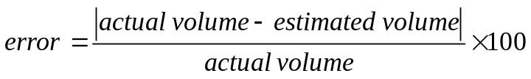 | (2)
The key evaluation parameters consisted of the average, 50th, 85th and 95th absolute percentile errors. These statistics give a clear profile of model’s error distribution.
Study Results and Discussion
Various models were tested on the data from six PTCs. This paper only presents some of the key results for illustration. For example, the results from initial models with low accuracy are only reported for one count. The results from refined models are presented for all six counts.
Table 2 shows the errors for the universal (for all 24 hours) neural network model and regression model of C011145t. GAs used same input selection schema for all hours. There was only one set of weights or coefficients for neural network and regression models. Universal neural network and regression models respond to all input patterns with same computation strategy. This led to high errors in prediction. As shown in Table 2, for 24-hour universal neural network model, the highest 95th percentile error is up to 894% for hour 6:00 – 7:00 a.m. Even the lowest 95th percentile error is around 50% for hour 1:00 – 2:00 p.m. For most cases, regression model performed better than neural network model. However, the majority of the 95th percentile prediction errors are higher than 50% for 24-hour universal regression model. The average errors for 24-hour universal regression model range from 9.98% for 12:00–1:00 p.m. to 114.99% for 7:00-8:00 a.m. Average errors for most of the hours from 10:00 a.m. to 12:00 p.m. (15 hours) are approximately 20%. 24-hour universal neural network model produced higher average errors than 24-hour universal regression model for 21 out of 24 hours. The average errors range from 14.70% to 253.70%. The 50th percentile errors for both models are consistently lower than their average errors. The difference ranges from less than 10% to over 100%. The 50th percentile error may be a better evaluation measurement than average error because they are not affected by the large errors resulting from the outliers.
To improve models’ performance, observations were split into subgroups. The observations from late evenings and early mornings were eliminated to develop 12-hour universal models. These models were used to update 12 successive missing values from 8:00 a.m. to 8:00 p.m. Figure 7 shows GAs selected inputs for the universal models for different counts. For non-recreational counts, input variables closer to the hour being predicted are important. Similarly, traffic volumes of hours closer to the same time period from one week ago were also selected by GAs. For recreational group, selected input variables distributed uniformly across the time series. For commuter, regional commuter and rural long-distance group, regression analysis also indicated that those hourly-volumes, which have the lag of 12n or 12n ± 1 (n = 0, 1, 2, …, 14) from prediction hour, have stronger correlation with the predicted hourly-volume. Usually the coefficients of those hourly-volumes in universal regression models are greater than 0.1.
Table 3 shows errors of 12-hour universal neural network and regression models. Compared with errors in Table 2, there are significant improvements in models’ performance. The average errors of 12-hour universal models range from 10% to 25%. Most of them are below 20%. The 50th percentile errors are between 7% and 12% for most hours. The 95th percentile errors of 12-hour universal neural network models for most hours are below 50%. The results of neural network model are slightly better than regression model for most cases.
Training patterns were further classified into more homogeneous groups for individual hours. Table 4 shows the errors from single-hour models for count C011145t. GAs were used to determine an input selection schema for each hour. Based on the selected inputs, one set of weights for neural network model and one set of coefficients for regression model were developed for each hour between 8:00 a.m. and 8:00 p.m. Figure 8 shows GAs selected inputs for different single-hour models. The distribution of GAs selected input variables were similar to universal models. Most of average errors for single-hour regression and neural network models range from 7% to 15%. The 50th percentile errors are consistently lower than the average errors by 2-3%. Compared with errors in Table 3, for single-hour regression models, the 95th percentile errors for 11 out of 12 hours are lower than 12-hour universal regression model. For single-hour neural network models, the 95th percentile errors for 8 out of 12 hours are lower than 12-hour universal neural network model. The 85th and 95th percentile errors for single-hour regression models are lower than single-hour neural network models in 7 out of 12 cases. The maximum errors usually occurred in the early morning and the minimum errors usually occurred in the afternoon.
Single-hour models reduced the errors significantly from universal models. The experience with single-hour models indicated that the observations for the same hour vary substantially over a year. Based on this observation, single-hour models were further split into seasonal single-hour models. In this paper, May-August single-hour models and July-August single-hour models were used to study the effect of seasons. Only the observations from same hours in certain season (e.g., July and August) were used to develop models. As expected, May-August single-hour models outperformed yearly single-hour models. The errors for July-August single-hour models were even lower. The results of July-August single-hour models are presented here for comparison. Table 5 shows the errors of July-August single-hour models for updating 12 successive missing values for C011145t. Average errors for July-August single-hour regression models are generally below 10%. July-August single-hour neural network models usually resulted in average errors below 13%. The 50th percentile errors for regression and neural network models are usually below 10%. Compared with Table 4, all the 95th percentile errors for July-August single-hour regression models are lower than yearly single-hour regression models. The improvements range from 4-5% to over 20%. For July-August single-hour neural network models, the 95th percentile errors are lower than yearly neural network single-hour models in 9 out of 12 cases. July-August single-hour regression models outperformed July-August single-hour neural network models in 10 out of 12 cases. This suggests that, as the observations become more homogeneous, regression models perform better than neural network models.
Since commuter travel is usually on weekdays and recreational travel on weekends, days of the week also have significant impact on trip patterns for certain roads. In order to further improve models’ performance, day-hour models were developed for each type of road. The observations from same hours of the same day in the week (e.g., 7:00-8:00 a.m. on all Wednesdays) of a year were used to develop models. Both Wednesday and Saturday day-hour models were developed for six study counts. It was found that for groups other than recreational, Saturday day-hour models usually produced larger errors than the corresponding Wednesday day-hour models. However, for recreational count – C093001t, most Saturday day-hour models outperformed the corresponding Wednesday day-hour models. For illustration, only the results of Wednesday day-hour models are presented here. Table 6 shows the errors for Wednesday day-hour regression and neural network models for C011145t. Nearly all average errors for both regression and neural network day-hour models are below 15%. The 50th percentile errors for day-hour regression models are all lower than 9%, and most 50th percentile errors for day-hour neural network models are below 12%. Compared with Table 5, the errors for day-hour models are lower than July-August single-hour models for only a few hours. But the dramatic error decreases from first single-hour model (for 7:00-8:00 a.m.) indicate that considering day of the week in developing models will improve the accuracy.
Previous experiments indicate that both seasons and weekdays have large impact on travel patterns. Seasonal day-hour models may result in even better performance. Tables 7 – 12 show the errors of July-August day-hour models for updating 12 successive missing values on the Wednesdays for six traffic counts. For first commuter count – C011145t, most average errors for regression models are less than 3% and those for neural network models are usually between 6% and 13%. Most 95th percentile errors for regression models are lower than 7%. Neural network models for different hours have considerably different 95th percentile errors, ranging from 7.5% to nearly 40%. This may be caused by the small number of observations in the training sets (only 36) and the test sets (only 9).
Table 8 shows errors for GAs designed July-August day-hour models for updating 12 successive missing values for C002181t. The average and the 50th percentile errors for regression models are usually below 1%. Even the 95th percentile errors are lower than 4% and most of them are less than 2%. GAs designed day-hour neural network models produced less accurate results than regression models. The average errors range from 2% to 8%. The 95th percentile errors for most hours are lower than 11%. For two regional commuter counts – C003061t and C022161t, regression model outperformed neural network models for nearly all the hours, as shown in Table 9 and Table 10. The average errors for regression models usually range from 1% to 3%. Most 95th percentile errors are lower than 6%. Most average errors for neural network models are between 3% and 8%. Most 95th percentile errors range from 8% to 15%.
Model’s performance deteriorates as traffic patterns become unstable. For example, the models for the commuter count tend to have lower errors than those for the recreational count. However, July-August day-hour regression models still performed reasonably well for rural long-distance count C001025t, as shown in Table 11. The average errors of regression models are all below 3%. The 50th percentile errors are all less than 2%. All the 95th percentile errors for regression models are lower than 5%. The average errors of July-August day-hour neural network models range from 3% to 15%.
GAs designed July-August day-hour regression models also performed well for updating missing values from recreational count – C093001t. As shown in Table 12, except for a few hours (e.g., 7:00 – 8:00 a.m.), the average errors for regression models for all the other hours’ are below 4% and the 95th percentile errors are lower than 10%. Neural network models were less accurate. For neural network models, the average errors were usually below 13%, and the 95th percentile errors range from 10% to 40%.
The analysis of previous results based on functional classes (e.g., minor collector or arterial) also provides an interesting relationship. Short-term traffic prediction models usually performed better with traffic counts located on higher functional class roads. Roads from higher functional class usually have large AADT values and their short-term traffic patterns are more stable. For example, day-hour regression models achieved better performance for the commuter count – C002181t (AADT = 41,575, principal arterial) than another commuter count – C011145t (AADT = 4,042, minor collector). The 95th percentile errors for day-hour regression models on Wednesdays in July and August for C002181t were lower than 8%, while for C011145t, they were 15 - 30% or higher. A possible reason for such a difference is that roads from lower functional classes usually have more variant short-term traffic patterns than those from higher functional classes.
CONCLUDING REMARKS
The principle of Base Data Integrity says that imputed data should not be mixed with base data. However, this doesn’t imply that traffic measurements can not be imputed during traffic analysis. Analysis of data from Canadian province of Alberta and Minnesota State shows that a large number of traffic counts have missing values. It will be difficult to eliminate these counts from traffic analysis. Under some circumstances, imputations may have to be used for further analysis.
Literature review indicated that various methods were used for estimating missing values by highway agencies (New Mexico 1990). Previous research (Southworth et al. 1989; Clark 1992; Redfern et al. 1993; Waston et al. 1993) on transport related time series mainly focused on detecting missing values or outliers. Predictions of missing values were only tested on small pieces of time series and comprehensive statistical evaluation is not available. In this study, advanced models based on three techniques – regression analysis, neural network, and genetic algorithms were used to estimate missing values from six PTCs. A top-down model design was used to search models with reasonable accuracy. Various models were tested and the performance of models was evaluated with absolute percentile errors based on the large number of observations. The small estimation errors in this study reflect the model’s stability and suitability in updating missing values. For example, when using July-August day-hour regression models to update missing values on Wednesdays for some counts, the average errors are below 2%, and the 95th percentile errors are lower than 4-5%. Even for recreational count C093001t, most average errors are below 4%, and most 95th percentile errors are lower than 10%.
The performance of models for updating missing values is not only affected by the trip purposes (e.g., commuter or recreational) of roads, but also depends on their functional classes (e.g., minor collector or arterial). Short-term traffic prediction models usually performed better for traffic counts from higher functional class roads.
The results presented in this study may have additional applications. Waston et al. (1993) described methods for detecting outliers. The models presented in this study can be used to impute more reasonable values for outliers in traffic data.
This study used short-term traffic prediction models to update missing values. The short-term predictions are only based on historical data. For the estimation of missing values, the data from before and after the failure is available. It will be interesting to develop missing values models based on the data from before and after the failure. The techniques used in this study can be easily adapted to such missing value models. Experiments on these missing value models are currently underway. Results of the experiments will be reported in a future publication. The effects of updating missing values on estimations of important traffic parameters, such as AADT and DHV, will also be studied and reported in the future.
ACKNOWLEDGMENTS
The authors are grateful towards NSERC, Canada for their financial support. Alberta Transportation and Minnesota Department of Transportation supplied the data used in this study. The authors would also like to thank Rui Yan and Jing Xu for their help with the experiments.

REFERENCES
Albright, D. History of Estimating and Evaluating Annual Traffic Volume Statistics. Transportation Research Record 1305, Transportation Research Board, Washington, D.C, pp. 103-107, 1991ª.
Albright, D. An Imperative for, and Current Progress toward, National Traffic Monitoring Standards. ITE Journal, Vol. 61, No. 6, pp. 23-26, June 1991^{b}.
America Association of State Highway and Transportation Officials. Guidelines for Traffic Data Programs. Washington, D.C., AASHTO, 1992.
America Society for Testing and Materials. Standard Practice E1442, Highway Traffic Monitoring Standards. ASTM. Philadelphia, PA, October 1991.
Beveridge, S. Least Squares Estimation of Missing Values in Time Series. Communications in Statistics: Theory and Methods, 21, no. 12, 1992.
Bole, V., Cepar, D. and Radalj, Z. Estimating Missing Values in Time Series. Methods of Operations Research, no. 62, 1990.
Box, G. and Jenkins, J. Time Series Analysis: Forecasting and Control. San Francisco, Holden-Day, 1970.
Buckles, B.P. and Petry, F.E. Genetic Algorithms. IEEE Computer Press, Los
Alamitos, California, 1994.
Chalmers, D. The evolution of learning: An experiment in genetic connectionism. In: D. Touretzky et al. (Eds.), Connectionist Models: Proceedings of the 1990 Summer School. San Mateo, Morgan Kaufmann, 1991.
Clark, S.D. Application of Outlier Detection and Missing Value Replacement Techniques to Various Forms of Traffic Count Data. ITS Working Paper 384, University of Leeds, 1992.
Friedman, J.H. Intelligent Local Learning For Prediction in High Dimensions. International Conference on Artificial Neural Networks, Paris, France, October 9-13, 1995.
Gupta, A. and Lam, M. S. Estimating Missing Values using Neural Networks. Journal of the Operational Research Society, 47, no. 2, pp.229-239, 1996.
Hansen, J.V., McDonald, J.B. and Nelson, R.D. Time Series Prediction with Genetic Algorithm Designed Neural Networks: An Experimental Comparison with Modern Statistical Models. Computational Intelligence, 15(3), pp. 171-184, 1999.
Harp, S., Samad, T. and Guha, A. Towards the Genetic Synthesis of neural networks. In: D. Shaffer (Ed.), Proceedings of the Third International Conference on Genetic Algorithms. San Mateo, Morgan Kaufmann, 1989.
Hecht-Nielsen, R. Neurocomputing. Addison-Wesley Pub. Co, Don Mills, Ontario, 1990.
Holland, J.H. Adaptation in Natural and Artificial Systems. Ann Arbor: University of Michigan Press, 1975.
Lingras, P. and Mountford, P. Application of a Hybrid of Neural, Statistical and Genetic Computations for Analysis of Two Time-Series of Different Lengths. Submitted to the International Journal of Forecasting.
Little, R.A. and Rubin, D.B. Statistical Analysis with Missing Data. Wiley, New York, 1987.
Locally Weighted Polynomial Regression. http://www.autonlab.org/lwpr_src/lwpr.ht ml#1, 2001.
Mendenhall, W. and Sincich, T. Statistics for Engineering and Science. Fourth Edition, Prentice-Hall, Inc, 1995.
Miller, G., Todd, P. and Hedge, S. Designing neural networks using genetic algorithms. In: D. Shaffer (Ed.), Proceedings of the Third International Conference on Genetic Algorithms. San Mateo, Morgan Kaufmann, 1989.
Montana, D. and Davis, L. Training feedforward networks using genetic algorithms. In: N. Sridhara (Ed.), Proceedings of Eleventh International Joint Conference on Artificial Intelligence, pp. 762-767, 1989.
New Mexico State Highway and Transportation Department. 1990 Survey of Traffic Monitoring Practices among State Transportation Agencies of the United States. Report No. FHWA-HRP-NM-90-05. Santa Fe, New Mexico. December 1990.
Ratner, Bruce. CHAID as a Method for Filling in Missing Values. http://www. dmstat1.com/missing.html (to be appear in Journal of Targeting, Measurement and Analysis for Marketing), 2000.
Redfern, E.J., Waston, S.M., Tight, M.R., and Clark, S.D. A Comparative Assessment of Current and New Techniques for Detecting Outliers and Estimating Missing Values in Transport Related Time Series Data. Proceedings of Highways and Planning Summer Annual Meeting. Institute of Science and Technology, University of Manchester, England, September 1993.
Schaal, S. and Atkeson, C. Robot juggling: An implementation of memory-based learning. Control Systems, 14, pp. 57-71, 1994.
Sharma, S.C. Minimizing Cost of Manual Traffic Counts: Canadian Example. Transportation Research Record 905, Transportation Research Board, Washington, D.C, pp. 1-7, 1983.
Sharma, S.C., Kilburn, P. and Wu, Y.Q. The precision of AADT Volumes Estimates from Seasonal Traffic Counts: Alberta Example. Canadian Journal of Civil Engineering, Vol. 23, No. 1, pp. 302-, 1996.
Sharma, S.C. and Werner, A. Improved Method of Grouping Provincewide Permanent Traffic Counters. Transportation Research Record 815, Transportation Research Board, Washington D.C., pp. 12-18, 1981.
Singh, V.P. and Harmancioglu, N.B. Estimation of Missing Values with Use of Entropy. NATO Advanced Research Workshop, Izmir, Turkey, pp. 267-274, 1996.
Southworth, F., Chin, S. M. and Cheng, P. D. A Telemetric Monitoring And Analysis System for Use during Large Scale Population Evacuations. Proceedings of IEEE 2nd International Conference on Road Traffic Monitoring, London, U.K., 1989.
Watson, S.M., Clark, S.D., Redfern, E.J. and Tight, M.R. Outlier Detection and Missing Value Estimation in Time Series Traffic Count Data. Proceedings of the Sixth World Conference on Transportation Research, Vol. II, pp. 1151-1162, 1993.
Williams, B.M., Durvasula, P.K. and Brown, D.E. Urban Freeway Traffic Flow Prediction: Application of Seasonal Autoregressive Integrated Moving Average And Exponential Smoothing Models. Transportation Research Record 1644, Transportation Research Board, Washington, D.C., pp.132-141, 1998.
Wright, P.M. Filling in the Blanks: Multiple Imputation for Replacing Missing Values in Survey Data. SAS 18th Annual Conference, New York, NY, 1993.

List of Figures

Figure 1. The Percentage of Permanent Traffic Counts with Missing Values
Figure 2. Time Delayed Neural Network Design

Figure 3. Hierarchical Grouping of Alberta Highway Sections

Figure 4. Daily Patterns of Six Study Counts

Figure 5. The Prototype of Updating Missing Values Model

Figure 6. TDNN Model Used for Prediction

Figure 7. GAs Selected Inputs for 12-hour Universal Models

Figure 8. GAs Selected Inputs for Single-hour Models for Count C011145t

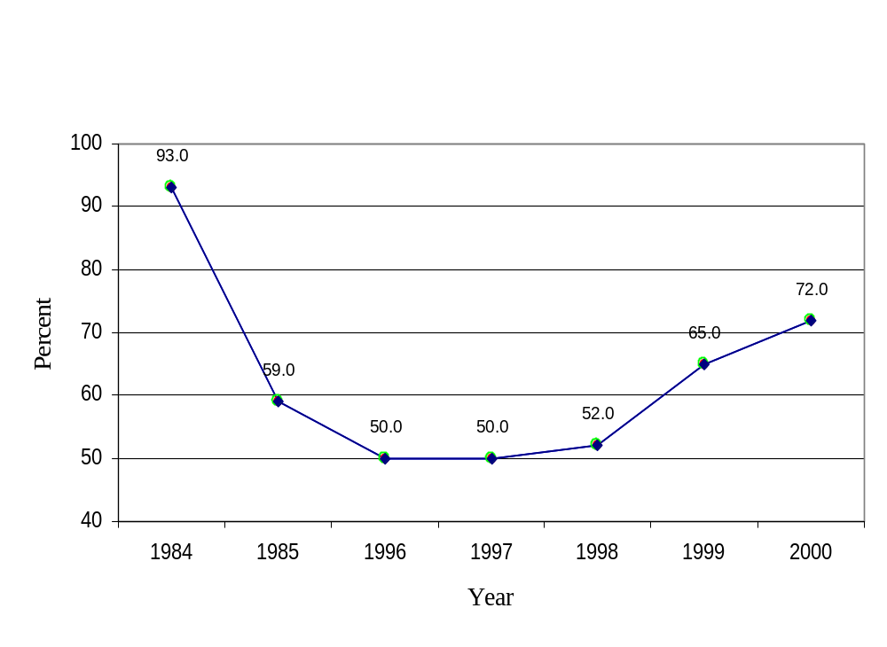

Figure 1. The Percentage of Permanent Traffic Counts with Missing Values

Output layer
Input layer
Hidden layer

Figure 2. Time Delayed Neural Network Design

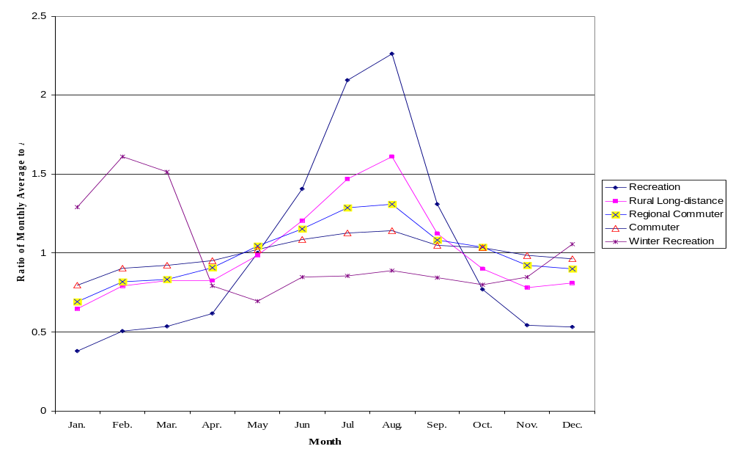

Figure 3. Hierarchical Grouping of Alberta Highway Sections

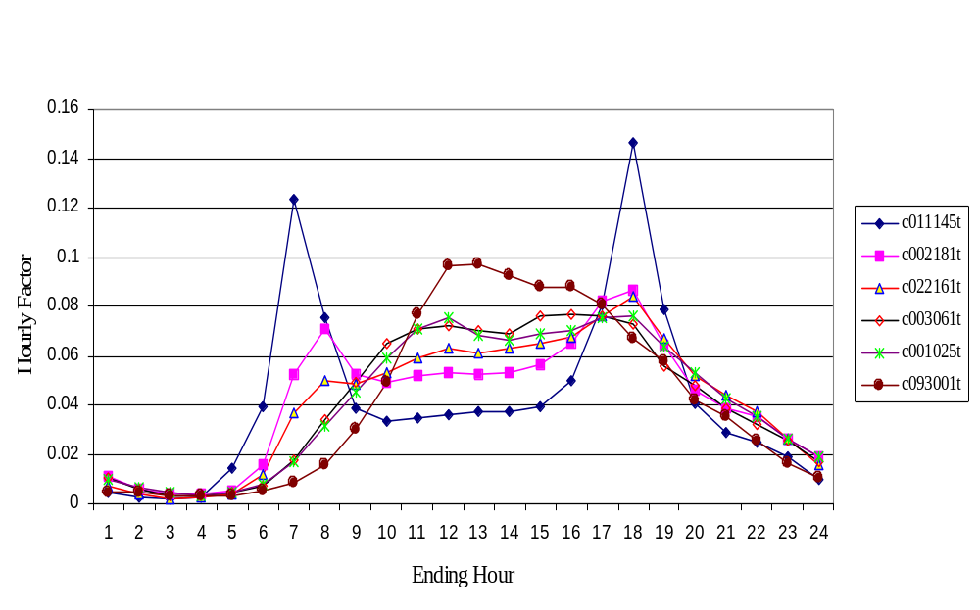

Figure 4. Daily Patterns of Six Study Counts

First Step
Predicted Value P1
Input Pattern
(168 hourly-volumes time series)
Predicted Value P2
Input Pattern
(168 hourly-volumes time series)
Third Step
Predicted Value P3
Input Pattern
(168 hourly-volumes time series)
P1
P2
P1

Second Step

Figure 5. The Prototype of Updating Missing Values Model

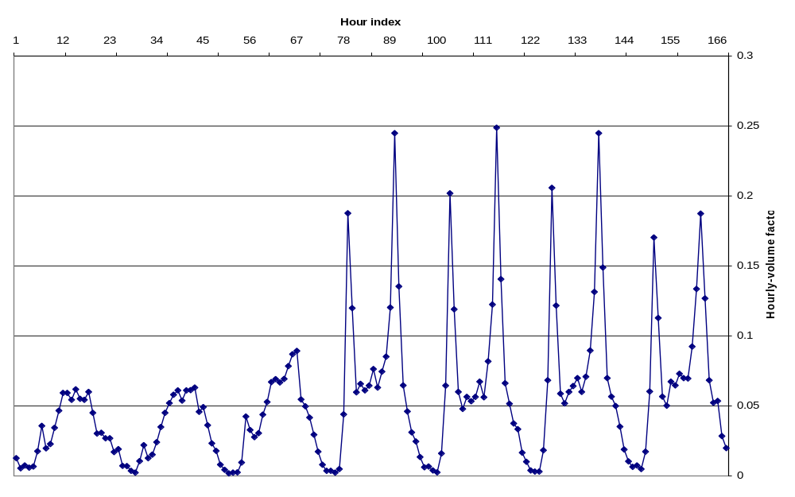
12 hidden neurons
24 input neurons
1 output neuron

Figure 6. TDNN Model Used for Prediction

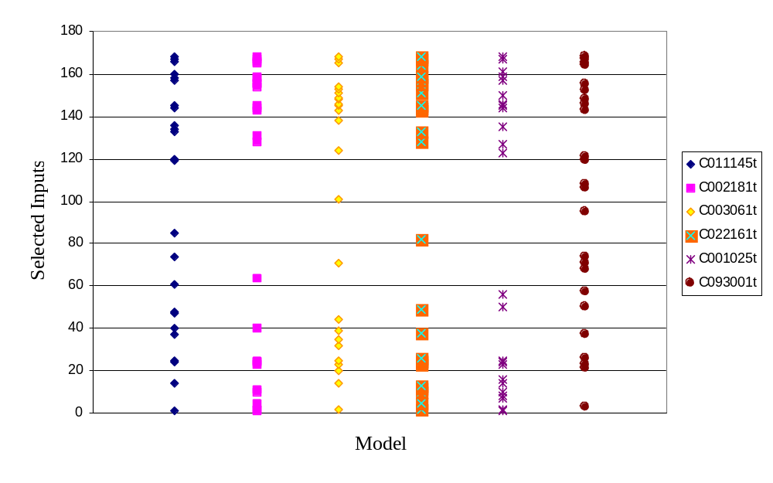Figure 7. GAs Selected Inputs for 12-hour Universal Models

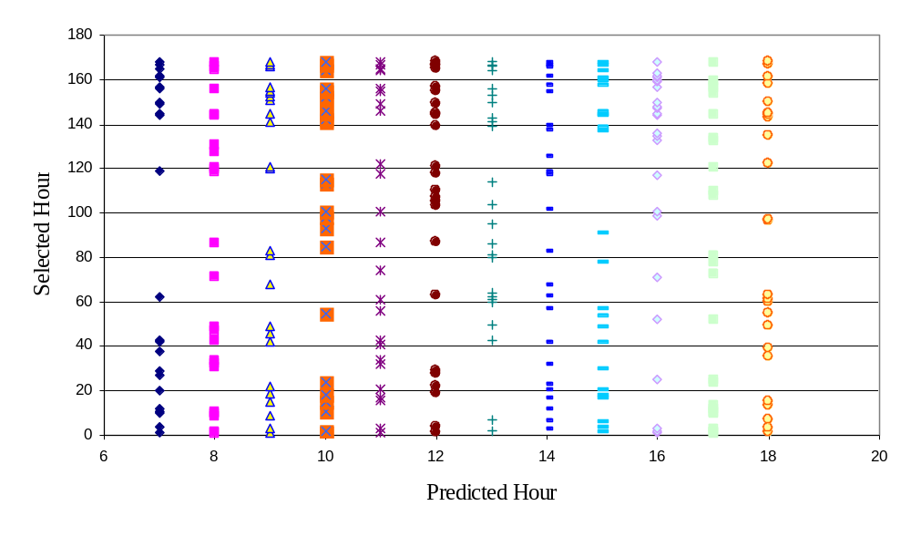

Figure 8. GAs Selected Inputs for Single-hour Models for Count C011145t

List of Tables

Table 1. Experimental Data from Different Groups
Table 2. Errors for Updating 24 Successive Missing Values with 24-hour Universal Models (C011145t)
Table 3. Errors for Updating 12 Successive Missing Values with 12-hour Universal Models (C011145t)
Table 4. Errors for Updating 12 Successive Missing Values with Single-hour Models
(C011145t)
Table 5. Errors for Updating 12 Successive Missing Values with July-August Single-hour Models (C011145t)
Table 6. Errors for Updating 12 Successive Missing Values on Wednesdays with Day-hour Models (C011145t)
Table 7. Errors for Updating 12 Successive Missing Values on Wednesdays with
July-August Day-hour Models for C011145t
Table 8. Errors for Updating 12 Successive Missing Values on Wednesdays with
July-August Day-hour Models for C002181t
Table 9. Errors for Updating 12 Successive Missing Values on Wednesdays with
July-August Day-hour Models for C003061t
Table 10. Errors for Updating 12 Successive Missing Values on Wednesdays with
July-August Day-hour Models for C022161t
Table 11. Errors for Updating 12 Successive Missing Values on Wednesdays with
July-August Day-hour Models for C001025t
Table 12. Errors for Updating 12 Successive Missing Values on Wednesdays with
July-August Day-hour Models for C093001t

Table 1. Experimental Data from Different Groups

Road Class | Counter Name | AADT | Functional Class | Training Set | Testing Set
Commuter | C011145t | 4042 | Minor Collector | 1996 – 1999 | 2000
 | C002181t | 41575 | Principal Arterial | 1996 – 1999 | 2000
Regional Commuter | C003061t | 3905 | Minor Collector | 1996 – 1999 | 2000
 | C022161t | 3728 | Major Collector | 1996 – 1999 | 2000
Rural Long-distance | C001025t | 13627 | Minor Arterial | 1996 – 1999 | 2000
Recreation | C093001t | 2002 | Major Collector | 1996 – 1998 | 2000

Table 2. Errors for Updating 24 Successive Missing Values with 24-hour Universal Models
(C011145t)
Hour  (1) | Testing Errors
Hour  (1) | Average |  | 50th % |  | 85th % |  | 95th %
Hour  (1) | Reg.  (2) | ANN  (3) | Reg.  (4) | ANN  (5) | Reg.  (6) | ANN  (7) | Reg.  (8) | ANN  (9)
00-01 | 26.88 | 79.64 | 21.11 | 43.30 | 46.58 | 152.01 | 74.76 | 237.41
01-02 | 44.17 | 253.70 | 32.63 | 146.68 | 73.14 | 491.03 | 119.45 | 750.05
02-03 | 69.33 | 113.32 | 40.22 | 52.83 | 99.27 | 214.55 | 172.02 | 395.33
03-04 | 51.70 | 66.60 | 39.39 | 36.11 | 90.01 | 113.43 | 138.10 | 245.58
04-05 | 60.07 | 58.94 | 32.46 | 31.96 | 104.19 | 101.98 | 216.73 | 198.96
05-06 | 62.50 | 74.51 | 16.20 | 29.32 | 162.15 | 125.02 | 317.84 | 322.16
06-07 | 77.65 | 180.33 | 13.22 | 30.81 | 214.87 | 450.51 | 413.31 | 894.34
07-08 | 114.99 | 87.16 | 16.36 | 21.55 | 265.43 | 203.48 | 590.42 | 340.66
08-09 | 44.11 | 38.09 | 12.45 | 15.09 | 107.61 | 86.43 | 209.34 | 124.86
09-10 | 21.48 | 21.59 | 12.85 | 11.17 | 36.09 | 47.72 | 80.66 | 78.19
10-11 | 13.84 | 17.91 | 9.33 | 9.38 | 25.10 | 33.89 | 39.86 | 77.60
11-12 | 11.29 | 15.85 | 8.07 | 9.08 | 19.75 | 23.41 | 31.22 | 71.70
12-13 | 9.98 | 14.70 | 7.40 | 8.06 | 16.72 | 22.92 | 25.17 | 68.22
13-14 | 10.13 | 15.91 | 7.60 | 9.85 | 18.47 | 29.72 | 27.80 | 50.83
14-15 | 10.11 | 24.01 | 7.44 | 17.61 | 17.27 | 44.49 | 26.51 | 70.83
15-16 | 12.64 | 37.73 | 9.25 | 19.36 | 22.86 | 90.23 | 35.35 | 116.68
16-17 | 22.71 | 41.48 | 14.43 | 34.15 | 44.01 | 74.26 | 68.29 | 90.91
17-18 | 36.39 | 32.21 | 14.25 | 26.40 | 78.85 | 50.28 | 160.97 | 98.97
18-19 | 21.96 | 30.23 | 13.67 | 22.95 | 39.75 | 54.36 | 76.92 | 99.05
19-20 | 17.21 | 25.50 | 13.54 | 16.23 | 28.97 | 49.62 | 46.84 | 91.64
20-21 | 16.89 | 21.92 | 14.23 | 14.46 | 28.87 | 36.82 | 40.66 | 79.81
21-22 | 17.38 | 20.97 | 15.02 | 13.62 | 29.52 | 38.21 | 39.14 | 78.92
22-23 | 17.22 | 24.93 | 13.12 | 18.37 | 29.49 | 43.30 | 42.96 | 80.87
23-24 | 22.79 | 32.12 | 18.79 | 25.70 | 42.57 | 58.17 | 56.98 | 81.07

Table 3. Errors for Updating 12 Successive Missing Values with 12-hour Universal Models
(C011145t)
Hour  (1) | Testing Errors
Hour  (1) | Average |  | 50th % |  | 85th % |  | 95th %
Hour  (1) | Reg.  (2) | ANN  (3) | Reg.  (4) | ANN  (5) | Reg.  (6) | ANN  (7) | Reg.  (8) | ANN  (9)
07-08 | 24.69 | 20.20 | 10.13 | 7.81 | 46.31 | 50.00 | 91.07 | 85.29
08-09 | 20.66 | 17.25 | 11.36 | 8.73 | 31.11 | 31.38 | 56.32 | 63.73
09-10 | 16.98 | 13.99 | 10.67 | 9.41 | 28.52 | 21.61 | 48.06 | 42.32
10-11 | 11.96 | 10.64 | 8.81 | 8.11 | 20.33 | 18.25 | 35.04 | 29.05
11-12 | 10.54 | 10.23 | 8.43 | 8.01 | 18.02 | 17.56 | 24.25 | 25.29
12-13 | 9.93 | 10.29 | 7.68 | 8.08 | 16.81 | 17.72 | 27.29 | 27.96
13-14 | 10.46 | 9.83 | 8.77 | 7.55 | 18.76 | 17.83 | 27.68 | 25.20
14-15 | 10.64 | 11.04 | 7.91 | 7.33 | 18.58 | 20.02 | 30.16 | 30.25
15-16 | 11.78 | 10.84 | 9.32 | 7.96 | 20.33 | 19.11 | 32.84 | 30.54
16-17 | 14.44 | 11.96 | 9.86 | 7.74 | 26.77 | 22.13 | 41.69 | 37.54
17-18 | 20.10 | 23.24 | 10.69 | 23.68 | 32.30 | 34.50 | 64.29 | 39.13
18-19 | 15.51 | 18.54 | 8.75 | 13.46 | 26.47 | 31.79 | 59.51 | 48.59

Table 4. Errors for Updating 12 Successive Missing Values with Single-hour Models
(C011145t)
Hour  (1) | Testing Errors
Hour  (1) | Average |  | 50th % |  | 85th % |  | 95th %
Hour  (1) | Reg.  (2) | ANN  (3) | Reg.  (4) | ANN  (5) | Reg.  (6) | ANN  (7) | Reg.  (8) | ANN  (9)
07-08 | 28.45 | 20.37 | 18.71 | 10.45 | 55.13 | 44.71 | 84.99 | 75.61
08-09 | 30.79 | 13.92 | 30.03 | 8.70 | 47.34 | 24.34 | 59.56 | 46.21
09-10 | 18.61 | 14.34 | 16.10 | 11.30 | 32.53 | 25.04 | 42.27 | 39.11
10-11 | 13.52 | 13.74 | 11.18 | 10.86 | 22.67 | 26.48 | 33.34 | 35.05
11-12 | 9.84 | 12.12 | 7.87 | 9.13 | 17.44 | 21.19 | 22.86 | 35.54
12-13 | 8.09 | 10.12 | 6.36 | 7.46 | 13.83 | 17.35 | 20.64 | 28.04
13-14 | 7.94 | 9.77 | 6.18 | 7.77 | 14.71 | 18.02 | 20.03 | 26.75
14-15 | 8.11 | 9.62 | 6.16 | 7.22 | 13.73 | 16.41 | 20.76 | 27.98
15-16 | 8.68 | 8.95 | 6.76 | 6.42 | 15.17 | 16.43 | 22.94 | 25.78
16-17 | 12.21 | 8.54 | 9.82 | 5.76 | 21.68 | 14.91 | 32.80 | 23.53
17-18 | 13.82 | 13.04 | 11.07 | 11.41 | 21.80 | 19.84 | 37.27 | 34.96
18-19 | 12.48 | 13.85 | 10.38 | 10.60 | 20.38 | 21.88 | 35.81 | 41.23

Table 5. Errors for Updating 12 Successive Missing Values with July-August
Single-hour Models
(C011145t)
Hour  (1) | Testing Errors
Hour  (1) | Average |  | 50th % |  | 85th % |  | 95th %
Hour  (1) | Reg.  (2) | ANN  (3) | Reg.  (4) | ANN  (5) | Reg.  (6) | ANN  (7) | Reg.  (8) | ANN  (9)
07-08 | 19.55 | 19.15 | 10.22 | 16.19 | 37.28 | 38.07 | 61.09 | 52.47
08-09 | 14.84 | 14.24 | 11.63 | 10.44 | 22.95 | 27.99 | 36.89 | 34.17
09-10 | 9.34 | 12.26 | 7.96 | 9.78 | 17.86 | 23.11 | 20.06 | 31.91
10-11 | 8.37 | 10.84 | 7.31 | 9.33 | 15.07 | 20.14 | 19.54 | 24.03
11-12 | 6.88 | 9.09 | 6.71 | 5.77 | 10.76 | 17.03 | 14.89 | 27.75
12-13 | 7.33 | 12.71 | 6.43 | 10.47 | 12.96 | 22.35 | 14.95 | 32.03
13-14 | 6.81 | 12.98 | 5.28 | 9.97 | 12.57 | 24.78 | 15.11 | 32.18
14-15 | 7.01 | 11.10 | 5.57 | 9.20 | 13.15 | 20.17 | 16.40 | 28.86
15-16 | 6.50 | 9.65 | 4.50 | 7.42 | 13.13 | 16.95 | 15.97 | 23.49
16-17 | 8.89 | 9.20 | 7.09 | 7.80 | 13.70 | 14.51 | 22.79 | 23.12
17-18 | 8.47 | 11.88 | 7.33 | 10.00 | 13.90 | 19.49 | 15.64 | 27.71
18-19 | 8.69 | 8.99 | 7.27 | 6.62 | 13.18 | 15.50 | 19.49 | 21.65

Table 6. Errors for Updating 12 Successive Missing Values on Wednesdays
with Day-hour Models
(C011145t)
Hour  (1) | Testing Errors
Hour  (1) | Average |  | 50th % |  | 85th % |  | 95th %
Hour  (1) | Reg.  (2) | ANN  (3) | Reg.  (4) | ANN  (5) | Reg.  (6) | ANN  (7) | Reg.  (8) | ANN  (9)
07-08 | 11.17 | 8.07 | 7.49 | 4.42 | 15.96 | 11.09 | 23.75 | 21.39
08-09 | 13.68 | 18.98 | 8.56 | 16.45 | 25.85 | 24.60 | 37.77 | 41.56
09-10 | 11.28 | 13.71 | 7.52 | 11.48 | 18.97 | 23.49 | 29.82 | 31.70
10-11 | 9.09 | 14.35 | 8.18 | 11.62 | 12.68 | 24.86 | 21.98 | 42.22
11-12 | 7.27 | 11.63 | 3.53 | 8.25 | 15.04 | 20.88 | 22.84 | 32.56
12-13 | 7.95 | 19.19 | 6.58 | 14.62 | 12.74 | 34.58 | 18.70 | 46.47
13-14 | 7.10 | 14.06 | 5.88 | 9.90 | 11.28 | 23.04 | 15.52 | 44.08
14-15 | 9.43 | 12.34 | 6.10 | 8.68 | 14.95 | 22.28 | 27.79 | 30.38
15-16 | 10.37 | 9.29 | 8.36 | 6.63 | 16.43 | 15.64 | 24.18 | 23.43
16-17 | 14.39 | 9.05 | 9.19 | 4.91 | 18.48 | 14.94 | 51.52 | 28.56
17-18 | 4.99 | 8.58 | 4.12 | 8.20 | 7.75 | 14.22 | 13.30 | 16.04
18-19 | 8.59 | 12.65 | 4.88 | 10.02 | 13.35 | 21.82 | 25.02 | 31.81

Table 7. Errors for Updating 12 Successive Missing Values on Wednesdays with
July-August Day-hour Models for C011145t

Hour  (1) | Testing Errors
Hour  (1) | Average |  | 50th % |  | 85th % |  | 95th %
Hour  (1) | Reg.  (2) | ANN  (3) | Reg.  (4) | ANN  (5) | Reg.  (6) | ANN  (7) | Reg.  (8) | ANN  (9)
07-08 | 2.71 | 24.59 | 2.25 | 22.51 | 3.86 | 36.55 | 5.33 | 39.85
08-09 | 2.34 | 13.52 | 2.60 | 9.21 | 4.23 | 24.26 | 4.70 | 35.75
09-10 | 2.50 | 6.55 | 2.03 | 4.23 | 4.44 | 14.74 | 6.27 | 17.57
10-11 | 1.66 | 6.97 | 1.69 | 4.32 | 2.25 | 10.49 | 2.97 | 17.63
11-12 | 0.82 | 4.86 | 0.72 | 3.47 | 0.94 | 6.02 | 1.64 | 12.79
12-13 | 2.76 | 12.72 | 1.71 | 9.29 | 4.15 | 23.46 | 6.40 | 27.98
13-14 | 1.71 | 11.56 | 1.31 | 11.68 | 3.13 | 21.14 | 4.48 | 23.19
14-15 | 2.50 | 8.10 | 2.29 | 8.08 | 3.74 | 14.64 | 4.55 | 16.16
15-16 | 3.83 | 8.00 | 4.59 | 4.59 | 5.63 | 10.77 | 6.52 | 24.76
16-17 | 5.85 | 12.90 | 5.64 | 14.09 | 7.48 | 20.00 | 9.57 | 21.14
17-18 | 0.75 | 4.05 | 0.79 | 3.84 | 0.95 | 7.25 | 1.34 | 7.48
18-19 | 9.19 | 7.55 | 9.74 | 7.85 | 12.88 | 11.96 | 14.18 | 14.06

Table 8. Errors for Updating 12 Successive Missing Values on Wednesdays with
July-August Day-hour Models for C002181t

Hour  (1) | Testing Errors
Hour  (1) | Average |  | 50th % |  | 85th % |  | 95th %
Hour  (1) | Reg.  (2) | ANN  (3) | Reg.  (4) | ANN  (5) | Reg.  (6) | ANN  (7) | Reg.  (8) | ANN  (9)
07-08 | 0.25 | 2.14 | 0.21 | 1.90 | 0.39 | 3.79 | 0.57 | 4.43
08-09 | 0.59 | 2.19 | 0.48 | 2.38 | 0.75 | 3.16 | 1.19 | 4.28
09-10 | 1.66 | 3.03 | 1.14 | 3.58 | 3.19 | 4.25 | 3.47 | 6.06
10-11 | 0.38 | 6.71 | 0.31 | 6.50 | 0.43 | 7.33 | 1.04 | 10.48
11-12 | 0.56 | 2.13 | 0.50 | 1.90 | 0.74 | 3.18 | 1.03 | 4.17
12-13 | 0.81 | 2.90 | 0.98 | 3.26 | 1.25 | 4.54 | 1.73 | 5.67
13-14 | 0.59 | 2.23 | 0.56 | 2.39 | 1.02 | 3.38 | 1.07 | 4.86
14-15 | 0.89 | 4.69 | 0.50 | 5.54 | 1.35 | 6.63 | 2.55 | 6.98
15-16 | 0.68 | 6.63 | 0.88 | 6.99 | 0.97 | 10.12 | 1.09 | 10.74
16-17 | 0.44 | 7.82 | 0.29 | 7.93 | 0.64 | 8.97 | 1.25 | 11.82
17-18 | 0.31 | 6.45 | 0.31 | 6.68 | 0.42 | 8.01 | 0.68 | 10.34
18-19 | 0.84 | 7.10 | 0.75 | 6.67 | 1.39 | 11.93 | 1.73 | 14.00

Table 9. Errors for Updating 12 Successive Missing Values on Wednesdays with
July-August Day-hour Models for C003061t

Hour  (1) | Testing Errors
Hour  (1) | Average |  | 50th % |  | 85th % |  | 95th %
Hour  (1) | Reg.  (2) | ANN  (3) | Reg.  (4) | ANN  (5) | Reg.  (6) | ANN  (7) | Reg.  (8) | ANN  (9)
07-08 | 2.51 | 10.51 | 2.29 | 8.47 | 3.57 | 17.65 | 5.47 | 20.52
08-09 | 2.20 | 4.67 | 1.87 | 4.51 | 4.49 | 6.97 | 4.98 | 9.38
09-10 | 1.98 | 3.34 | 1.72 | 2.74 | 3.48 | 4.52 | 3.90 | 6.87
10-11 | 0.83 | 5.07 | 0.70 | 5.45 | 1.33 | 6.00 | 1.60 | 8.20
11-12 | 1.19 | 3.57 | 0.67 | 2.73 | 2.34 | 7.81 | 2.65 | 8.32
12-13 | 1.10 | 7.79 | 0.99 | 7.55 | 1.75 | 9.76 | 2.64 | 17.50
13-14 | 1.64 | 6.25 | 1.99 | 4.22 | 2.48 | 12.47 | 2.87 | 12.78
14-15 | 3.92 | 5.13 | 4.58 | 4.66 | 6.41 | 8.40 | 6.97 | 11.13
15-16 | 0.49 | 4.21 | 0.52 | 4.07 | 0.74 | 7.63 | 1.10 | 8.63
16-17 | 2.82 | 4.77 | 2.30 | 5.99 | 4.80 | 6.81 | 5.43 | 7.70
17-18 | 1.32 | 3.24 | 1.11 | 3.63 | 2.32 | 5.14 | 2.69 | 5.28
18-19 | 1.81 | 4.88 | 1.47 | 2.87 | 2.72 | 9.63 | 4.55 | 12.80

Table 10. Errors for Updating 12 Successive Missing Values on Wednesdays with
July-August Day-hour Models for C022161t

Hour  (1) | Testing Errors
Hour  (1) | Average |  | 50th % |  | 85th % |  | 95th %
Hour  (1) | Reg.  (2) | ANN  (3) | Reg.  (4) | ANN  (5) | Reg.  (6) | ANN  (7) | Reg.  (8) | ANN  (9)
07-08 | 1.66 | 5.81 | 1.59 | 4.77 | 2.51 | 10.37 | 4.18 | 11.33
08-09 | 3.26 | 2.91 | 2.37 | 2.89 | 5.33 | 4.71 | 9.05 | 4.95
09-10 | 2.03 | 8.38 | 2.25 | 8.69 | 2.92 | 11.22 | 2.94 | 18.20
10-11 | 1.93 | 4.10 | 1.62 | 3.91 | 3.28 | 6.70 | 3.61 | 6.96
11-12 | 1.29 | 4.49 | 0.80 | 3.82 | 2.71 | 7.24 | 3.00 | 10.79
12-13 | 2.76 | 5.10 | 2.82 | 4.66 | 3.99 | 7.05 | 4.97 | 12.34
13-14 | 2.83 | 7.29 | 2.68 | 7.17 | 4.38 | 12.85 | 4.80 | 14.26
14-15 | 1.82 | 5.84 | 1.64 | 4.19 | 2.76 | 8.77 | 4.38 | 14.18
15-16 | 0.82 | 4.21 | 0.73 | 2.42 | 1.37 | 7.02 | 1.70 | 9.32
16-17 | 2.12 | 6.34 | 1.69 | 6.81 | 3.53 | 9.51 | 4.33 | 10.31
17-18 | 1.47 | 4.80 | 1.49 | 4.52 | 2.66 | 8.98 | 2.95 | 9.21
18-19 | 2.91 | 3.40 | 2.71 | 2.91 | 5.95 | 5.84 | 6.68 | 5.95

Table 11. Errors for Updating 12 Successive Missing Values on Wednesdays with
July-August Day-hour Models for C001025t

Hour  (1) | Testing Errors
Hour  (1) | Average |  | 50th % |  | 85th % |  | 95th %
Hour  (1) | Reg.  (2) | ANN  (3) | Reg.  (4) | ANN  (5) | Reg.  (6) | ANN  (7) | Reg.  (8) | ANN  (9)
07-08 | 1.33 | 5.95 | 0.75 | 4.55 | 2.18 | 11.75 | 3.53 | 13.13
08-09 | 0.90 | 3.39 | 0.56 | 3.46 | 1.42 | 5.11 | 2.14 | 6.39
09-10 | 1.34 | 2.95 | 1.18 | 2.75 | 2.01 | 5.57 | 2.27 | 6.21
10-11 | 2.08 | 9.30 | 1.98 | 8.72 | 3.28 | 13.62 | 4.40 | 21.49
11-12 | 2.12 | 7.60 | 1.65 | 6.34 | 3.03 | 11.30 | 3.94 | 18.09
12-13 | 2.09 | 7.81 | 1.73 | 6.43 | 3.04 | 10.88 | 3.93 | 14.96
13-14 | 1.39 | 12.18 | 1.07 | 10.74 | 2.15 | 16.12 | 3.05 | 29.07
14-15 | 1.43 | 15.01 | 1.25 | 16.16 | 2.08 | 21.08 | 3.38 | 28.85
15-16 | 1.22 | 8.64 | 1.14 | 6.23 | 1.83 | 9.39 | 2.56 | 21.86
16-17 | 1.17 | 12.97 | 0.78 | 10.63 | 2.47 | 16.63 | 2.65 | 25.75
17-18 | 1.17 | 7.22 | 1.40 | 7.01 | 2.10 | 9.86 | 2.41 | 12.75
18-19 | 1.53 | 10.14 | 1.55 | 8.48 | 2.43 | 14.61 | 3.37 | 22.84

Table 12. Errors for Updating 12 Successive Missing Values on Wednesdays with
July-August Day-hour Models for C093001t

Hour  (1) | Testing Errors
Hour  (1) | Average |  | 50th % |  | 85th % |  | 95th %
Hour  (1) | Reg.  (2) | ANN  (3) | Reg.  (4) | ANN  (5) | Reg.  (6) | ANN  (7) | Reg.  (8) | ANN  (9)
07-08 | 6.08 | 17.12 | 4.60 | 12.73 | 9.97 | 27.98 | 15.00 | 39.98
08-09 | 1.07 | 10.72 | 0.97 | 10.93 | 1.58 | 13.44 | 1.84 | 19.56
09-10 | 0.76 | 12.10 | 0.82 | 7.52 | 1.30 | 17.33 | 1.49 | 38.06
10-11 | 3.78 | 9.29 | 2.50 | 9.21 | 7.58 | 15.57 | 10.05 | 18.91
11-12 | 1.43 | 12.47 | 1.13 | 12.13 | 2.83 | 19.46 | 3.57 | 21.31
12-13 | 1.70 | 6.09 | 1.09 | 4.60 | 3.28 | 11.38 | 3.89 | 12.40
13-14 | 1.34 | 6.66 | 1.19 | 5.78 | 2.38 | 11.40 | 2.79 | 13.00
14-15 | 1.81 | 7.73 | 1.41 | 7.99 | 2.92 | 12.87 | 3.73 | 13.10
15-16 | 1.83 | 9.26 | 1.94 | 10.46 | 2.25 | 15.14 | 3.17 | 16.33
16-17 | 0.87 | 4.90 | 0.90 | 4.71 | 1.27 | 6.03 | 1.97 | 10.22
17-18 | 13.09 | 10.91 | 8.70 | 9.16 | 18.24 | 12.53 | 26.87 | 26.01
18-19 | 7.52 | 10.64 | 6.04 | 5.87 | 12.31 | 21.74 | 17.16 | 23.82

