A Special Case of a Game based on Vertex-Magic Total Labelings

E. Boudreau, B. Hartnell, K. Schmeisser and J. Whiteley
Saint Mary’s University, Halifax, Nova Scotia, Canada

Abstract: For a given graph G, let V be the number of vertices and E be the number of edges. Consider a labeling of the vertices and edges which is a one-to-one mapping of the set of integers {1,2,…,V + E} onto the vertices and edges of the graph, with the property that for every vertex the sum of the labels assigned to that vertex and all edges incident with it is some constant k. Although work to date has been on deciding which graphs admit such a labeling (called a vertex-magic total labeling), we shall consider a game based on this concept. This report describes a winning strategy for a special family of graphs and is meant to supplement a separate paper [1].

Introduction:

As in [1], we first describe the game and the setting.
We shall examine the following two person game played on a graph G, where V is the number of vertices and E is the number of edges. The set {1,2,…,V + E} will be the set of labels, each of which can be used at most once. Each vertex and edge can be assigned at most one label. The players alternate assigning an unused label from {1,2,…,V + E} to an unlabeled vertex or edge. For a given vertex x, let S(x) be the set consisting of x and all the edges meeting x. If not all elements of S(x) have been assigned a label yet, we call the partial weight of x the sum of the labels of those elements of S(x) that have a label. Once all of S(x) has a label we call the weight of the vertex x the sum of the labels assigned to itself and all of its incident edges. The first time some vertex and all incident edges are labeled, the sum of those labels is called the magic constant, k. If the first time this occurs it involves two vertices (by labeling the edge joining them), both weights must be the same. Once the magic constant has been set, all other weights must be equal to this magic constant. If this cannot be accomplished at some vertex, then either that vertex or one of its incident edges must remain unlabeled. Note that as long as either the vertex or an incident edge remains unlabeled, the partial weight may actually exceed k.
The last player able to make a legal move wins. Thus, in general, the game will be over before all the vertices and edges have been labeled. In fact, for many graphs it is impossible to find a one-to-one mapping of the set of integers {1,2,…,V+E} onto the vertices and edges of the graph, with the property that for every vertex the weight is a constant, k. If such a labeling does exist, it is called a vertex-magic total labeling [3]. To our knowledge, work to date has been on determining which graphs admit such a labeling. The reader is referred to [2,4] for further references to the extensive literature on labelings in general.
Several definitions will be useful in what follows. A vertex of degree one is called a leaf while a vertex with at least one leaf as a neighbour is called a stem. The subgraph consisting of a stem and all the neighbours that are leaves along with the edges joining the stem to those leaves is called a star. If the stem has at least three leaves it will be called a big star, otherwise it is called a small star. We shall call a leaf and the edge joining it to the adjacent stem a one-arm. The core of a graph is the subgraph that results when all the one-arms of the graph are deleted.
Let us consider an illustration of the game. If G is the path on 3 vertices (Fig. 1), then the set of possible labels is {1,2,3,4,5}. If Player 1 assigned the label 1 to an edge and Player 2 responded by giving the label 5 to the leaf incident with that edge, then the magic constant would be set to 6. If Player 1 then gave the label 2 to the vertex of degree two, Player 2 could move by playing the number 3 on the last edge (the weight of the middle vertex is 6 which is legal). But now Player 1 cannot play, as placing a 4 on the last leaf would give a weight of 7 which is not legal. Hence Player 2 would win in this
case. On the other hand, if after three moves the label 4 was assigned to the vertex of degree two and the edges had the labels 2 and 3, then no further move is possible (the magic constant is 9 but 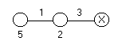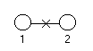this cannot be achieved at either leaf).

Fig. 1 A path on three vertices Fig. 2 A path on two vertices

As another example, if G were the graph consisting of the path on two vertices (Fig.2) and Player 1 and Player 2 have assigned labels to the vertices, then it is now not legal to assign a number to the edge since so doing would simultaneously result in two vertices having different weights (thus the magic constant cannot be set). Hence Player 2 would win.

Some Results:

The following lemma (from [1]) will be required for the special family of graphs in this report and hence is included for completeness.
We first show that if the game is in progress then, under suitable conditions, the second player to move can win.
If the magic constant, say k, has been set, and two labels, say x and y, add to k, then we say that x is the match for y.

Lemma A [1]. Let G be a graph in which every vertex is either a leaf or a stem. Furthermore, G has been partially labeled and satisfies the following conditions:
(i) the magic constant has been set.
(ii) the labels that have not been used yet can be partitioned into pairs, each of which
adds to the magic constant.
(iii) the total number of possible remaining moves in the core is even.
(iv) every stem has at least two one-arms that have no label assigned or else no labels can be assigned to any of its one-arms (these one-arms already have two labels or in the case a one-arm has just one label, then the match has already been used elsewhere).

Then the second player to move on the graph G can win.

Proof. Let G be a graph on which the game is being played and which satisfies the hypothesis of the lemma. Let k be the magic constant. Partition the labels that have not yet been used into pairs adding to k and call each of the labels in these pairs the match for the other.
The next player to play on the graph must make a move either on the core or on a one-arm. If they play on the core, the second player responds by playing on the core as well with the match. If they play on a one-arm and there are still two other one-arms in the same star that have no labels yet, the second player responds by playing the match on the same one-arm. If there is only one other one-arm in the same star without a label, the second player responds by assigning the match to the leaf of that one-arm. This strategy guarantees that if we have a graph G satisfying the hypothesis of the lemma that the remaining number of moves that can be made will consist of an even number of labels for the core and two labels for every one-arm of each star except for two one-arms of that star and each of these will be assigned one label. Thus the total number of moves remaining is even and the second player will win. ■

In [1], using Lemma A, the following two theorems were proved. In each situation, a winning strategy was described.

Theorem 1[1]. Let G be a graph in which every vertex is either a stem or a leaf where at least one stem has at least three leaves as neighbours and all other stems have at least two adjacent leaves. If G has an odd core, then Player 1 can win. Otherwise, Player 2 can win.

Theorem 2[1]. Let J be a graph where every vertex but one, say v, is either a leaf or a stem, where all stems have at least three adjacent leaves. Furthermore, let the total number of leaves be even. If J has an odd core, then Player 1 can win.

New Results:

We now consider a special family of graphs that were not handled in [1].
Consider the family of graphs, K, where for a graph K belonging to K every vertex is a leaf or a stem. Furthermore, exactly two adjacent stems, X and Y, have one leaf attached, a and b respectively, and are each incident with at least two edges in the core. All other stems have at least three adjacent leaves. We will show that if the core is odd and the total number of leaves is even, then there is a winning strategy for Player 1.

Theorem. Let K be a graph where every vertex in K is either a leaf or a stem, where exactly two adjacent stems, X and Y, have one leaf attached, a and b respectively, and are each incident with at least two edges in the core. Also, let all other stems have at least three adjacent leaves. Furthermore, let the total number of leaves be even. If K has an odd core, then Player 1 can win.

Proof. Let K be a graph satisfying the hypothesis of the theorem and let V and E be the sets of vertices and edges of K, respectively. Let m = V + E. Then the set of labels that are allowed is {1, 2,…,m}. Player 1 begins by labeling the edge XY with the label, m. Then the remaining labels can be divided into pairs (1, m-1), (2, m-2),…, ([m-1]/2, [m-1]/2 +1). Thus, every label has a match. Player 1 responds to any label that Player 2 chooses by selecting its match.

The following three cases must be considered to demonstrate the winning strategy for Player 1. Each case represents a possible setup of labeled and unlabeled edges in the core before the leaves are played on. Because of the odd core of the graph, Player 1 will never be the first player forced out on the leaves; therefore, each case begins at Player 2’s turn. Case 1 is the situation where X, Y and all of their incident edges in the core have been labeled. Case 2 is the situation where one of X or Y and all of its incident edges in the core are labeled. The other stem and its incident edges in the core may or may not be labeled, as long as they are not all labeled. Case 3 is the situation where there is at least one move available on X or its incident core edges and at least one move available on Y or its incident core edges.

Unless otherwise noted, Player 1 should adhere to the following strategy. The first time Player 2 labels X or Y or one of their incident edges in the core, Player 1 responds by playing on either the same stem, if it is unlabeled, or one of its unlabeled incident edges in the core. This ensures that the partial weight of each X and Y is greater than 2m. If Player 2 plays in the core, Player 1 also plays in the core but does not label the last of X or Y and their incident core edges. Moves such as this can occur at any point during play, but will not affect the strategies described. Player 1 must ensure that for all stems which are not X or Y, one incident edge not in the core remains unlabeled. This can be accomplished by Player 1 (once the magic constant is set) by labeling a leaf of a unlabeled one-arm when Player 2 labels a leaf or edge of another one-arm of the same star. This ensures that every stem and every core edge incident with the stems (other than possibly X or Y) can be labeled. It may occur that although play starts out in a Case 2 or Case 3 scenario, play may revert back to a previous case. For instance, this may occur if after play begins, Player 2 labels either X and all of its incident edges in the core or Y and all of its incident edges in the core, or both. All of the graphs considered here have an odd number of edges and vertices eligible for labeling. The magic constant can always be set to either m or greater than 2m and the strategies will ensure that an even number of vertices and edge are ineligible for labeling. Thus, Player 1 can always win.

Case 1: X, Y and all of their incident edges in the core have been labeled, and no one-arms have been labeled.

1.1: If Player 2 plays on a one-arm of a stem which is not X or Y, Player 1 immediately sets the constant k = m by playing the match on the same one-arm. Now, edges aX and bY are ineligible to be labeled. When, at some point in the game, Player 2 plays on either a or b, Player 1 responds by playing the match on the other unlabeled leaf (either a or b). Player 1 can win on the remaining unlabeled subgraph by Lemma A.

1.2: If instead, Player 2 plays on a or b, Player 1 plays on the edge bY or aX respectively, setting k > 2m. On the other hand if Player 2 plays on edge bY or aX, setting k > 2m, Player 1 plays on a or b respectively. Now either a and bY or b and aX are ineligible. There is now an even number of moves in the core and an even number of one-arms, each of which can only have one edge or vertex labeled, and therefore Player 1 can win.

Case 2: One of X or Y and all of its incident edges in the core are labeled. The other stem and its incident edges in the core may or may not be labeled, as long as they are not all labeled. Without loss of generality, let Y and all of its incident edges in the core be labeled. It may occur that X and all of its incident core edges become labeled during play, in which case a Case 1 situation may arise.

2.1: If Player 2 plays on a one-arm of a stem which is not X or Y, Player 1 immediately sets the constant k = m by playing the match on the same one-arm. Now the edge bY becomes ineligible to be labeled. Player 2 can now either play on vertex a or b, or edge aX.

2.1.1: If Player 2 plays on either vertex a or b, then Player 1 responds by playing the match on the other, b or a respectively. This means aX is ineligible for play, and Player 1 can win by Lemma A.

2.1.2: If instead Player 2 plays on edge aX, then Player 1 responds on a. When, at some point in the game, Player 2 plays on either the core or b, Player 1 responds by playing the match on the other (either the core or b). Now a core edge incident with X or X itself is ineligible to be labeled. Player 1 can win on the remaining unlabeled subgraph by Lemma A.

2.2: If instead Player 2 plays on either bY or a, then Player 1 responds on the other, a or bY respectively. This sets k > 2m. Both aX and b can no longer be labeled and since there is now an even number of moves in the core and an even number of one-arms, each of which can only have one edge or vertex labeled, Player 1 can win.

2.3: If instead Player 2 plays on aX, then Player 1 responds by playing the match on a. This sets k = m. The edge bY and a core edge incident with X or X itself become ineligible to be labeled. When, at some point in the game, Player 2 plays on either the core or b, Player 1 responds by playing the match on the other (either the core or b). Player 1 can win on the remaining unlabeled subgraph by Lemma A.

2.4: If instead Player 2 plays on b, then Player 1 responds on a part of the core other than X or its incident core edges unless those are the only core moves available. Note that there is an even number of moves available in the core, and thus there will be at least one of X and its incident edges remaining unlabeled after Player 1’s turn. Now the edge bY is ineligible for play and Player 2 has three options. Player 2 can either play on the last unlabeled core edge incident with X or X itself, on the one-arm of X, or on a one-arm of a stem which is not X or Y.

2.4.1: If Player 2 plays on the last unlabeled core edge incident with X or X itself, then Player 1 plays on aX, setting k > 2m. Now a can no longer be played on. There remains an even number of moves in the core and an even number of one-arms, each of which can only have one edge or vertex labeled. Therefore Player 1 can win.

2.4.2: If instead Player 2 plays on the one-arm of X, then Player 1 plays the match on the same one-arm setting k = m. A core edge incident with X or X itself becomes ineligible for play. This leaves an even number of moves in the core and Player 1 can now win by Lemma A.

2.4.3: If instead Player 2 plays on a one-arm of a stem which is not X or Y, then Player 1 plays the match on the same one-arm setting k = m. Player 2 now has two options. Player 2 can play on X’s one-arm or in the core.

2.4.3.1: If Player 2 plays on X’s one-arm, then Player 1 plays on the same one-arm. Now a core edge incident with X or X itself becomes ineligible to be labeled and Player 1 can win by Lemma A.

2.4.3.2: If instead Player 2 plays on the core, then Player 1 plays on a. The edge aX can no longer be labeled. Player 1 can now win by Lemma A.

Case 3: There is at least one move available on X or its incident core edges and at least one move available on Y or its incident core edges. It may occur that X and all of its incident core edges or Y and all of its incident core edges become labeled during play, in which case a Case 2 situation may arise.

3.1: If Player 2 plays on a one-arm of a stem which is not X or Y, then Player 1 plays the match on the same one-arm setting k = m. Player 2 now has two options. Player 2 can either play on a or b, or one of the edges aX or bY.

3.1.1: If Player 2 plays on a or b, then Player 1 plays on the other, b or a respectively. Now edges aX and bY are ineligible for play. Player 1 can now win by Lemma A.

3.1.2: If instead Player 2 plays on one of the edges aX or bY, then Player 1 plays on the other, bY or aX respectively. Now vertices a and b are ineligible for play as well as X or one of its core incident edges and Y or one of its core incident edges. Thus the number of unlabeled vertices and edges in the core remains even. Player 1 can now win by Lemma A.

3.2: If instead Player 2 plays on a one-arm of X or Y (without loss of generality let Player 2 play on the one-arm attached to Y ) then Player 1 plays the match on the same one-arm setting k = m. One of the core edges incident with Y or Y itself becomes ineligible to be labeled. Player 2 now has three options. Player 2 can either play on a one-arm of a stem which is not X or Y, on the unlabeled one-arm of X, or on the core.

3.2.1: If Player 2 plays on a one-arm of a stem which is not X or Y, then Player 1 plays on the unlabeled edge aX. Now a and the other part of the one-arm previously labeled by Player 2 cannot be labeled. Also, a core edge incident with X becomes ineligible to be labeled, and hence there is an even number of eligible edges and vertices in the core. Now Player 1 can win by Lemma A.

3.2.2: If instead Player 2 plays on the unlabeled one-arm of X, then Player 1 plays on the same one-arm. Now X or one of its core incident edges becomes ineligible to be labeled. Therefore there is an even number of eligible edges and vertices in the core and Player 1 can win by Lemma A.

3.2.3: If instead Player 2 plays on the core. Player 1 responds on a. The edge aX becomes ineligible to be labeled. Now Player 1 can win by Lemma A.

This completes the proof of Case 3, and thus the proof of the theorem. ■

Acknowledgment: This work is based on an NSERC supported summer research project at Saint Mary’s University. The support of NSERC is gratefully acknowledged.

References

[1] E. Boudreau, B. Hartnell, K. Schmeisser and J. Whiteley, “A Game based on Vertex-Magic Total Labelings”, submitted.

[2] J. Gallian, “A dynamic survey of graph labeling”, Elect. J. Combin. Dynamic Survey DS6 (2001).

[3] J. Macdougall, M. Miller, Slamin and W. D. Wallis, “Vertex-magic total labeling", Utilitas Math. (to appear).

[4] W. D. Wallis, “Magic Graphs”, Birkhauser Boston (2001).

Case 1 – Both X and Y are saturated in the core

* Two # of the same colour (except for black) indicates that the sum of the two labels is equal to MAX. Thus, whenever the magic constant k = MAX, it follows that the two # of the same colour are matches. An “X” indicates that the edge or vertex cannot be labeled.

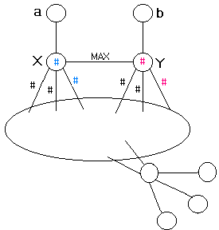
1.1
1.2

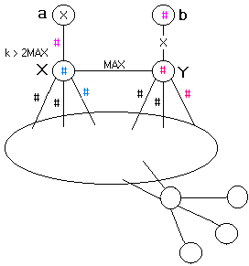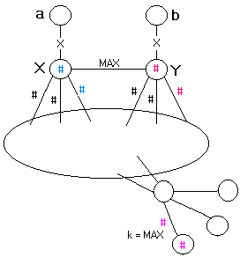

Case 2 – One of X and Y is saturated in the core but the other is not

* Two # of the same colour (except for black) indicates that the sum of the two labels is equal to MAX. Thus, whenever the magic constant k = MAX, it follows that the two # of the same colour are matches. An “X” indicates that the edge or vertex cannot be labeled.
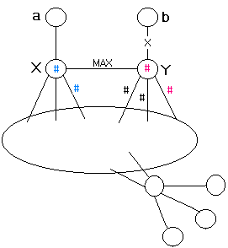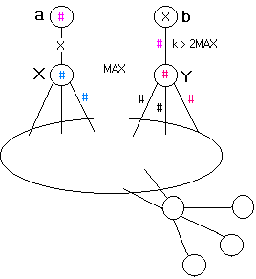
2.3
2.2

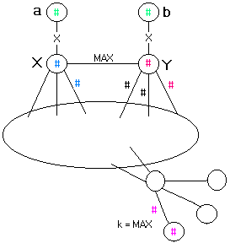
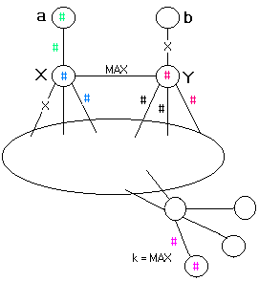
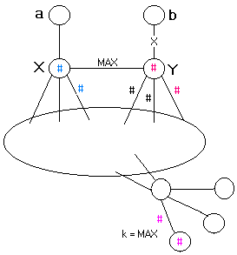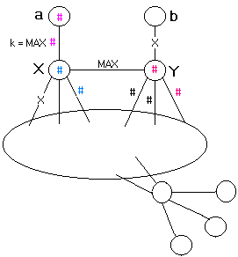
2.1
2.1.1
2.1.2

Case 2 Continued
2.4
2.4.1
2.4.3
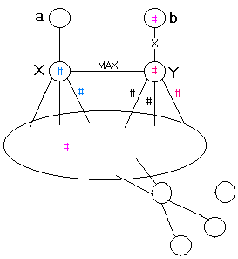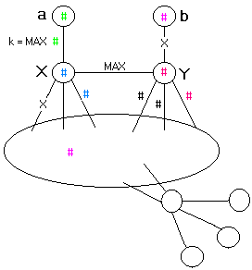
2.4.2
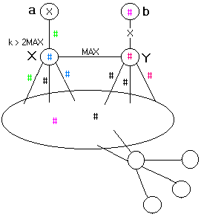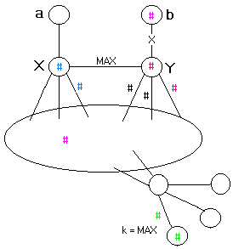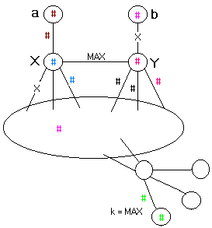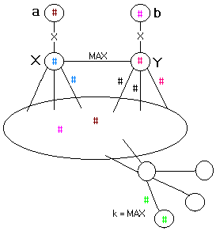
2.4.3.1
2.4.3.2

Case 3 – Neither X nor Y is completely saturated in the core

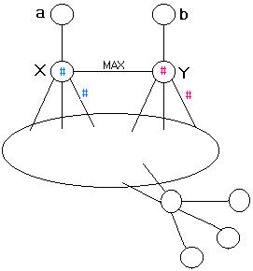
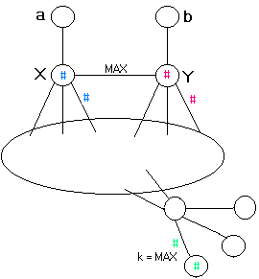
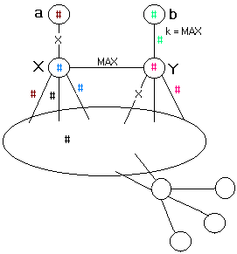
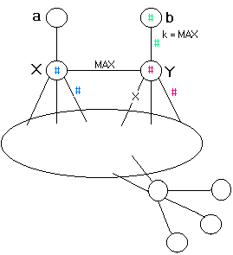
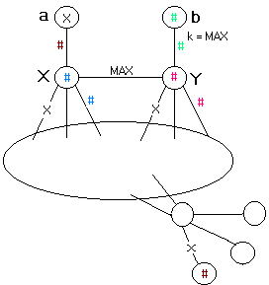
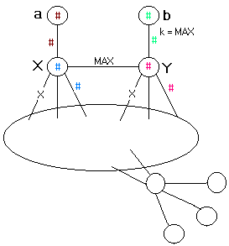
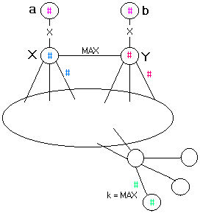
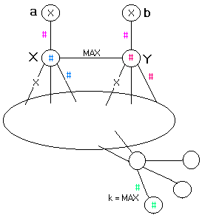
* Two # of the same colour (except for black) indicates that the sum of the two labels is equal to MAX. Thus, whenever the magic constant k = MAX, it follows that the two # of the same colour are matches. An “X” indicates that the edge or vertex cannot be labeled.
3.1
3.2
3.2.1
3.2.2
3.2.3
3.1.2
3.1.1

