Searches

- Linear search

for( int i = 0; i<n; i++ )
if( a[i] == target ) return found;
return false;
O(n)

- Can't do better than that
- If "a" is sorted we can do better

for( int i=0; i<n && target > a[i]; i++);
if( i<n && a[i] == target ) return true;
return false;
- O(n) in worse case.

Binary search can do a lot better
left = 0;
right = n-1;
while( left <= right )
{
middle = ( left + right ) / 2;
if( a[middle]==target) return true;
else if( a[middle] > target ) right = middle - 1;
else left = middle + 1;
}
return false;

O(n)
O(log n)

7 items

Search tree
- node where comparison is made

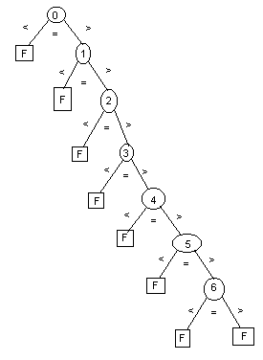
three branches < = >
|
will not expand

- Search tree for Linear search

- Empty tree has height of -1
- Other wise, height = max( height of left subtree, height of right subtree ) + 1
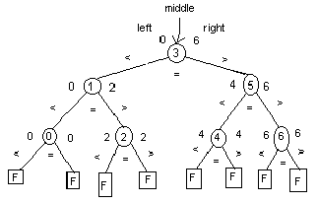
- Height of the search tree = worse case comparisons
- We will get perfectly balanced search trees for binary search
if n = 1, 3, 7, 15, 31, 63, 127, 255, i.e. n = 2^{h} - 1

- For n = 7, height = 3

- We need height as function of n

level 0 = 1 node
level 1 = 2 node
level 2 = 4 node
level 3 = 8 node
.
.
.
level i = 2^{i} nodes

level height = 2^{height} nodes

- All the leaf nodes are F

- if n=2^{h} - 1, all the leaf nodes are at level height

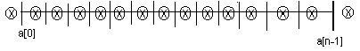
possible
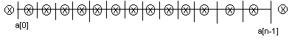

- Total possible failures = n - 1 + 2 = n + 1

n+1 = 2^{height}

height = log₂(n+1)

c=a^{b}
log_{a}c = b

height = O(log(n))

