Saint Mary’s University
Department of Mathematics and Computing Science

Intelligent Data Mining CS677

Assignment 2. Neural Prediction of Daily Consumption of One Product

Presented by Ming Zhong Date: July 9th , 2002
------------------------------------------------------------------------------------------------------------------

1. Login to DB2, connect to the CS677 database and select data we need:

create view nm_qty(TRNDATE, QTY) as select TRNDATE, SUM(QTY)
from administrator.nm_item where int(cat)=603 and subc=1
group by trndate;

select * from nm_qty

2. Clean the data by excluding Sunday’s observations (usually the quantity of this observations are less than 100). Export data to Excel for convert CSV file to plain text file and draw the time series.

create view nm_qty_cleaned(trndate, qty) as select trndate, qty from nm_qty
where qty > 100

select * from nm_qty_cleaned

3. Using program to prepare input patterns for ANN

01/11/2000 | 403 | 310 | 410 | 465 | 910 | 743 | 399 | 211 | 372
02/11/2000 | 310 | 410 | 465 | 910 | 743 | 399 | 211 | 372 | 532
03/11/2000 | 410 | 465 | 910 | 743 | 399 | 211 | 372 | 532 | 727
04/11/2000 | 465 | 910 | 743 | 399 | 211 | 372 | 532 | 727 | 608
06/11/2000 | 910 | 743 | 399 | 211 | 372 | 532 | 727 | 608 | 358
07/11/2000 | 743 | 399 | 211 | 372 | 532 | 727 | 608 | 358 | 335
08/11/2000 | 399 | 211 | 372 | 532 | 727 | 608 | 358 | 335 | 298
09/11/2000 | 211 | 372 | 532 | 727 | 608 | 358 | 335 | 298 | 537
10/11/2000 | 372 | 532 | 727 | 608 | 358 | 335 | 298 | 537 | 1161
13/11/2000 | 532 | 727 | 608 | 358 | 335 | 298 | 537 | 1161 | 679
14/11/2000 | 727 | 608 | 358 | 335 | 298 | 537 | 1161 | 679 | 524
15/11/2000 | 608 | 358 | 335 | 298 | 537 | 1161 | 679 | 524 | 552

4. Convert this text file into CSV file using Excel

5. Create a table for loading the input patterns from CSV file
create table inputforANN(trndate date, qty1 int, qty2 int,
qty3 int, qty4 int, qty5 int, qty6 int, qty7 int, qty8 int, qty9 int) in csc67719

6. Importing the data into the table you created
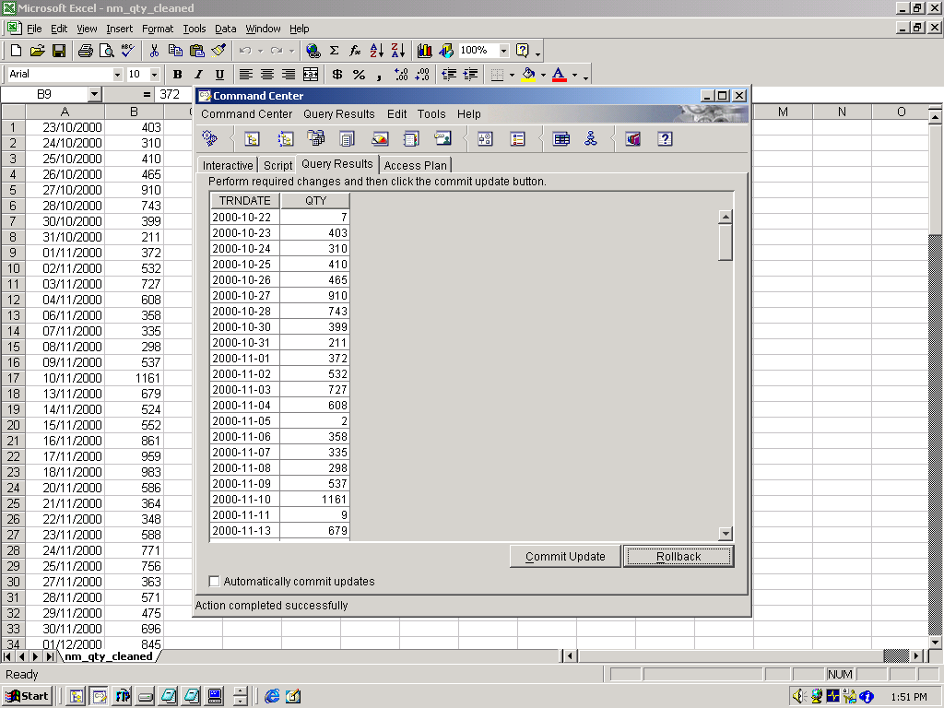

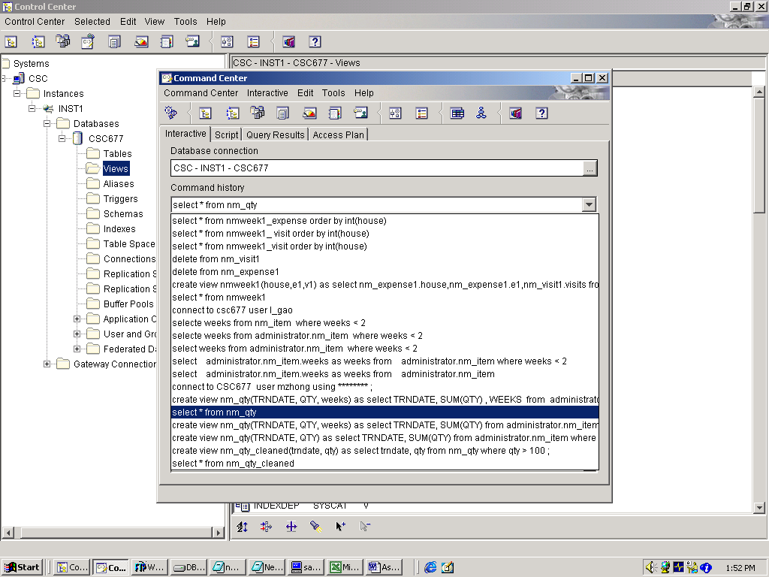

- The time series of daily consumption of one product in NewMinus

7. Using IBM Intelligent Miner Neural Network for Prediction

- Connect to Intelligent Miner Server
- Start->Programs->DB2 Intelligent Miner ->Intelligent Miner
- Log on the server : Server Name :csc.stmarys.ca

User ID: UserName and Password

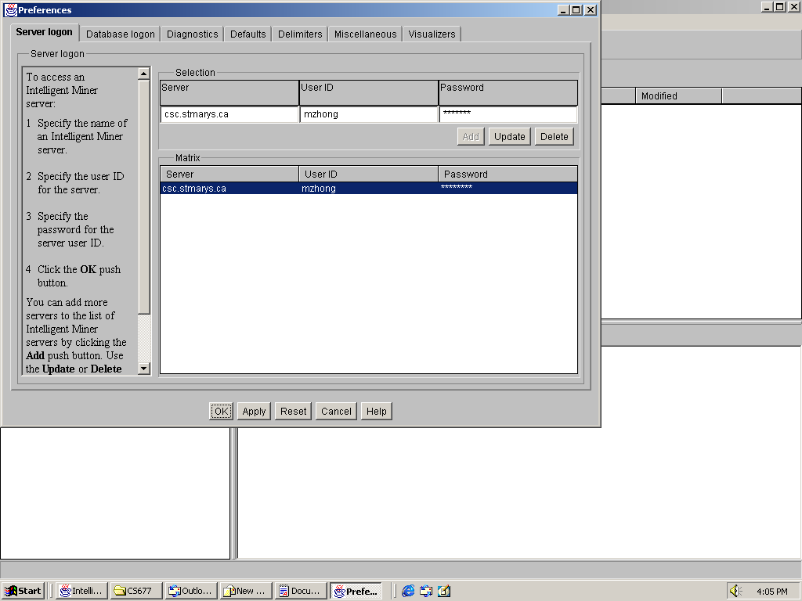
- Log on the Database: Database : csc677, User ID, Password

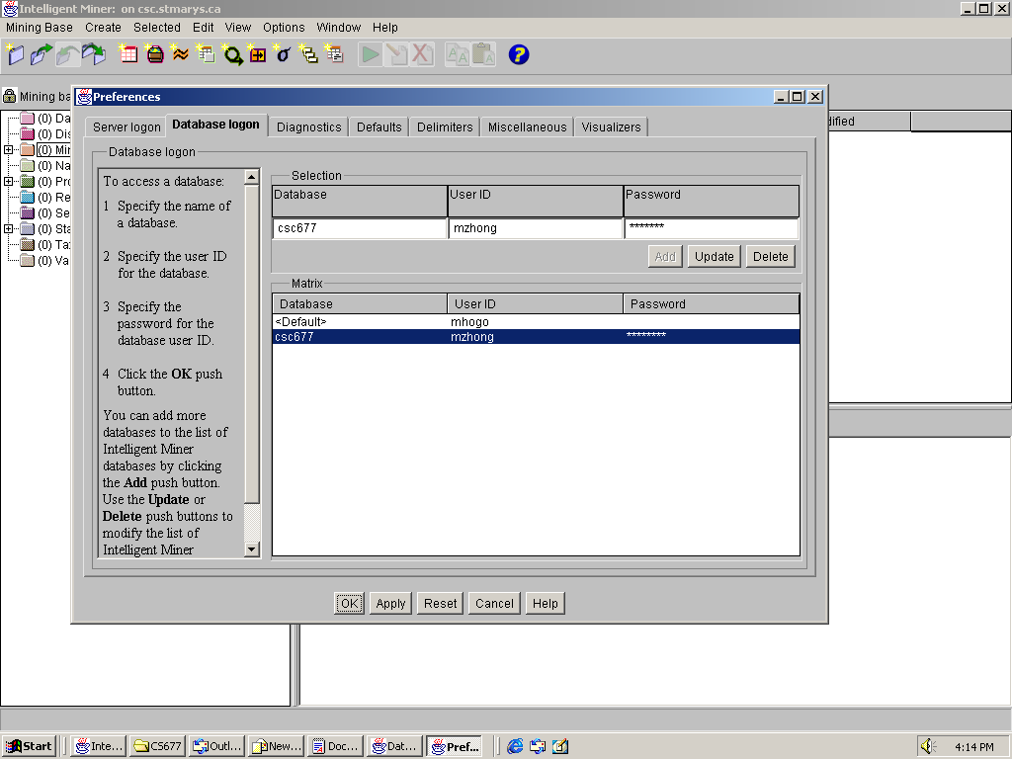
- Open a new Mining Base and Save it
- In Mining Base menu, choose New Mining Base;
- Then choose Save Mining Base As… in Mining Base menu to save it,
- Give a name to your mining base you just created and save it.

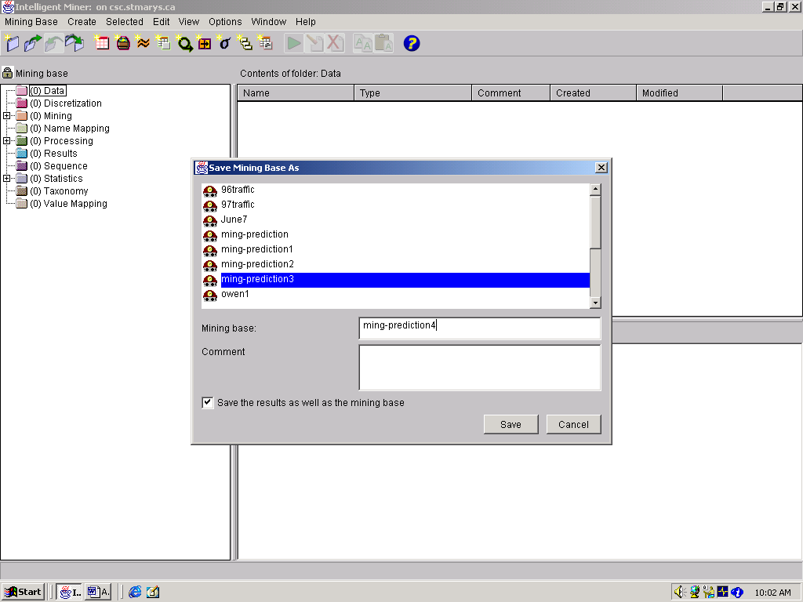
- Create Data Object (Choose Data function in Create menu)

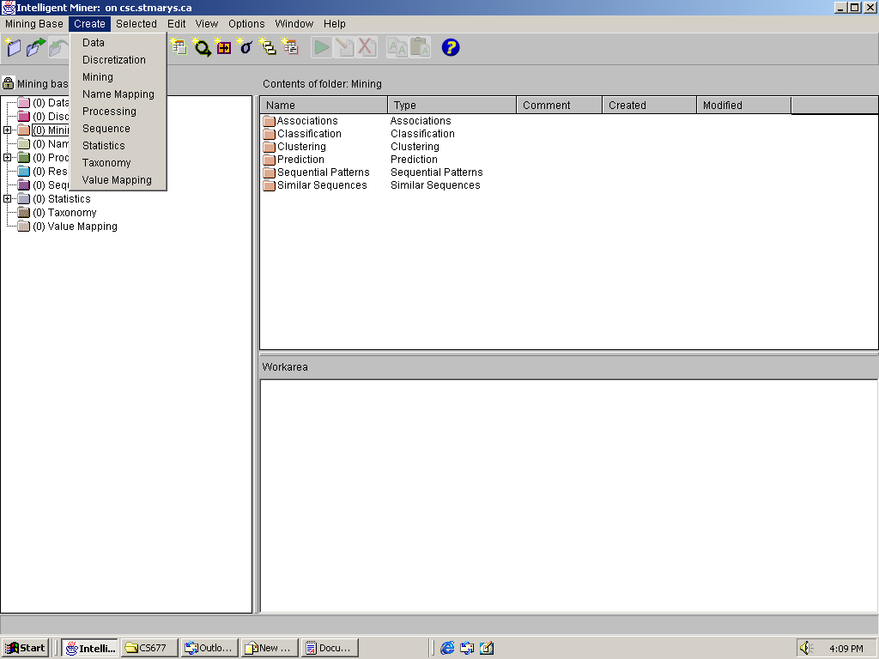

  - Choose database Table/view
  - Give a name to your data object in Setting Name box, Then press Next,

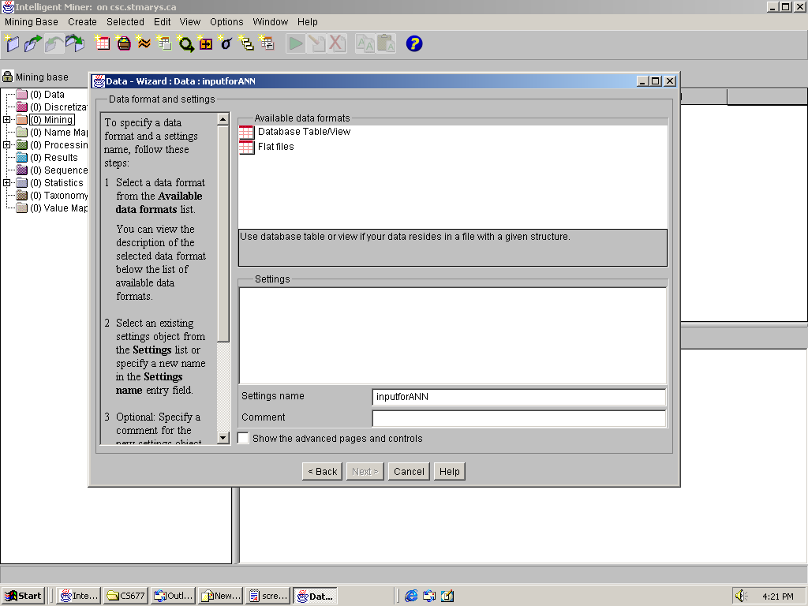
- Select database server to be CSC677, and choose your schema – your USERNAME, and then choose your input table in DB2, which has the input patterns for ANN.

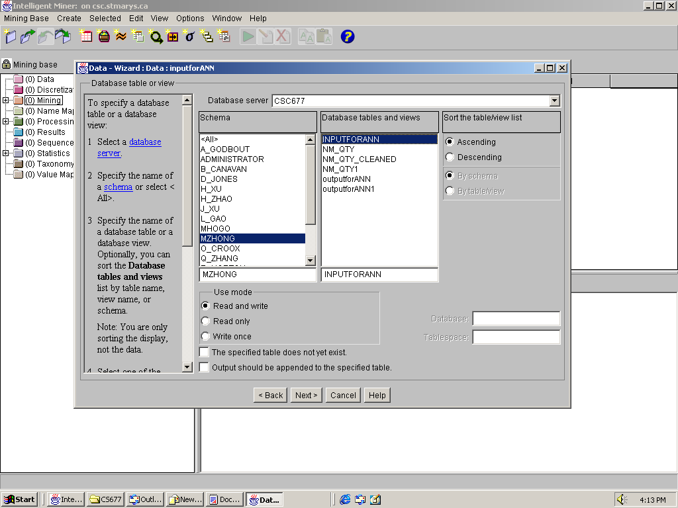
- This page shows the attributes of your input table, just press Next button.

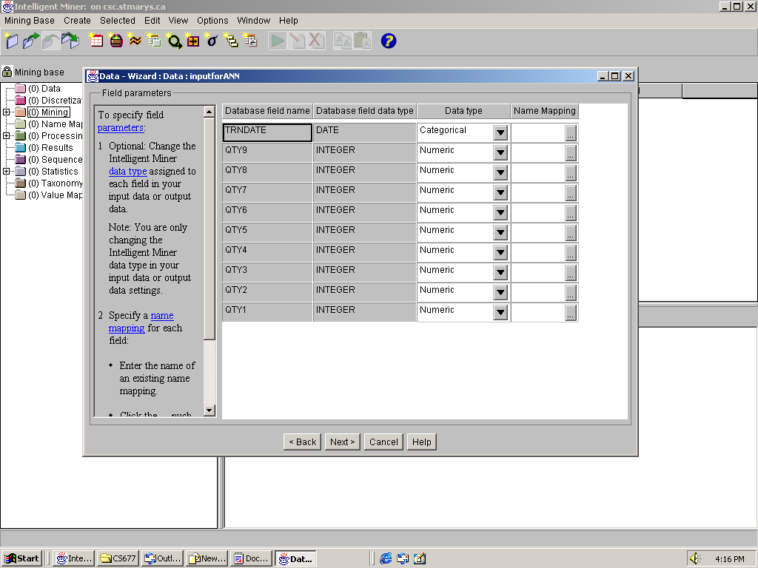
- Press Next button for this page

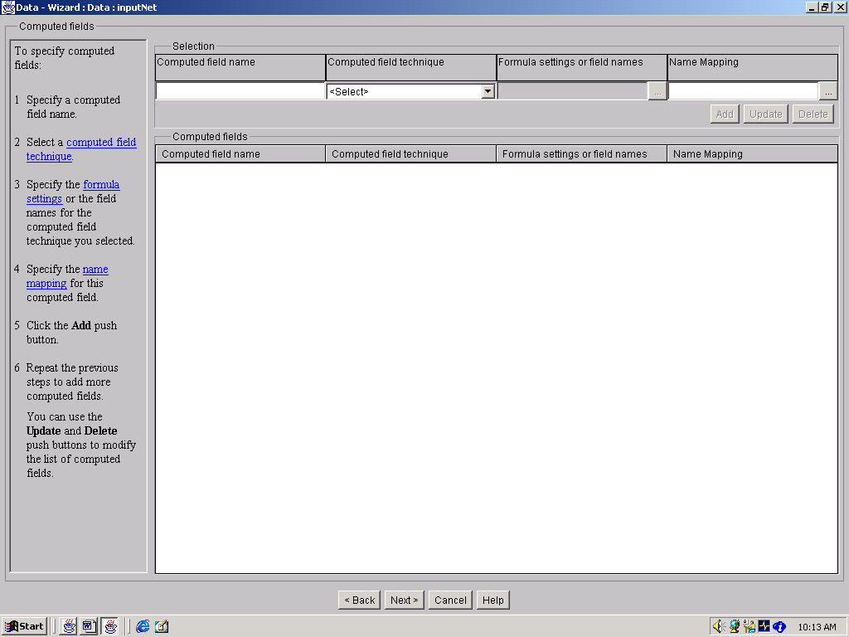
- Right now press Finish button to end the process for Create Data Object.

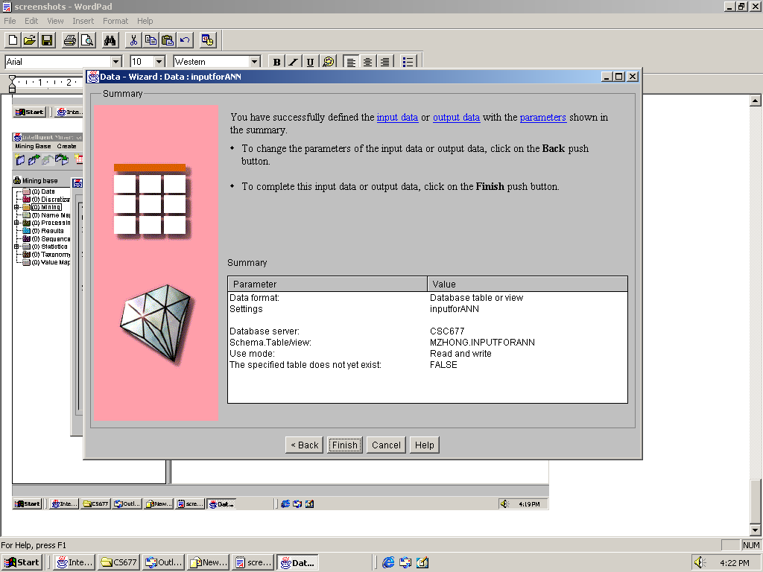

(you will find “1” (instead of “0”) occurred besides Data object in the main Window)

- Create Prediction Mining function. In the main Window, Right Click Prediction Button

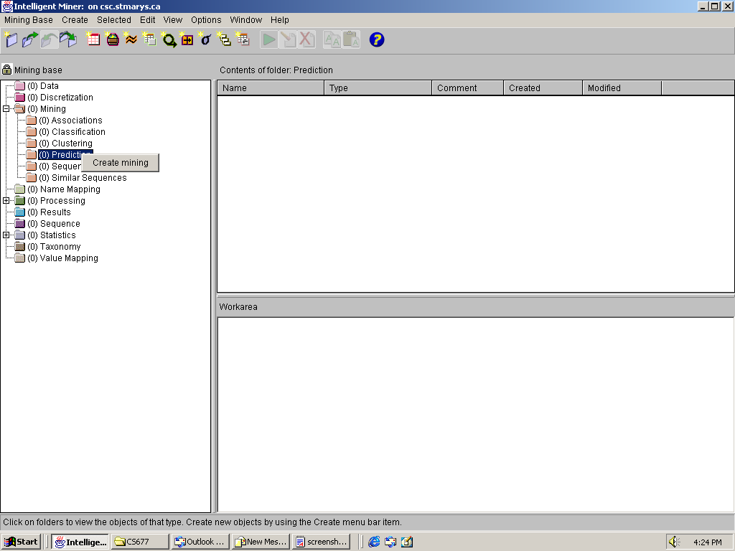
- Select Prediction-Neural in Available Mining Functions
- Give a name to your Mining Object in Settings Name box, check the Show The Advanced Pages and Controls then press Next button
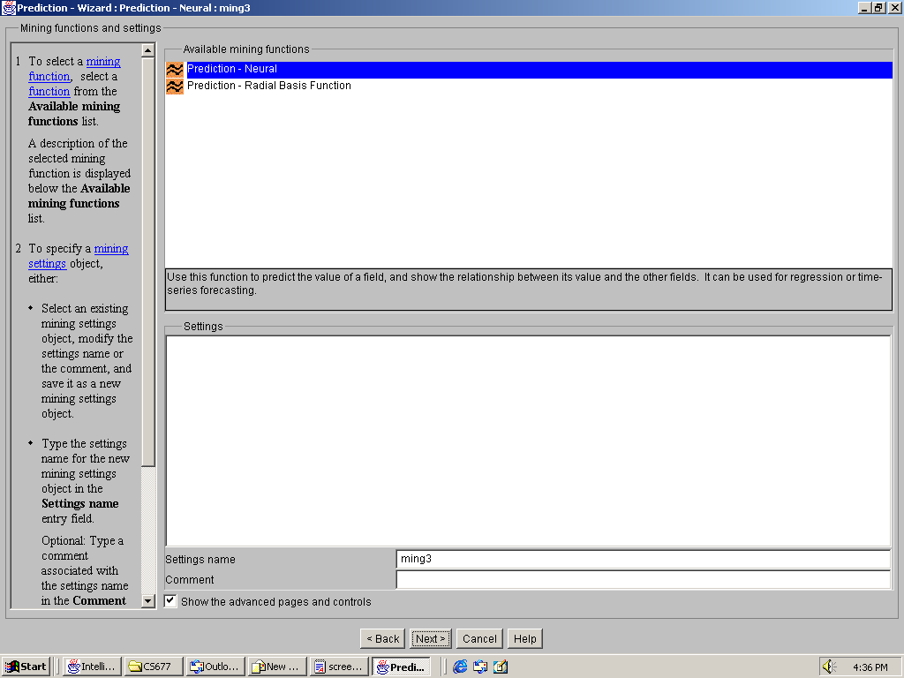
- Click the object in Available input data to define the input Table and Check Time as Optimize Mining Run for, then press Next.

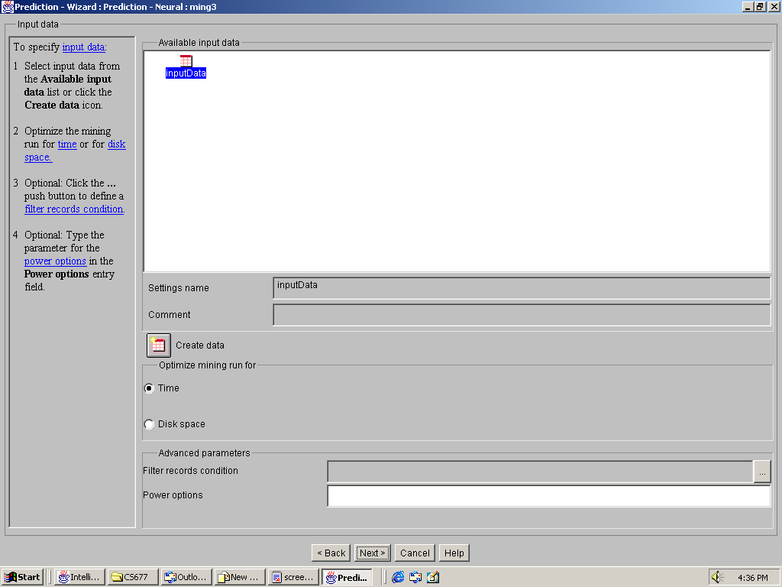
- In the Training Mode, Choose “1” for In-sample size and “0” for Out-sample size. Choose Use Default for other settings. Also Check Regardless of the mode, normalize the input data box. Then press Next button.
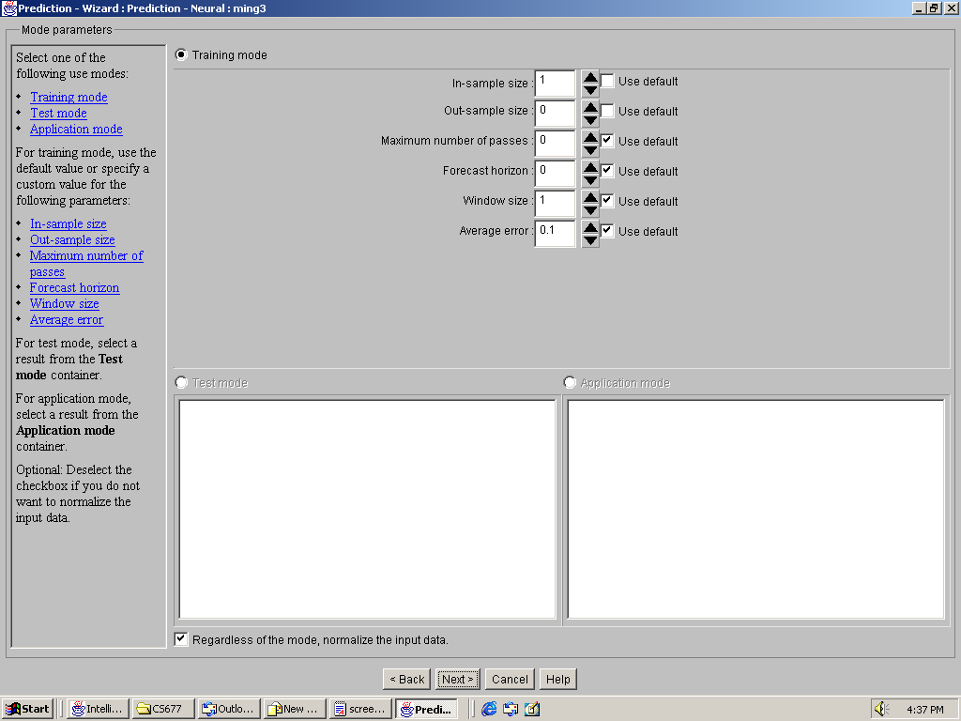
- Select qty1 to qty8 as Active fields, TRNDATE as Supplementary fields, and qty9 as Prediction fields, and then press Next button.
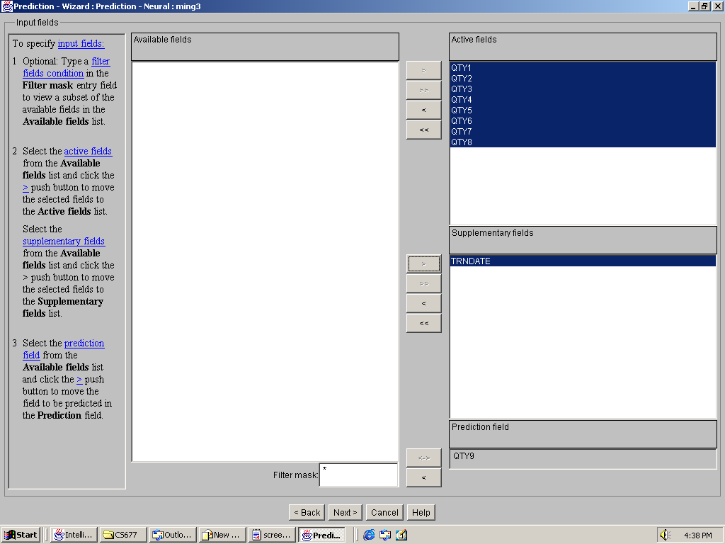
- Check Automatic architecture determination of neural network, then press Next.
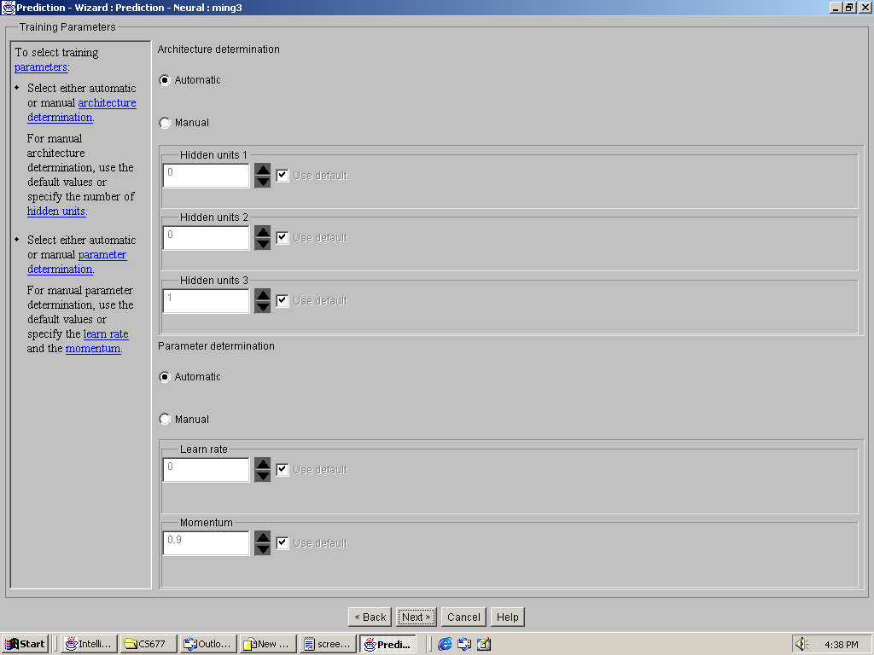

- Check Generate quantiles and press Next button.
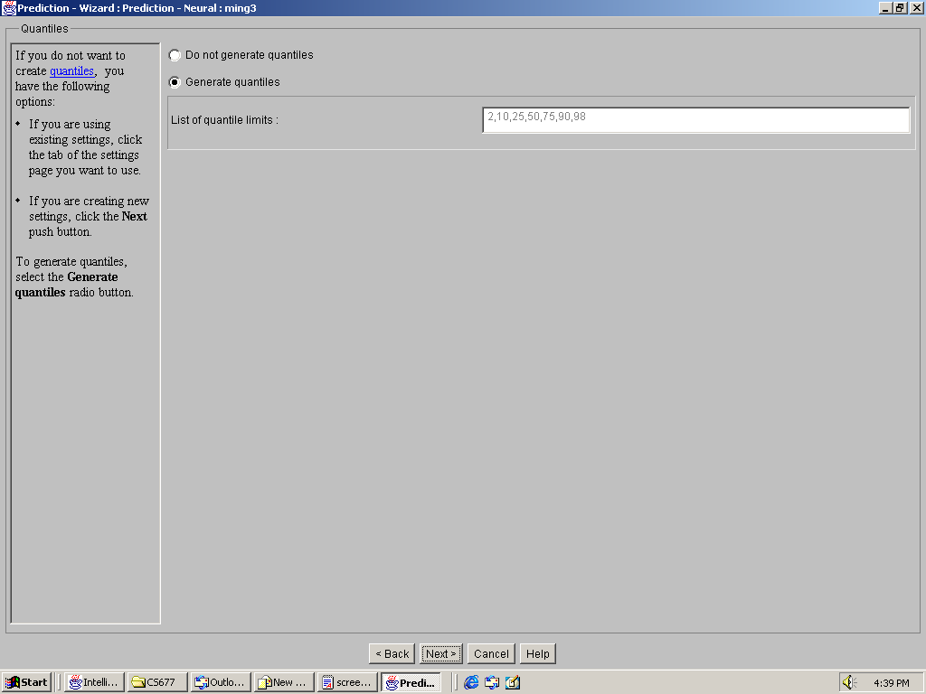

- Check the Create output data, then specify qty9 as Output fields. And give a name to Predicted value field name and then press Next.
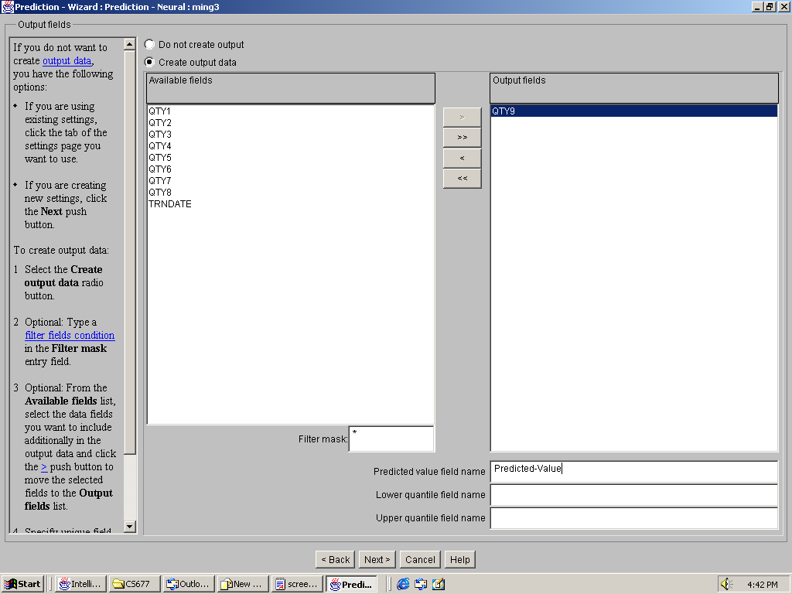
- Press Create Data button for defining output data object.
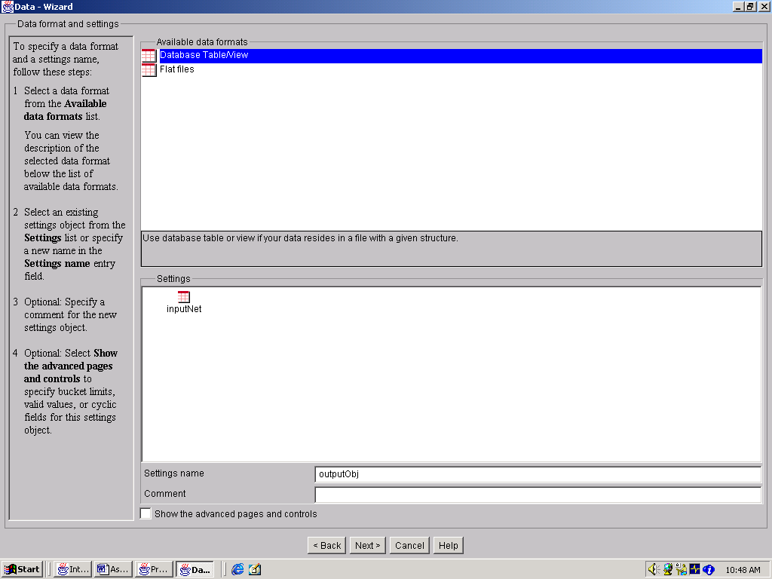

- Choose Database Table/view and give a name to your output data object in Settings name box
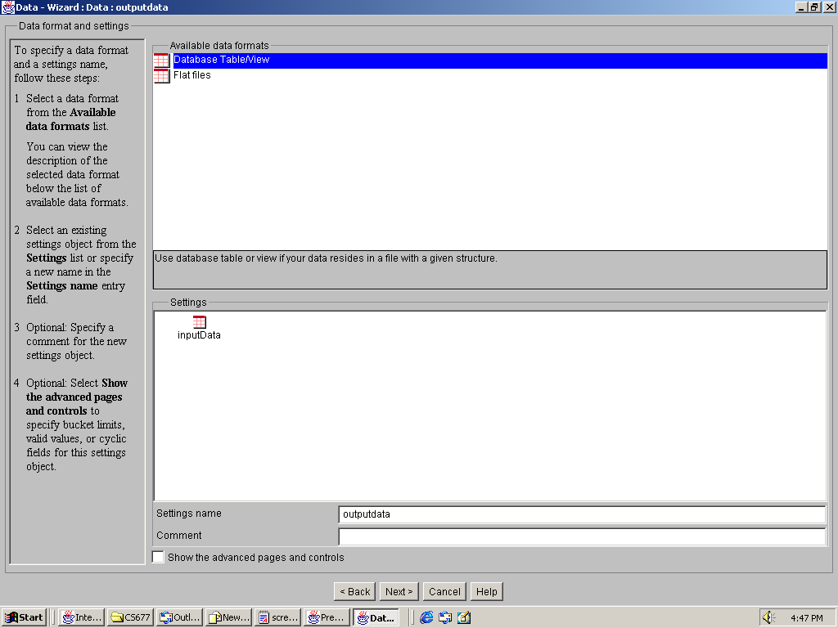

- Choose CSC677 database, your schema(your username) and give a name to the output table in the bottom of Database tables and views box. Please also check The specified table does not exist. The press Next button.

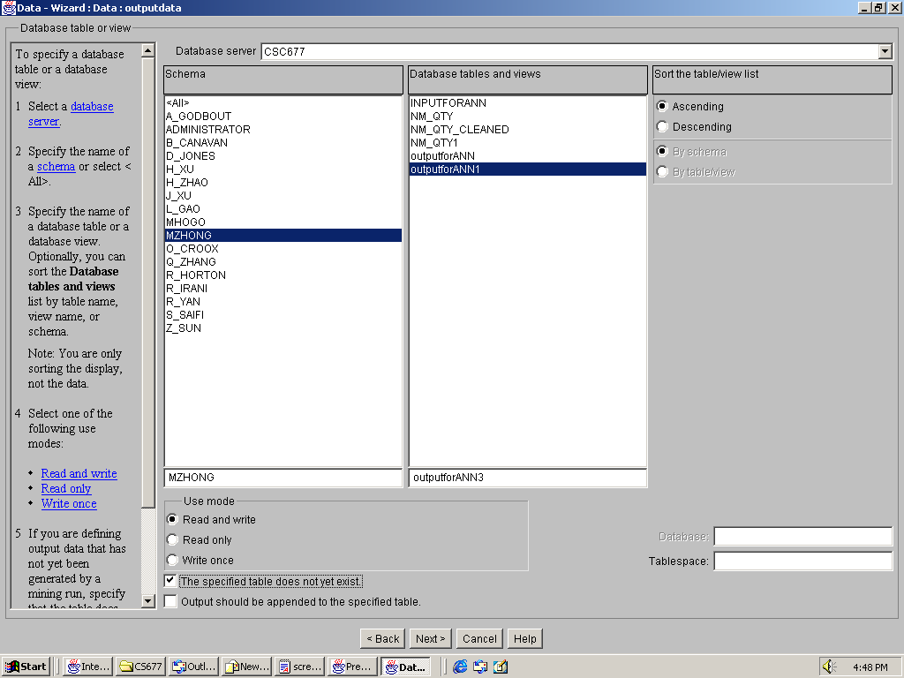
- Press Finish to end the process for defining output object.
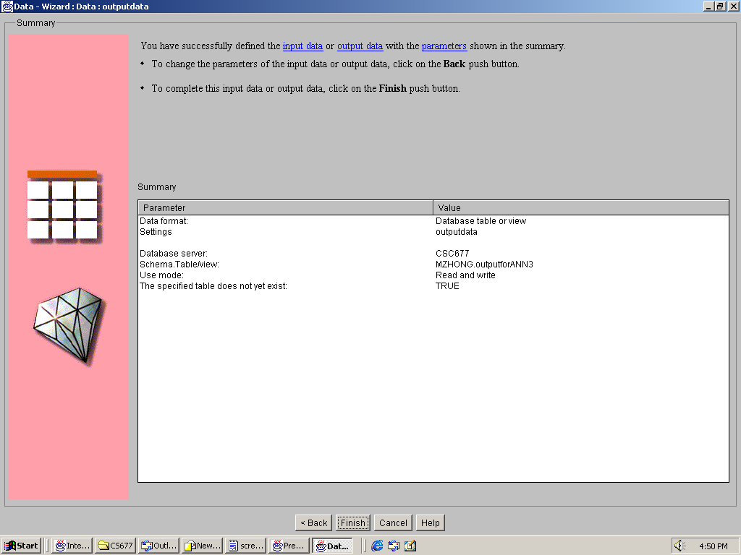

- Then you will return to Prediction Wizard. Click Output data object name in Available output data and then press Next button.
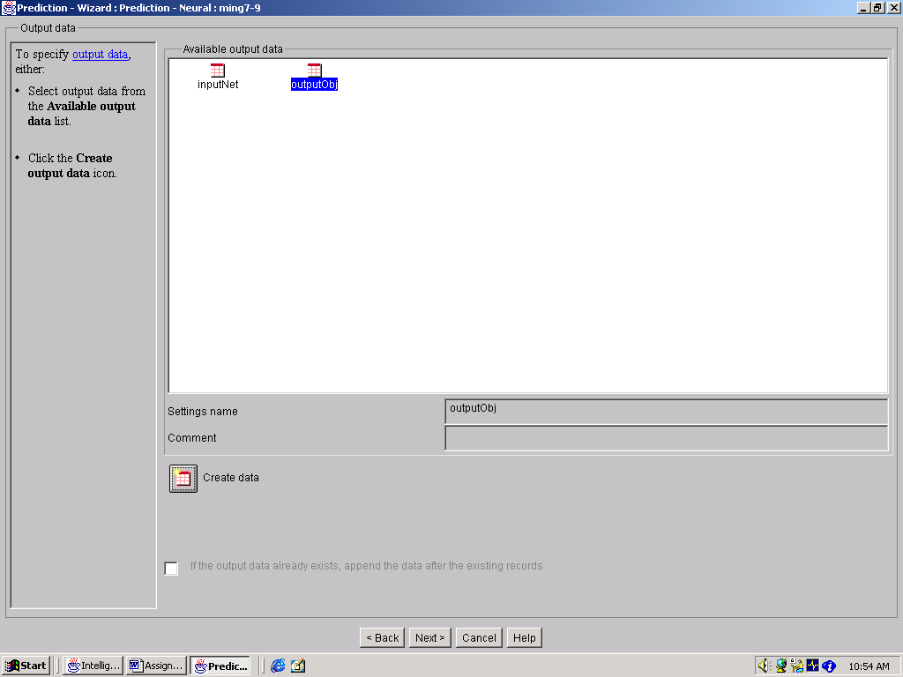
- Give a name to results in Results name box. You may also want to check “if a result with this name exist, overwrite it” box. Then press Next button.
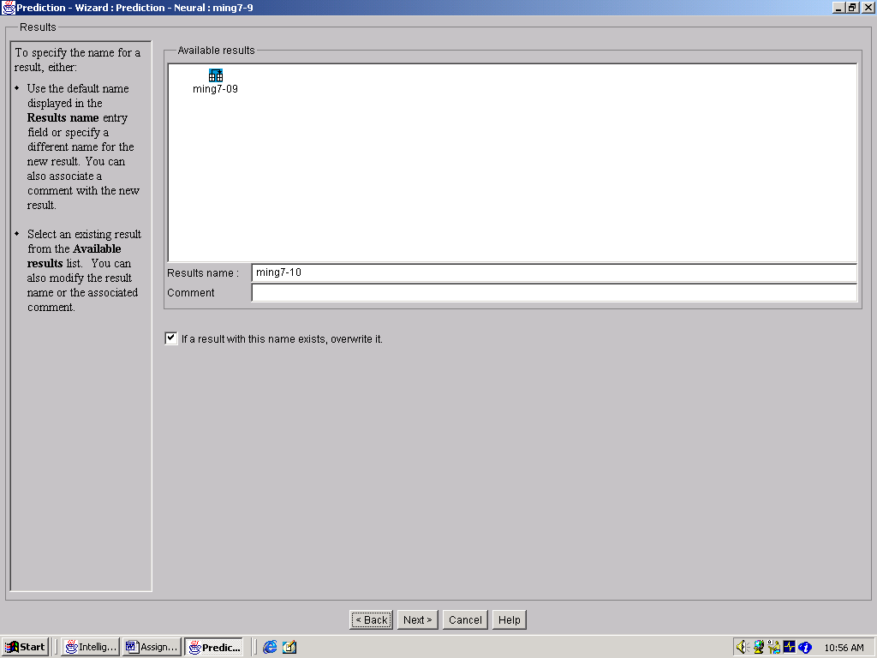
- This page shows the parameters you specified for neural prediction. Check “Run this settings immediately” box. And then press Finish button.
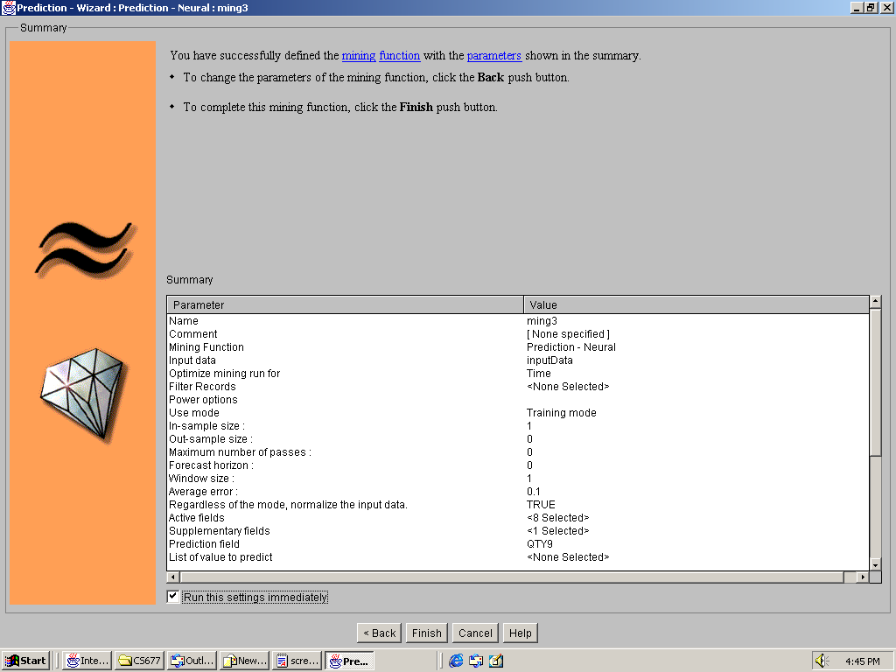
- A dialogue box will show the prediction is in the process.
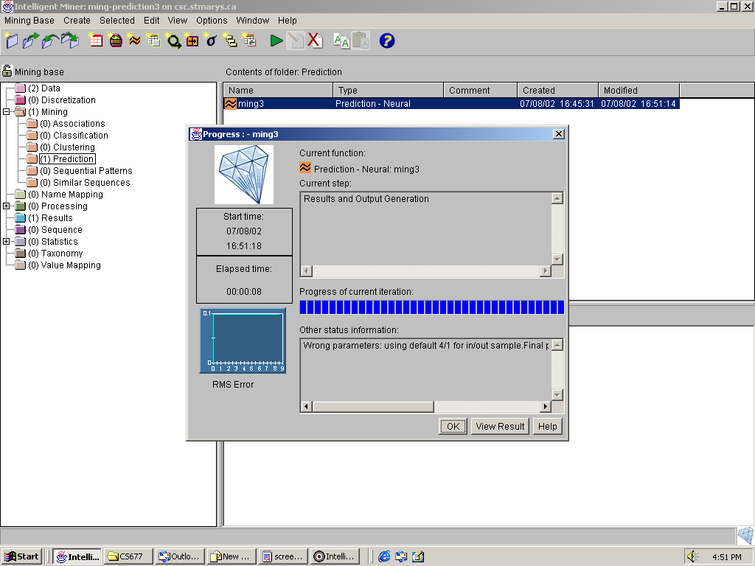

- The statistical analysis results from DB Miner.
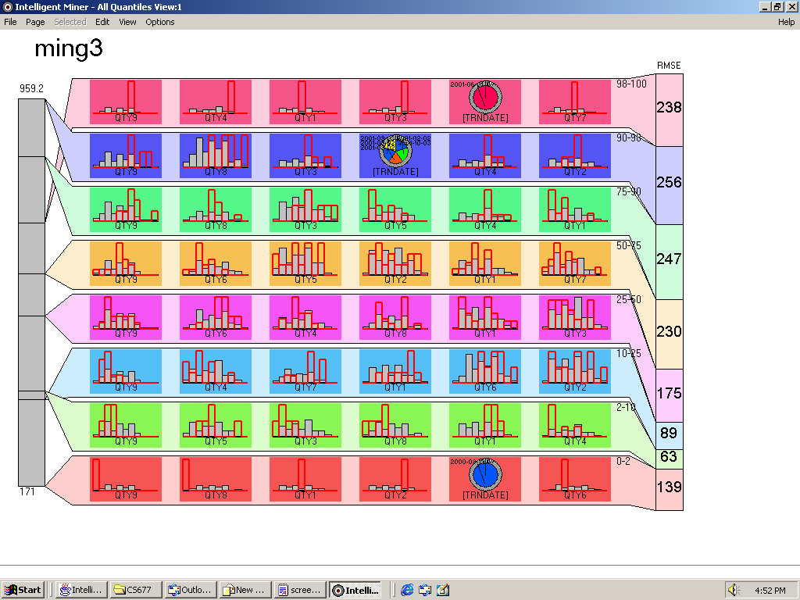

8. Export your results to Excel for statistical analysis.

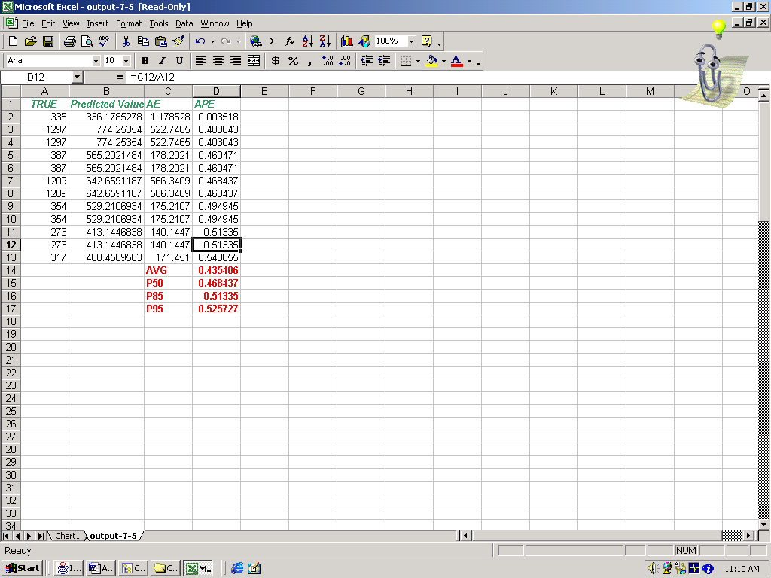
The 50th percentile error = 19.42%
The average error = 21.09%
The 85th percentile error = 37.60%
The 95th percentile error = 46.84%

