Saint Mary’s University
Department of Mathematics and Computing Science

Intelligent Data Mining

Cluster web data using Intelligent Miner

Created by Rui Yan Date: July,18th ,2002
---------------------------------------------------------------------------------------------------
1) Log on the DB2 and Miner Server
- Log on the Intelligent Miner server (include log on the database):
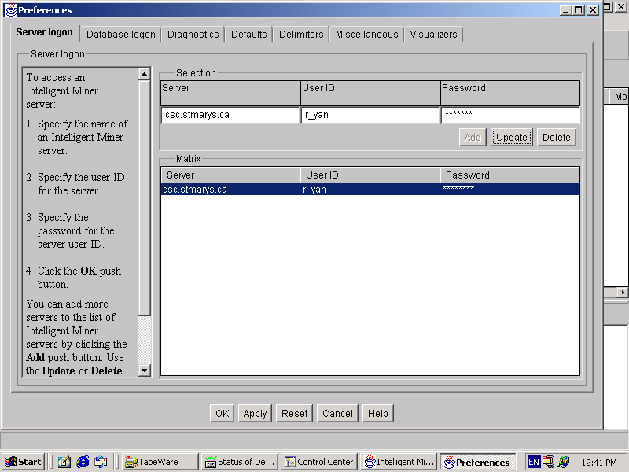

- Log on the database server
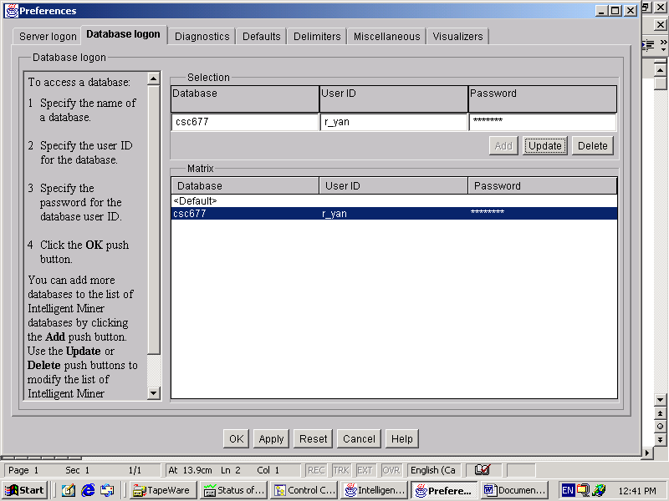

- Open your mining base (You can use the one you created for the prediction)
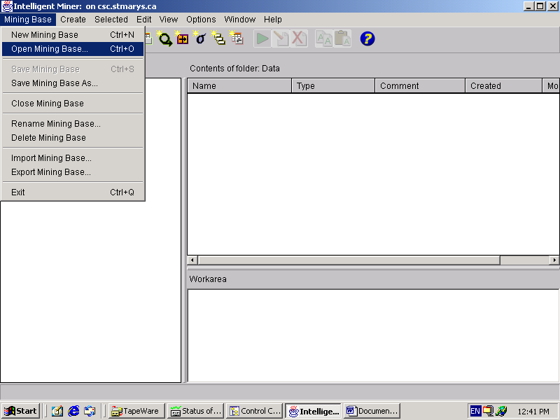

2) Create Data Object
- click the icon to create the data object:

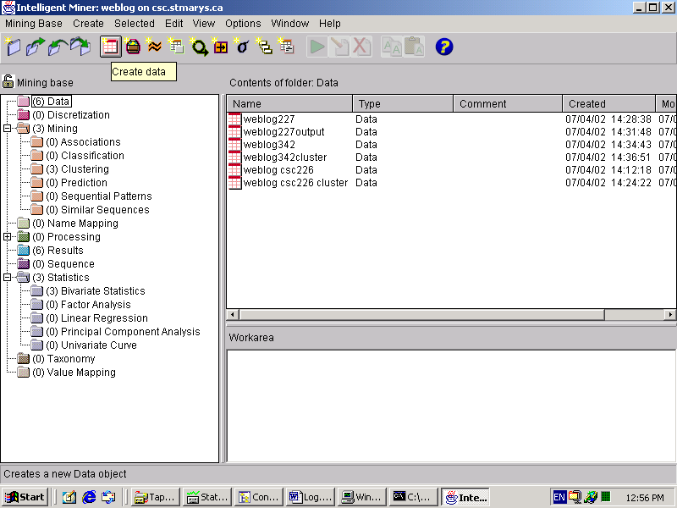

- Welcome page for the creating data object wizard
Click Next

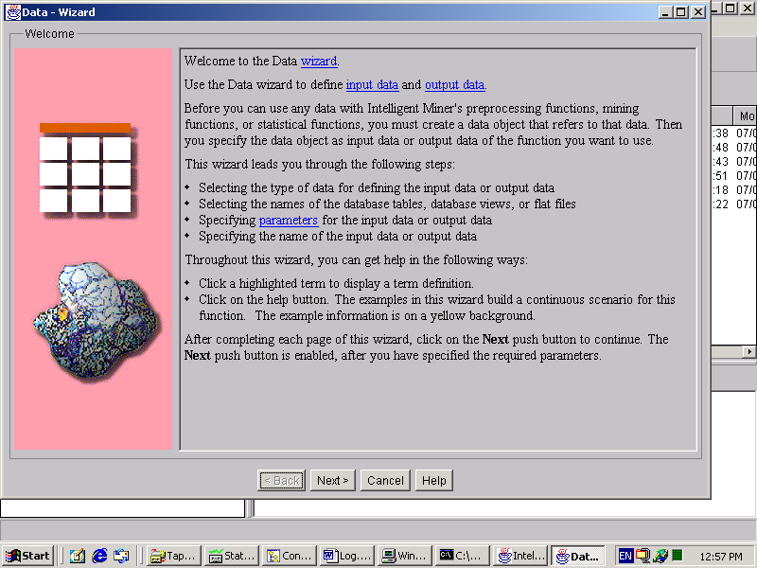

- Select ‘Database Table/View’ from ‘Available data formats’
Write the data object name. In this case, the data object is the input object for cluster function.
So, the settings name is ‘226 input’ (you can choose any name you want)
Click next

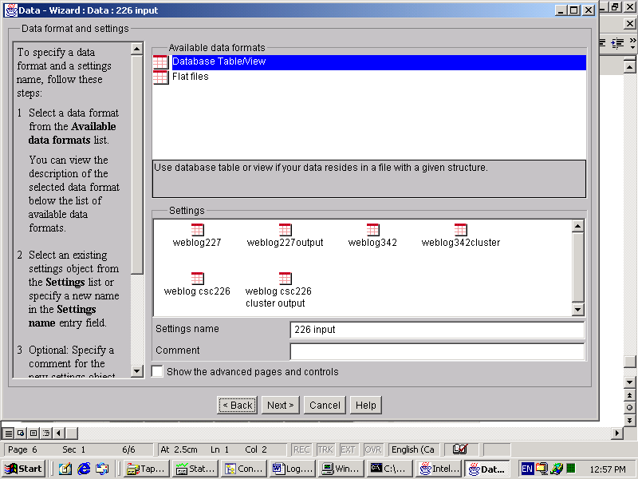

- Select ‘csc677’ as your database server
In the ‘Schema’, choose ‘Administrator’
In the ‘Database tables and views’ ,select CSC226 ( this is table located the actual input data )
Click Next
Do not need to make any change in the next two pages, just click next
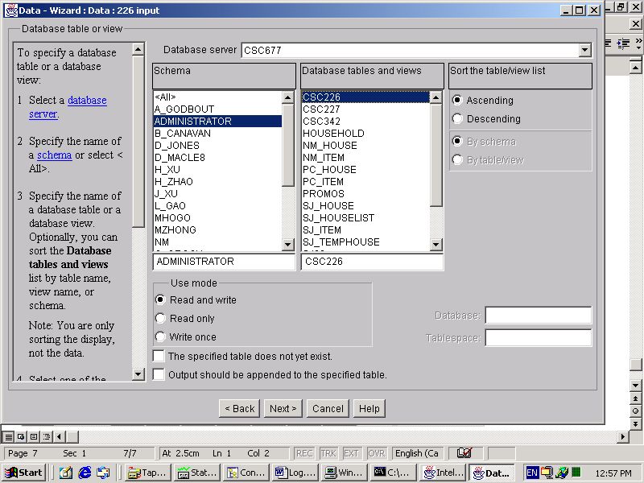

- This is last page for creating input data object.

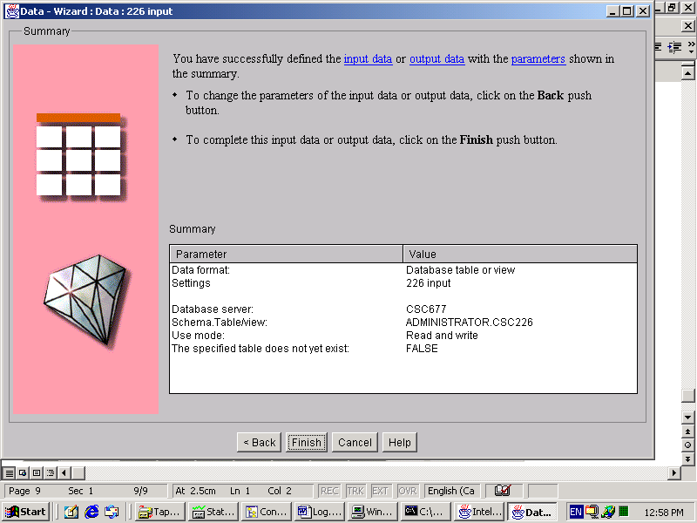

- As you can see, the 226 input data object lists in the ‘Contents of folder:Data ‘
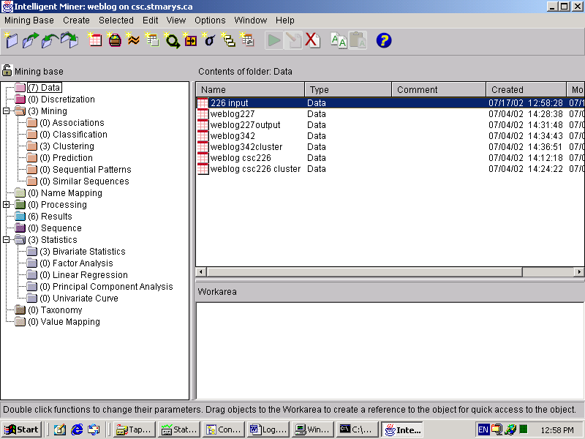

- Create the Clustering Mining :
- Expand the ‘Mining’ till you see the ‘Clustering’
Right Click the ‘Clutering’ , you will see ‘creating mining’
Select the ‘create mining’
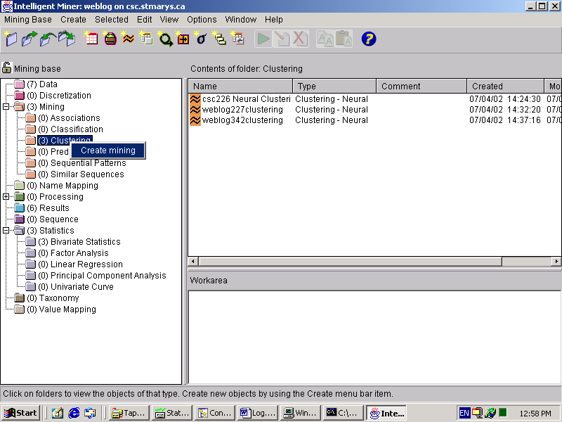

- Select ‘Clustering-Neural’ in the ‘Available mining functions’
Write down a settings name as ‘226 clustering’ (you can define the name by your own)
Make sure you check the “show the advanced pages and controls”
Click Next
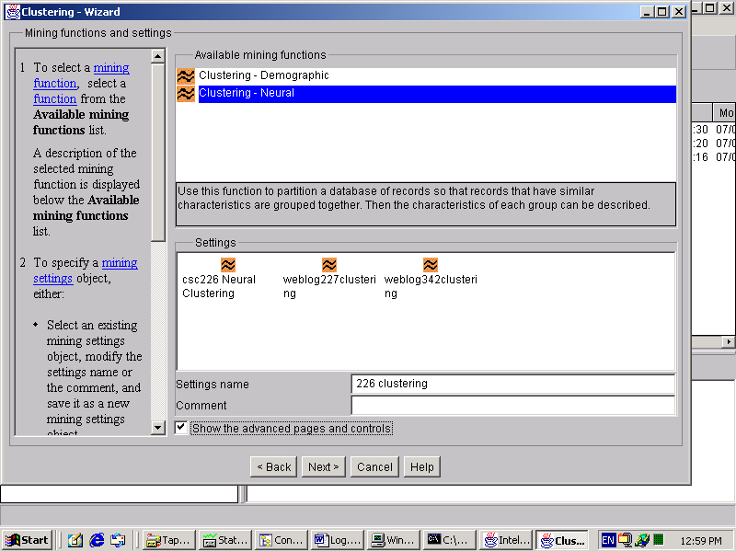

- Select the data object you just created
Choose ‘Time’ for Optimize mining run (for neural function, usually choose this one)
Click Next
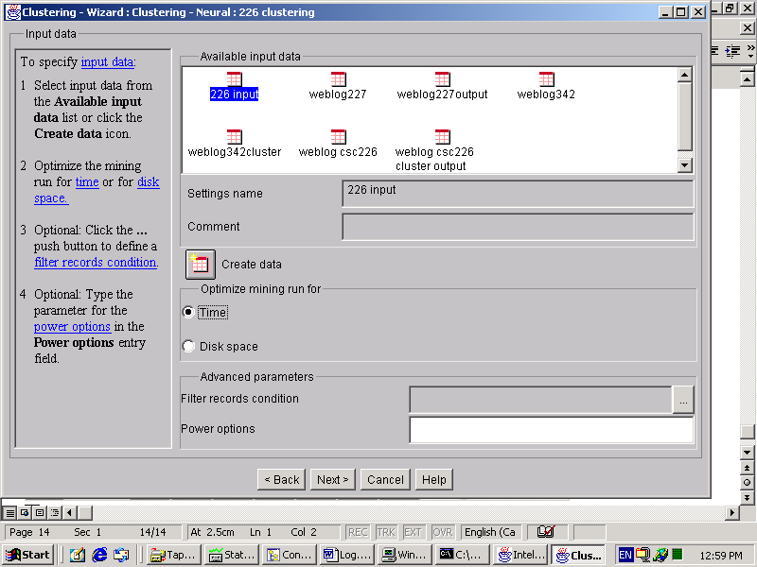

- Specify Maximum Passes :100
Maximum rows :3 ( means: we want to cluster the data into 3 groups)
Maximum columns :1 ( generally, The clustered groups are rows* columns)
Next.

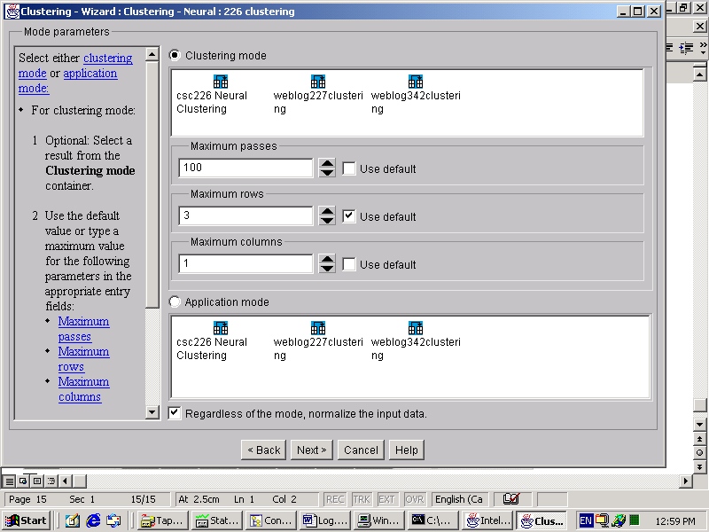

- select all fields but series field from ‘Available fields ‘ into ‘Active Fields’
select ‘series’ into supplementary fields
and click next.
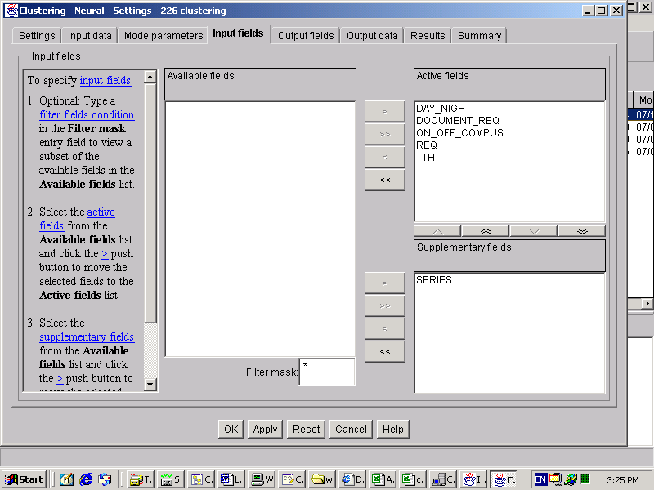

- Click Next
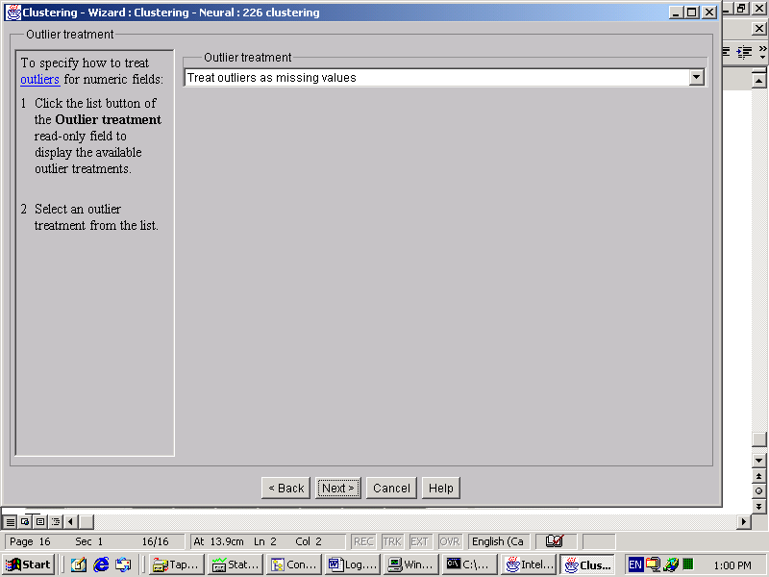

- Select all fields from ‘Available fields’ to the “Output fileds”
Write down the name for cluster ID field name: ClusterID
So, the output file will contain 7 fields.

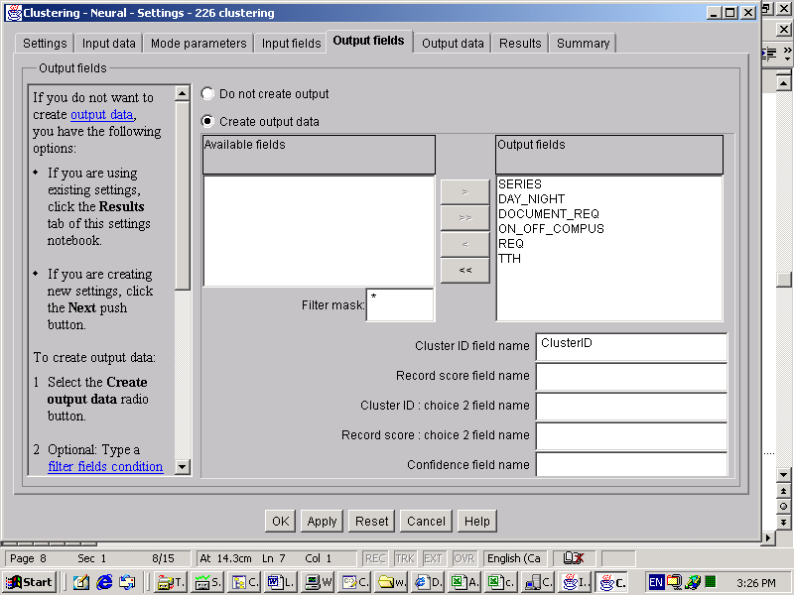

- Now it is time to create output data object.
Click ‘create data’ icon
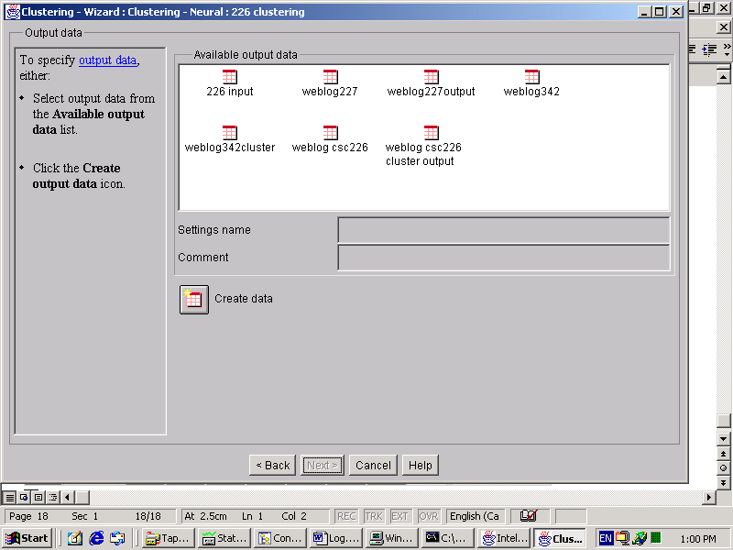

- Similar as the creating input data object, a welcome page appears.
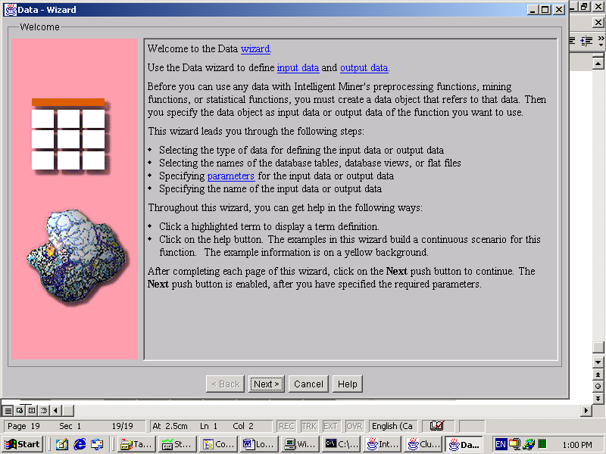

- Select ‘Database Table/View’
Write down the name as the settings name :226 output, which is the name for the output data object .( this name only is used in the Mining base. )

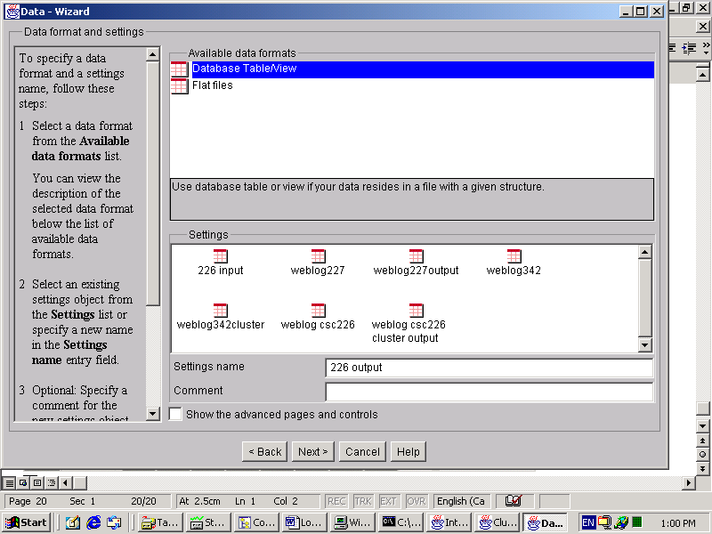

- Select the database server : csc677
Select your name list in the schema :
And specify a table name : 226clusteroutput (this name is the actual output file name. And the output file is a table. This table will be listed in the database.)
Make sure you check the ‘The specified table does not yet exist”
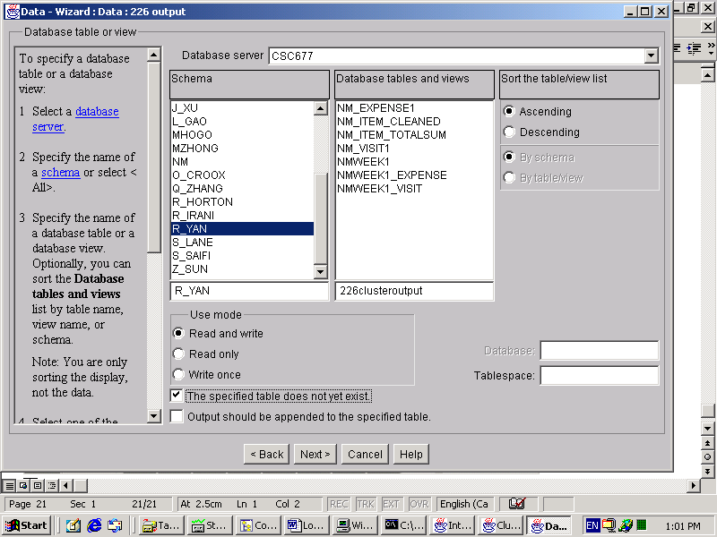

- Last page for creating the output data object.

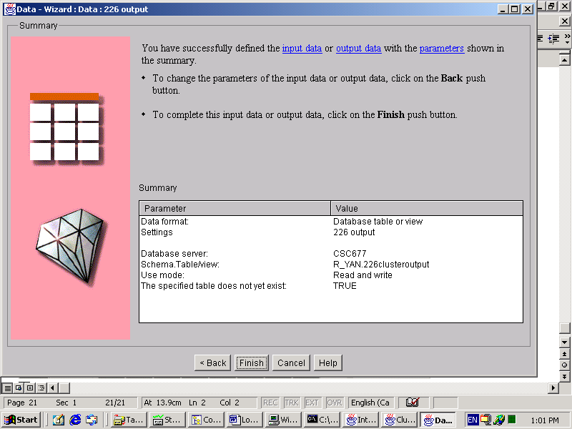

- back to the clustering mining :
the ‘226 output’ data object is listed in the ‘available output data’
select ‘226 output’ as the settings name and click next
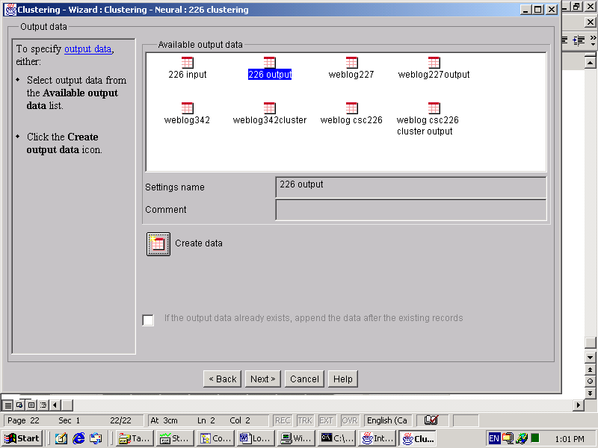

- make sure you check the ‘If a result with this name exists, overwrite it’
next
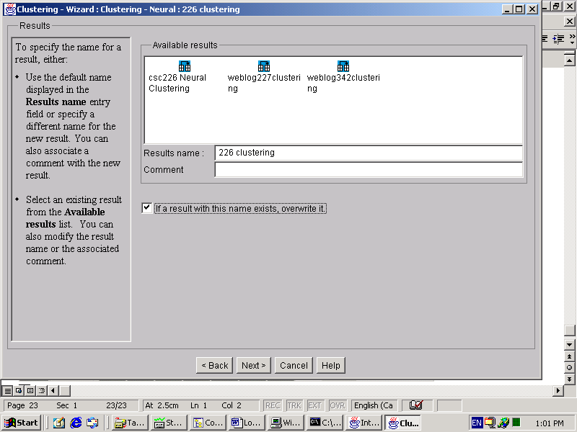

- check ‘Run this settings immediately’
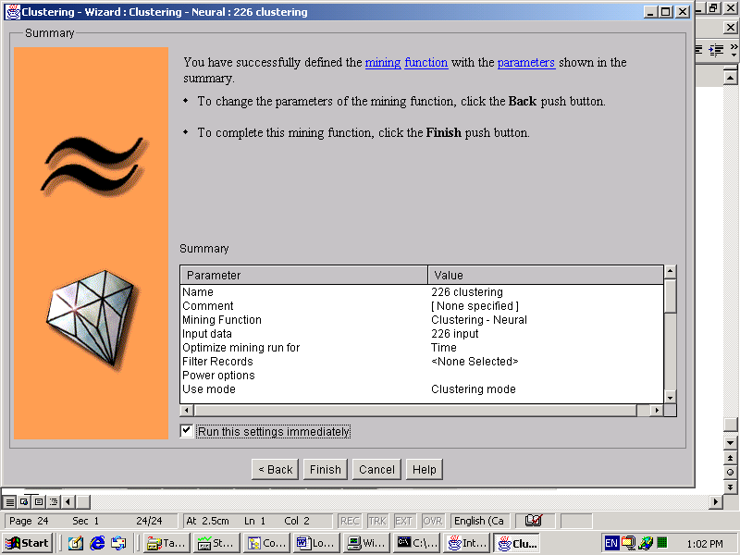

- Now you can see this Miner is running.

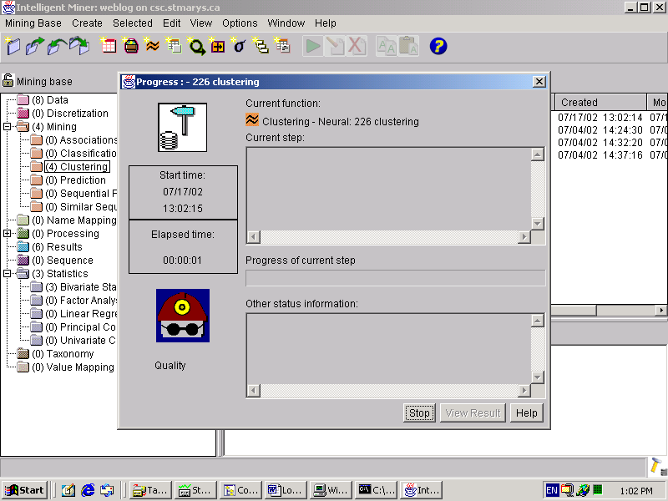

- Clustering function generates the result.
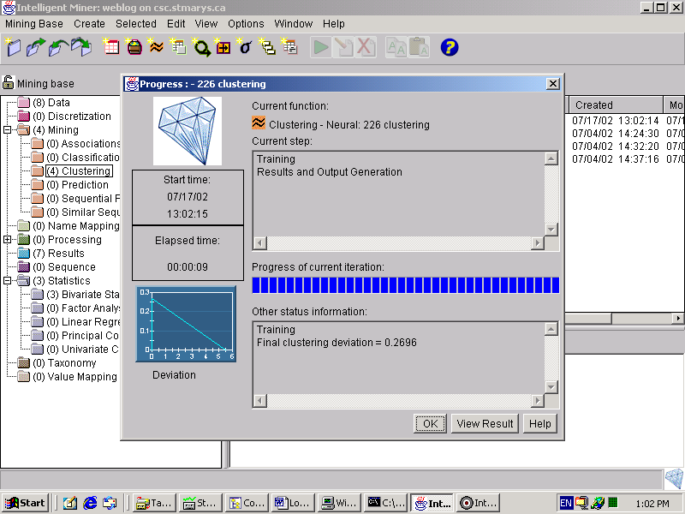

- Here is the result
Three groups. (0,1,2)
The first group (0) occupies 40%
The second group(1) occupies 8%
And the last group(2) occupies 52%
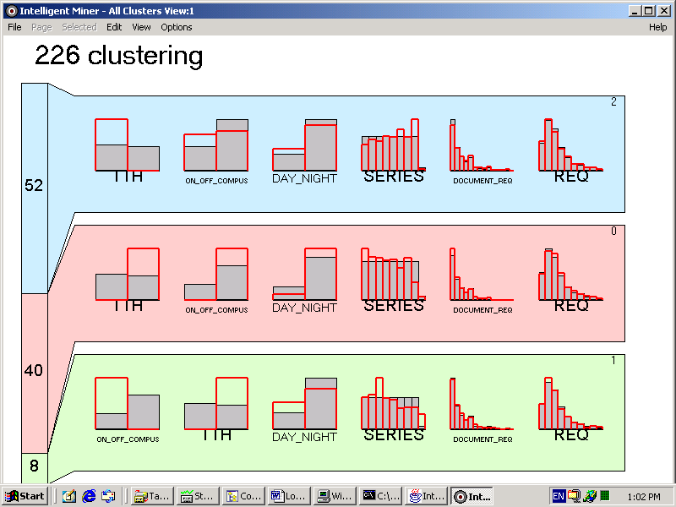

- Back to the DB2. and you can see the table “226clusteroutput” is listed in the “Tables”

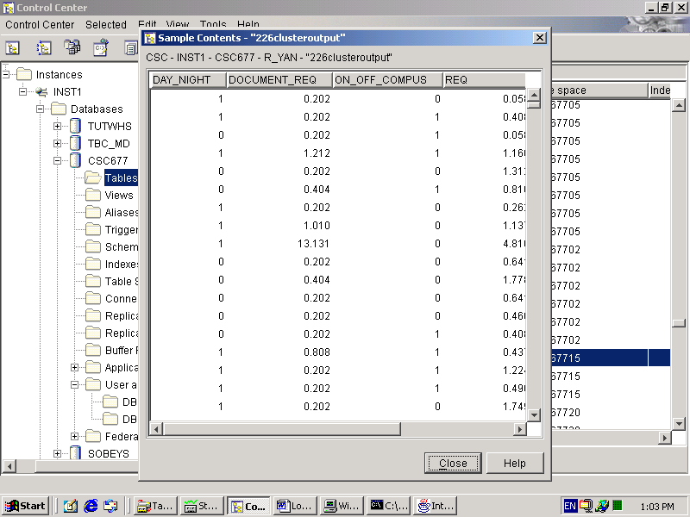

4) Use SQL to see the content in the table

- select * from “226clusteroutput”
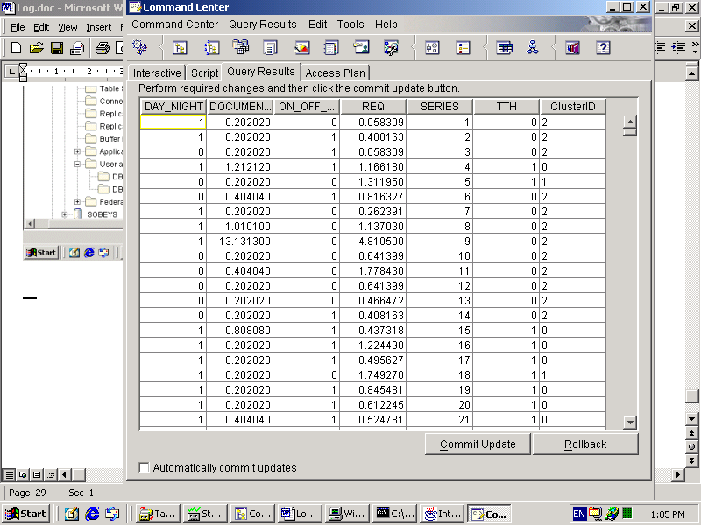

- Use SQL to separate the total file into 3 groups.
- create view csc226group1(day_night,document_req,on_off_compus,req,tth)
as select
day_night,document_req,on_off_compus,req,tth
from "226clusteroutput"
where int("ClusterID")=0

- select count(*) from csc226group1 (you can check the number in each groups)

- create view csc226group2(day_night,document_req,on_off_compus,req,tth)
as select
day_night,document_req,on_off_compus,req,tth
from "226clusteroutput"
where int("ClusterID")=1

- create view csc226group3(day_night,document_req,on_off_compus,req,tth)
as select
day_night,document_req,on_off_compus,req,tth
from "226clusteroutput"
where int("ClusterID")=2

5) Analyze the result
- Export the data in the three tables into local disk and use excel.
- get the average for each field
- draw the figures

