Saint Mary’s University
Department of Mathematics and Computing Science

Intelligent Data Mining
---- Association

Created by Rui Yan Date: July,23rd ,2002
---------------------------------------------------------------------------------------------------
1)Log on the DB2 and Intelligent Miner. First step for Miner is to create data object as the input for the mining function. In this case, we do not need to prepare any data. We just use table “NM_ITEM” as the input data.
- Create Data object: Use table ‘NM_ITEM’ as the input data.
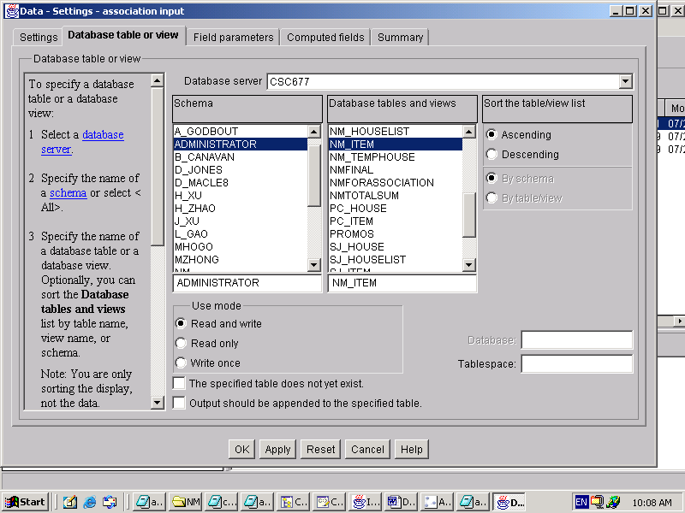

2) Create association mining function
- Right click the ‘Association’.
- Click “Create Mining”
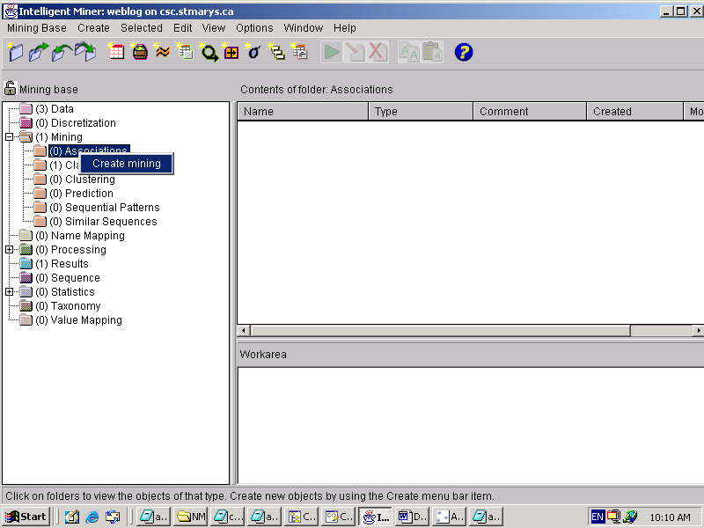

- Click ‘Associations’ in the Available mining function.
- Give the setting name :nmassociation
- Check “Show the advanced pages and controls”
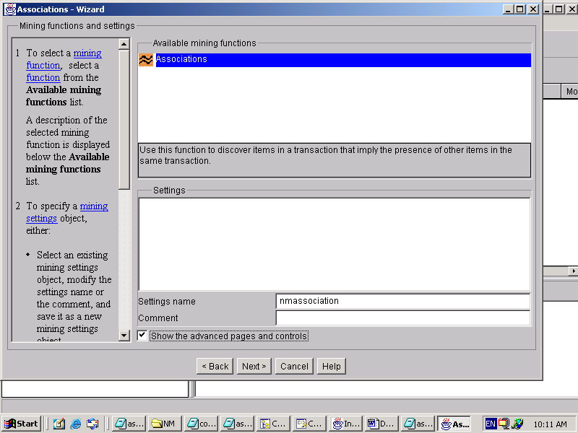

- Choose ‘association input’ data object as the input data (the ‘association input ‘ is the data object we created above)
- Choose ‘Time’ as optimize mining run
- Next
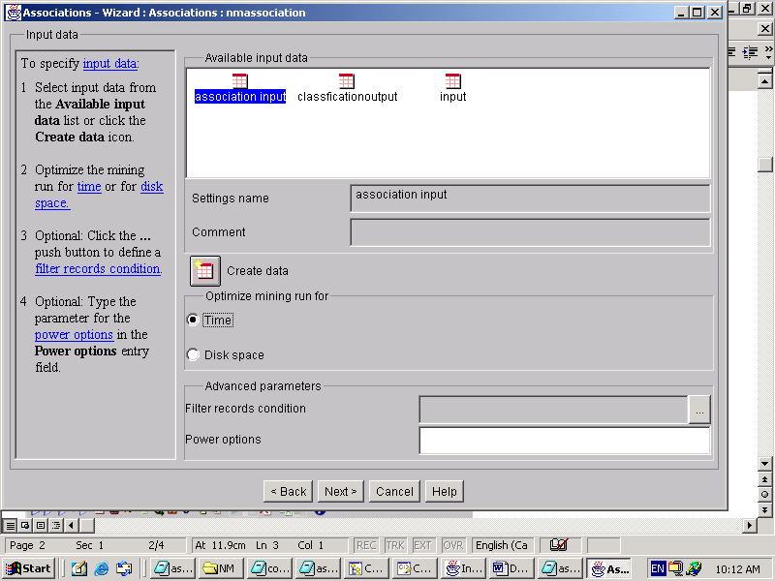

- Transaction field : House
- Item field: CAT
- The DB2 data type of this filed that you select as the ‘Transaction ID’ field must be CHAR or VARCHAR.
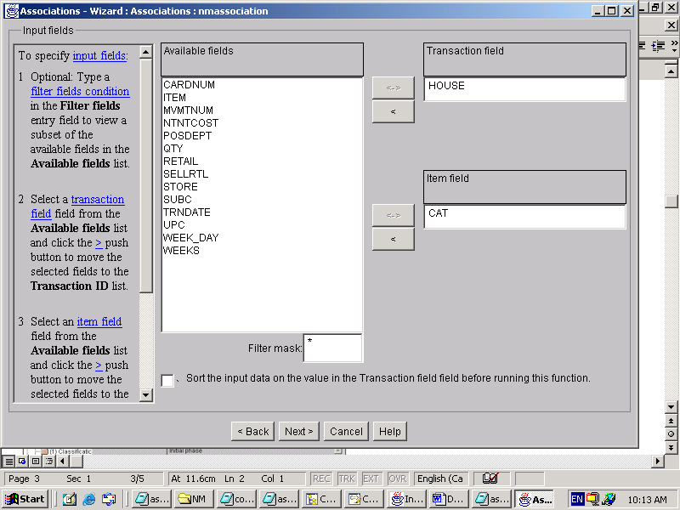

- Minimum support :5%
- Minimum confidence: 25%
- Maximum rule length :3
- Item Constraints: 102;201;202;203;204;205;206;602;603;706;905;1004;1206;901;903;904;707;801;802;803;804;805;806;807;808;809;810;811;1205;1307;1101;1207;1302;1202;1003;1503;1504;1501;1502;1710;1718;1716;1717;1714;1720;1801;1811;1809;1814;1304;1102;1103;1719;1715
- In class , we just choose the first 4 items.
- Item constraints: ‘Include ‘ means only rules containing at least one of the specified items are generated. ‘Exclude’ means rules containing one of the specified items are discarded from the results.
- Use ‘;’ to separate each item

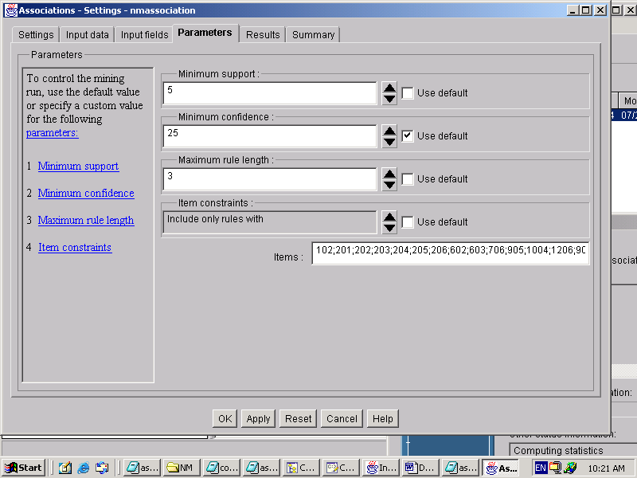
- Results name: nmassociation
- Make sure you check ‘If a result with this name exists, overwrite it’

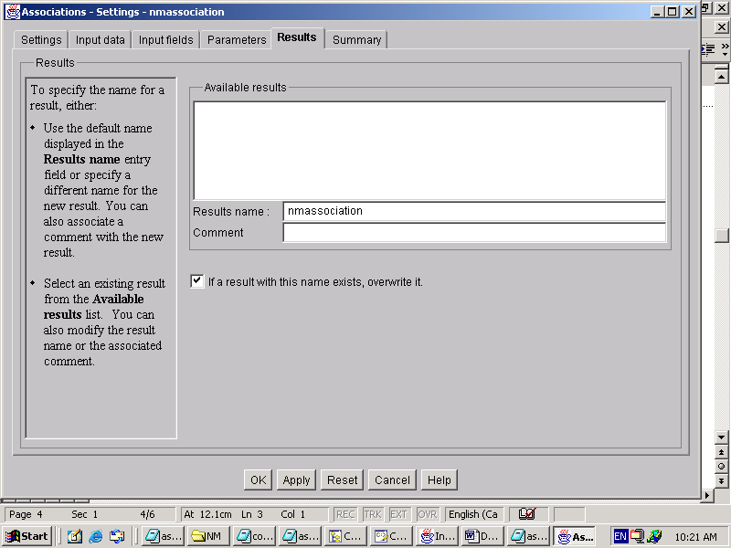

- Summary
- Start to run the mining function
- Result is in the Association visualization
- There are two results: Detail lists, rules graphs.

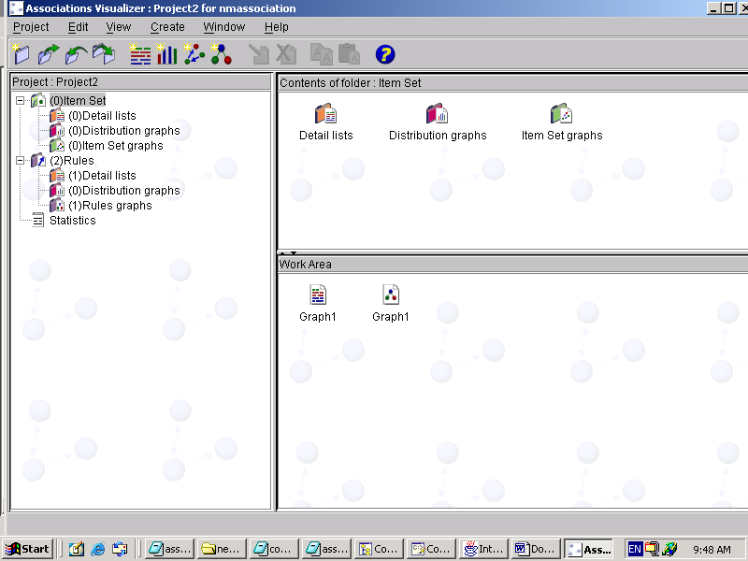

- Let’s have a look at the Graph1
- Right click it and choose “view”

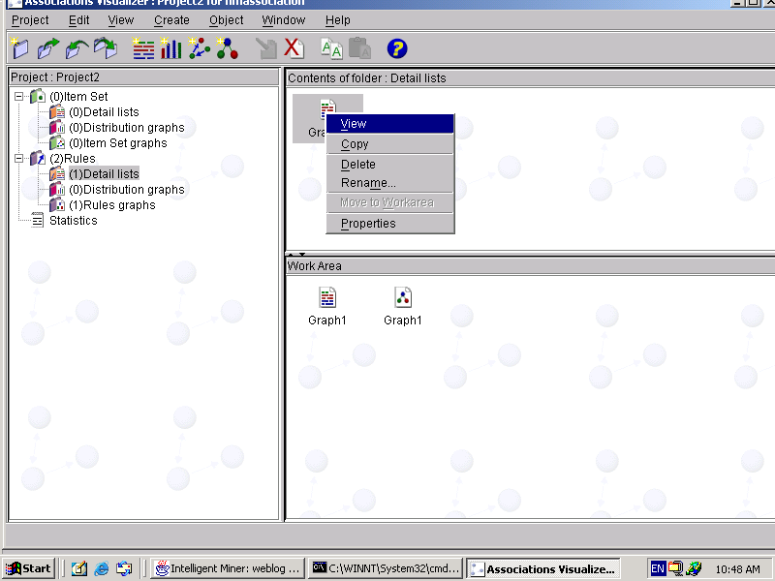

- Here is the content in the Rules Detail List
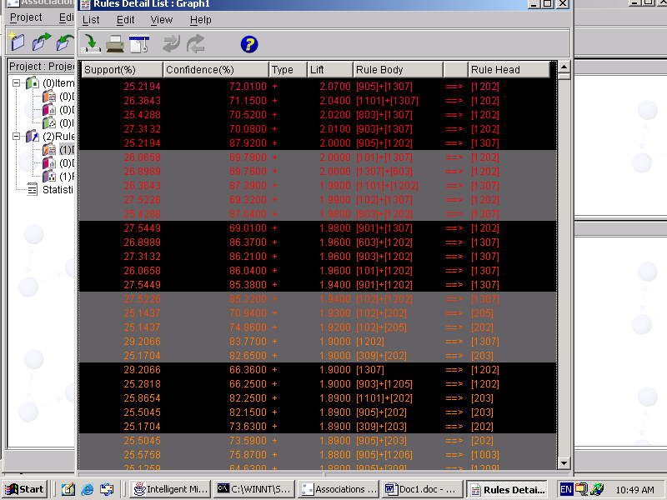

- Sorting on columns in the rules detail list
- Click the column header “confidence(%)” to sort the list in ascending order
- Click it again to sort the list in descending order.
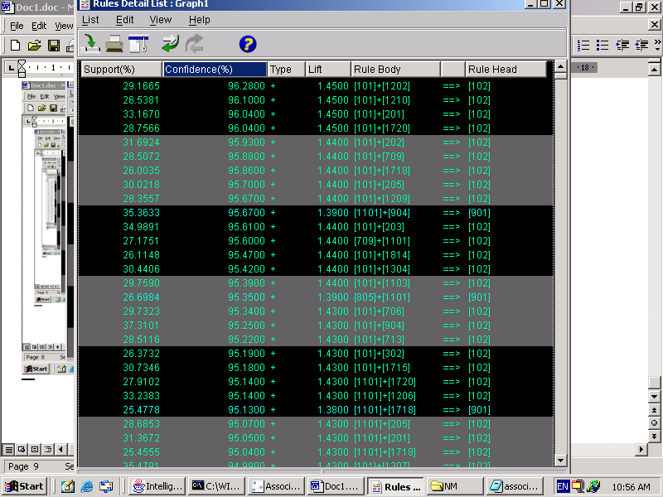
- You can select all the rules with a particular item
- Select “Edit->Custom Selection”
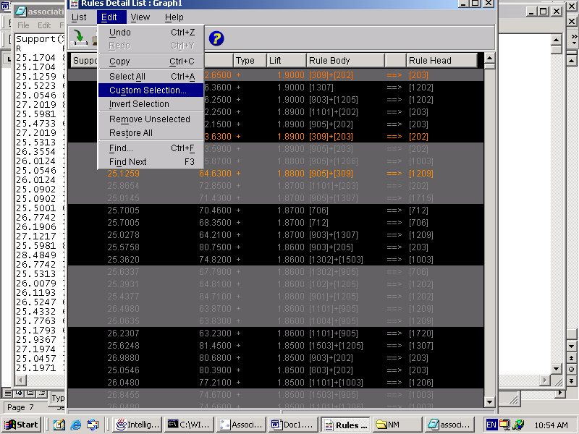

- In the prompt window
- Wrote down “101:” as the item you want to select
- Make sure you check “Match all words”
- OK
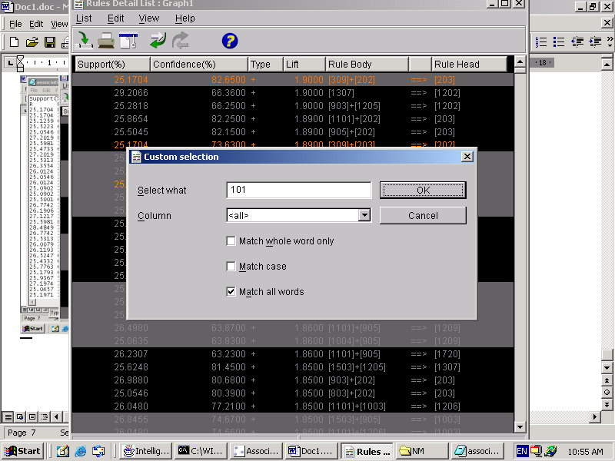

- If you want only the select rules are showed in this window.
- Select “View->Unselected->Hidden”
- Now only the rules you specified are listed in the window
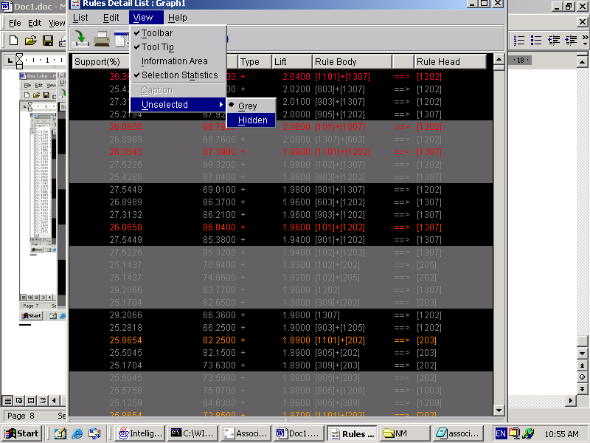

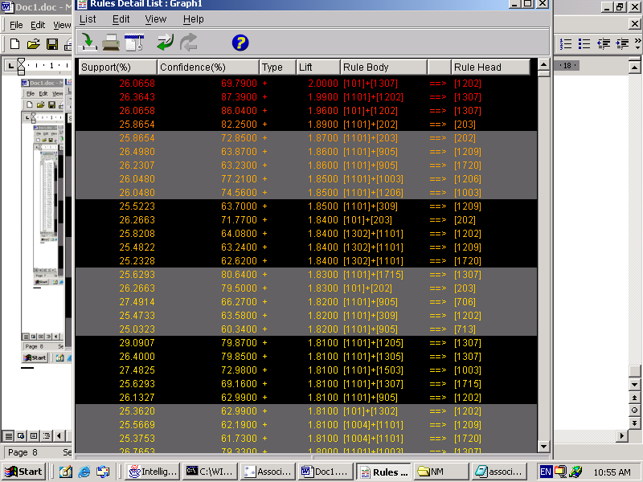

- Finally, you can save these record into the local disk.

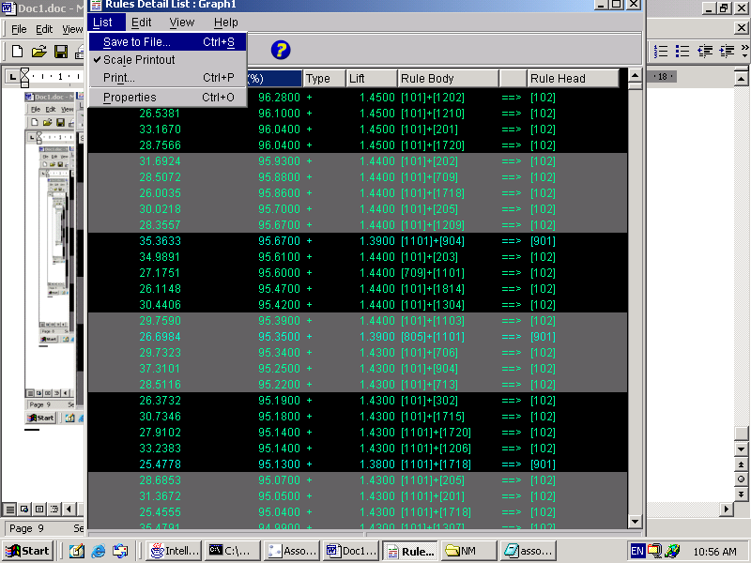

Support(%) Confidence(%) Type Lift Rule Body Rule Head
R R S R S S S
34.4500 96.3300 + 1.4500 [101]+[1206] ==> [102]
29.1665 96.2800 + 1.4500 [101]+[1202] ==> [102]
26.5381 96.1000 + 1.4500 [101]+[1210] ==> [102]
33.1670 96.0400 + 1.4500 [101]+[201] ==> [102]
28.7566 96.0400 + 1.4500 [101]+[1720] ==> [102]
31.6924 95.9300 + 1.4400 [101]+[202] ==> [102]
28.5072 95.8800 + 1.4400 [101]+[709] ==> [102]
26.0035 95.8600 + 1.4400 [101]+[1718] ==> [102]
30.0218 95.7000 + 1.4400 [101]+[205] ==> [102]
28.3557 95.6700 + 1.4400 [101]+[1209] ==> [102]
35.3633 95.6700 + 1.3900 [1101]+[904] ==> [901]

