Saint Mary’s University
Department of Mathematics and Computing Science

Intelligent Data Mining
---- Classification

Created by Rui Yan Date: July,25th ,2002
---------------------------------------------------------------------------------------------------

- Input data contains House, ClusterID, Spending in 35 categories (so, total 37 attributes).
- Open Intelligent Miner and create the input data object

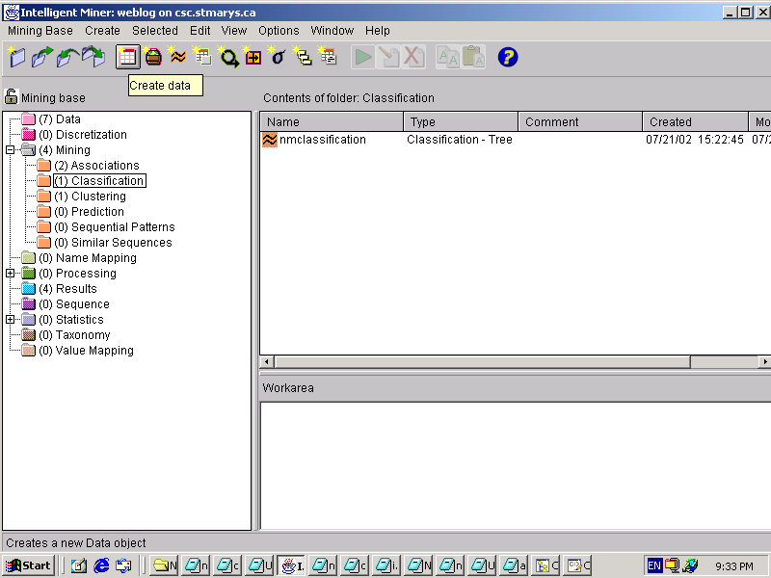

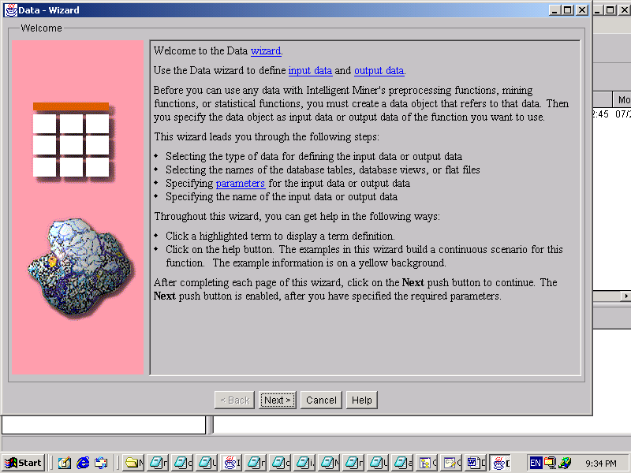

- Create data object: give it a name: classification input
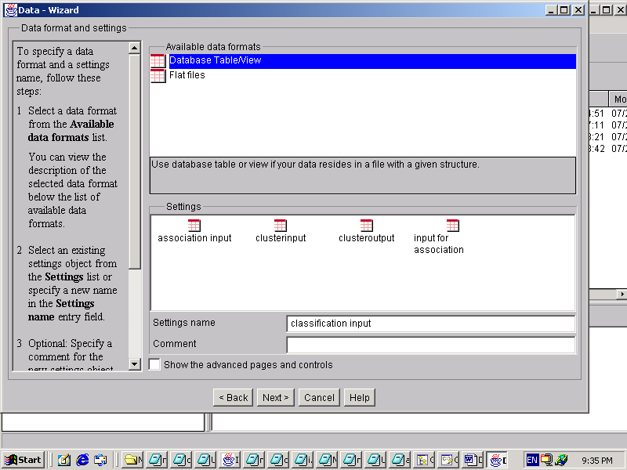

- Input data is in Database, called NMINPUT
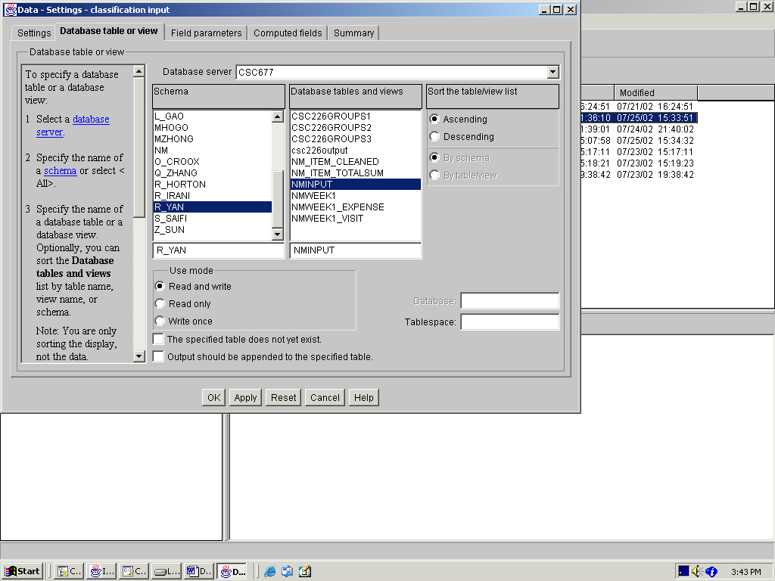
- There are 37 fields
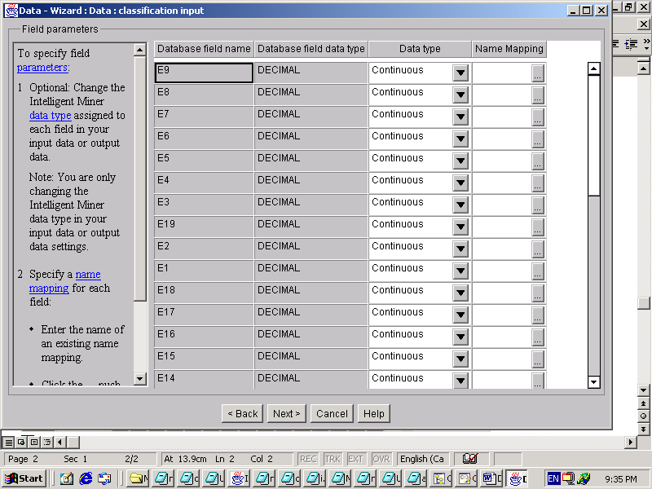

- Data object has been created.
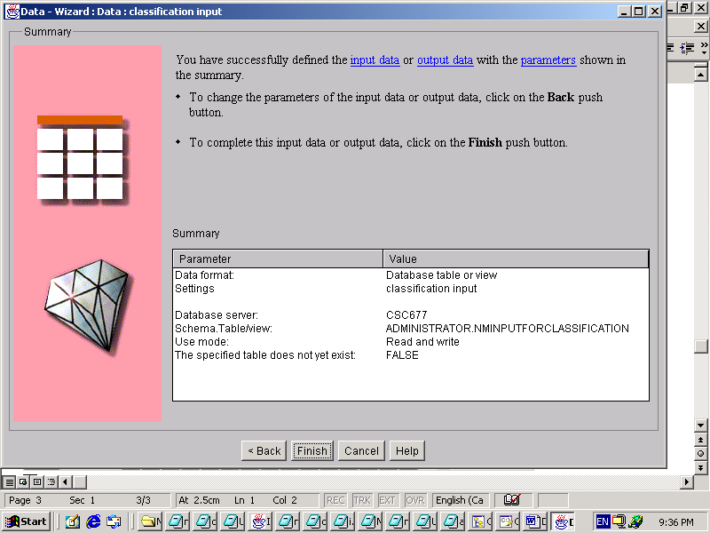

3)Now it is time to create the classification mining function
- Right click the “Classification” and select “Create Mining”

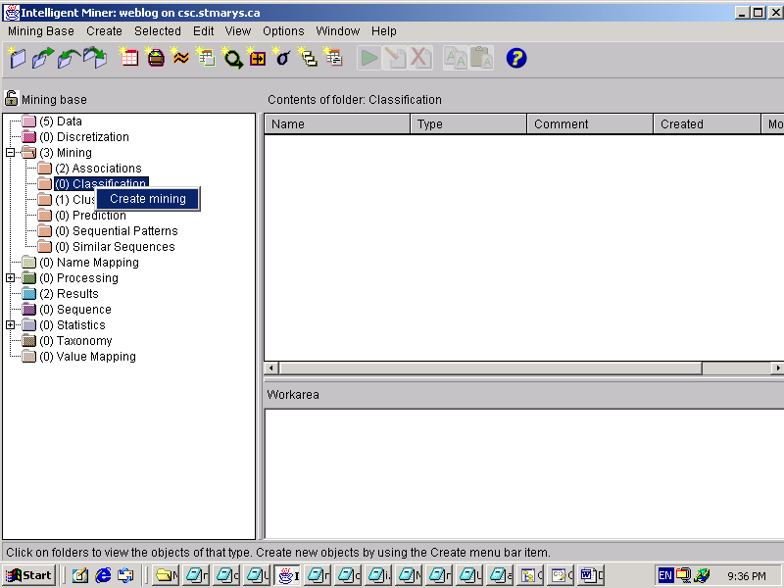

- Select ‘Classification-Tree’
- Give this setting a name: “nm classification”

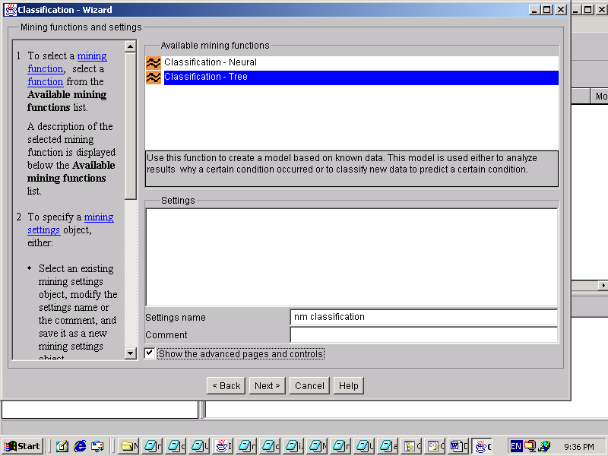
- Select the input data object
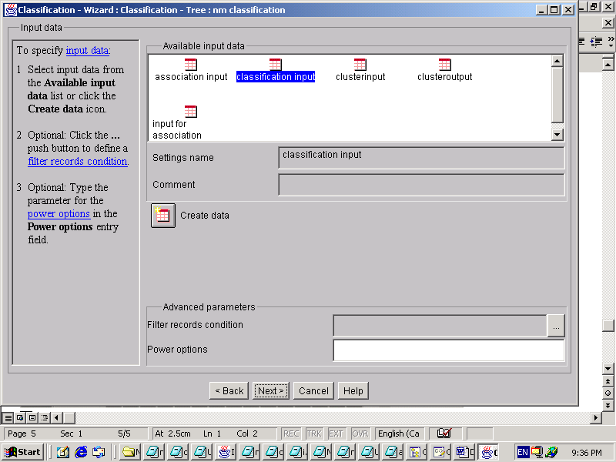

- Maximum tree depth: 7 (this parameter limits the number of node levels for the tree)
- Maximum purity per internal node: 70 (This parameter stops further splitting of nodes that have reached the specified purity value)
- Minimum records per internal node :5 (This parameter determines how many records are included in an internal node before it splits to the next node)
- In this case, our tree has 3 levels, at least 5 records per internal node and stop further splitting of nodes when 70% correct classification is reached.

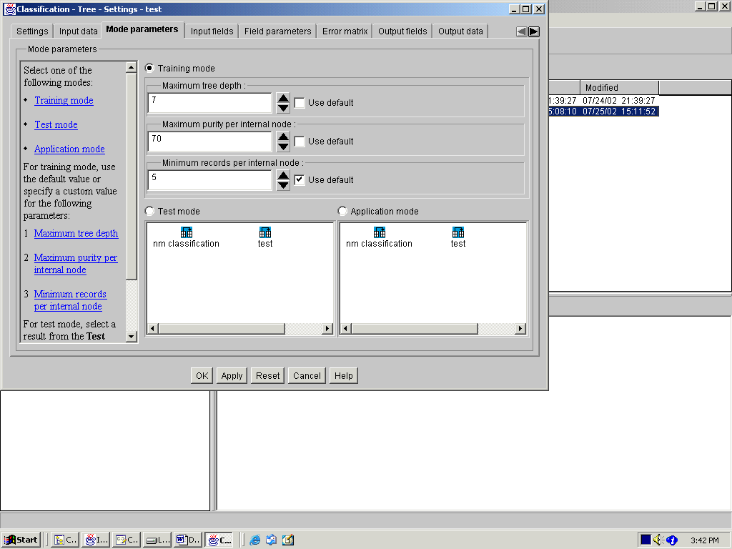
- Input fields: spending in 35 categories
- Class labels:clusterid

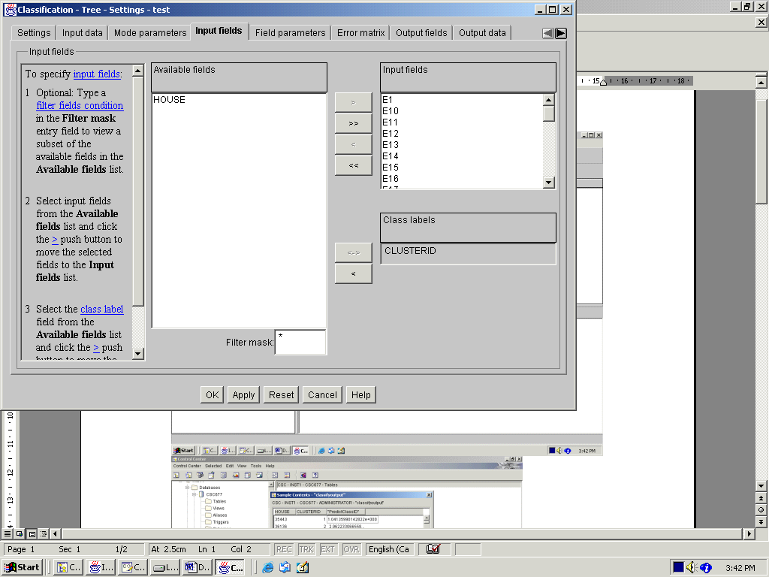

- You can specify the different weight for each input fields
- In this case, all fields have an equal weight
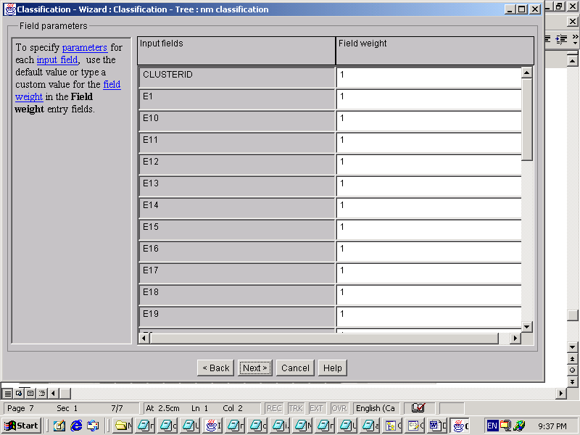
- Create output data

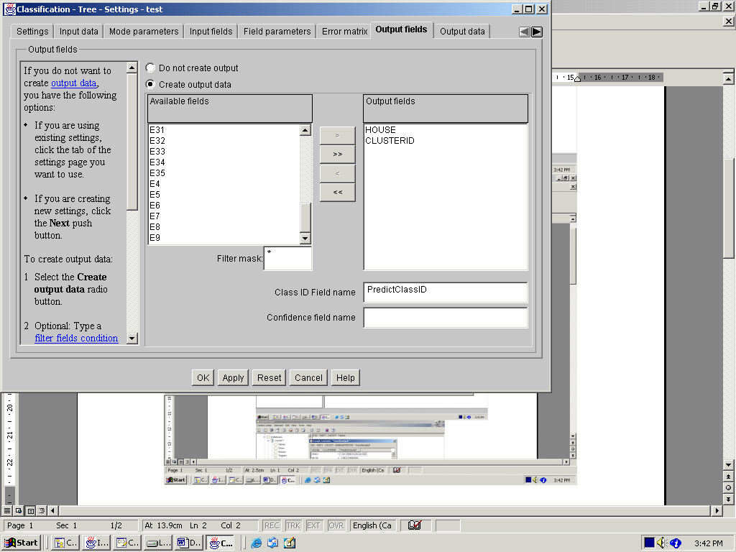

- Create output data object
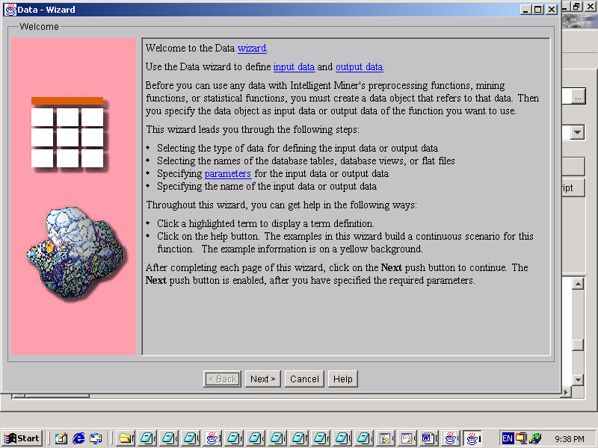
- Give the output data object a name: classification output
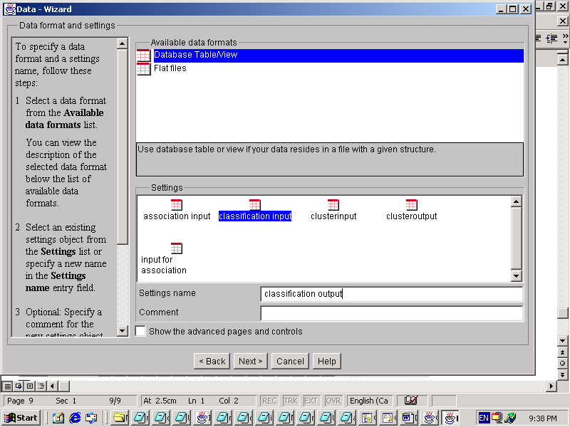

- Output data will be created into the database as a table: NMclassificationoutput
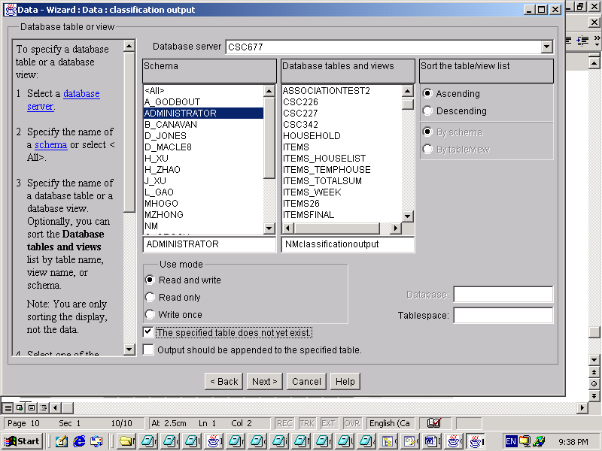
- output data object is created
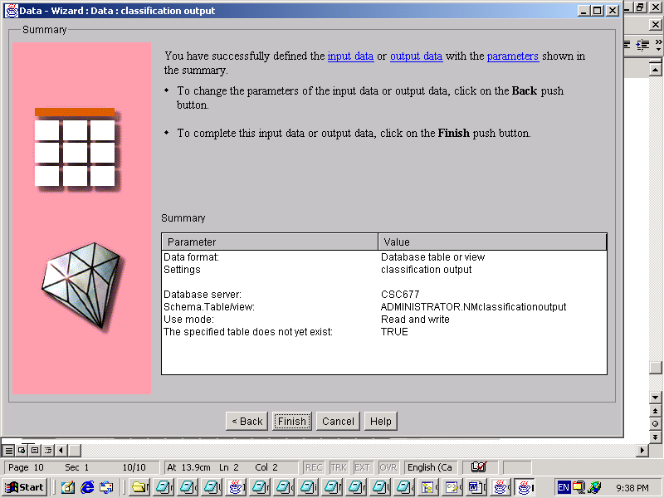

- Select the output data object
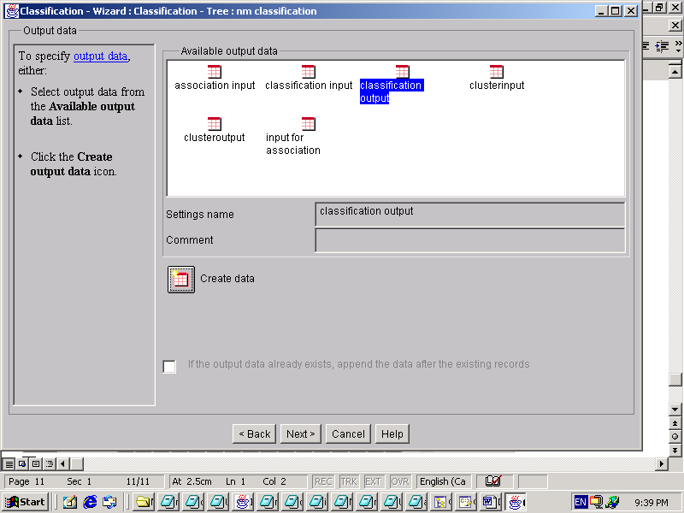

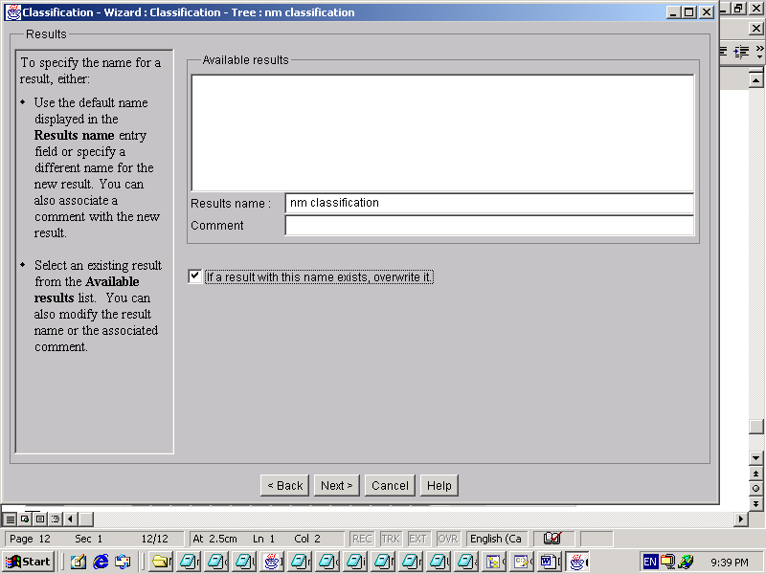
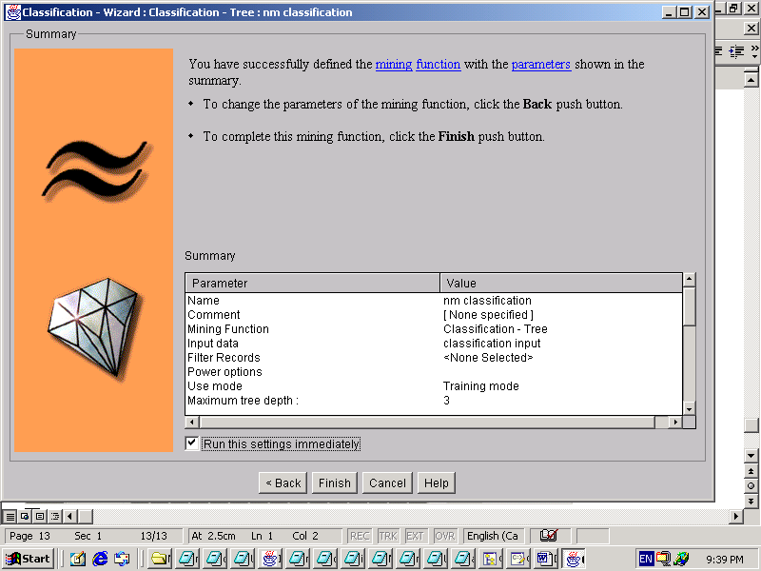
- Now classification function is running
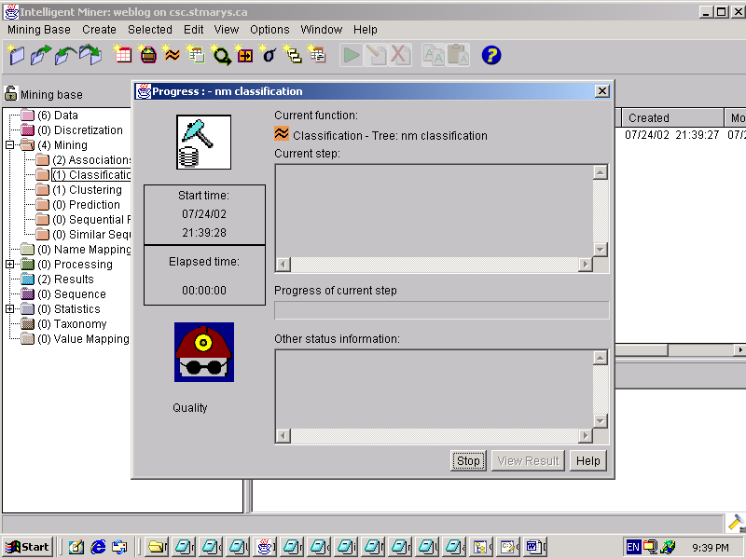

- Here is the Classification results
- Click ‘Show Pruned Tree ‘ or ‘Show Unpruned Tree’ to see details
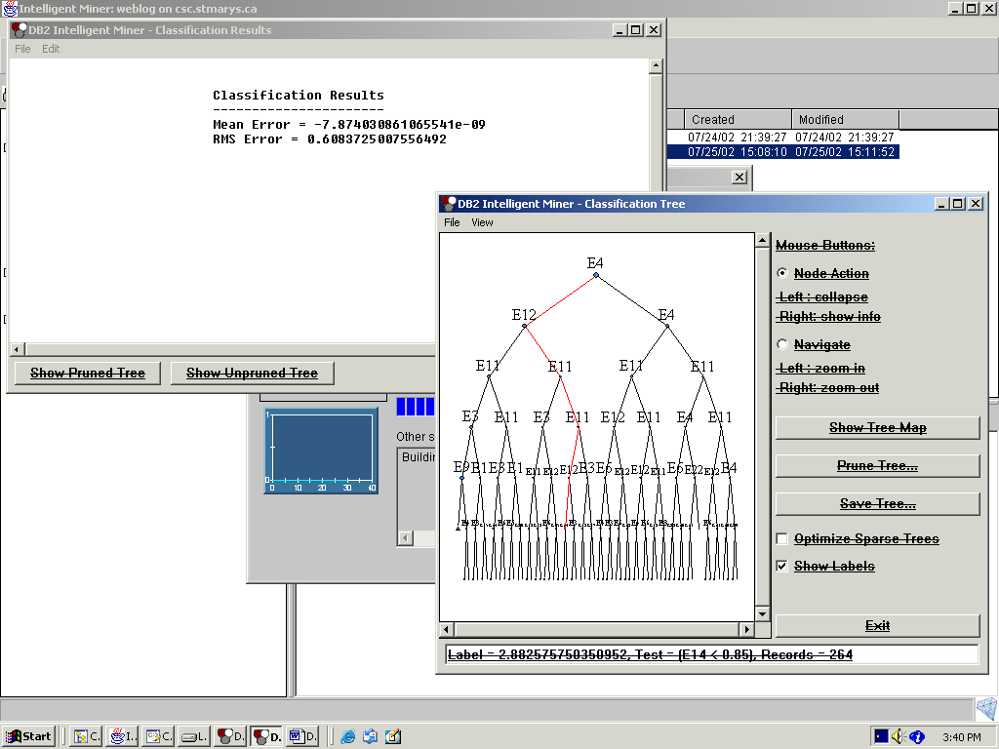

- Back to DB2. The table :Nmclassificationoutput is created in the database
See the samples in the table:

