

Liberated Learning Concept
The Liberated Learning concept revolutionizes the way students and professors interact in a university environment. It has the potential to spark exciting and unprecedented outcomes for both students and faculty.
The Liberated Learning concept is founded on two interrelated applications:
- using speech recognition technology to automatically transcribe spoken language and display it as readable text, and
- using speech recognition to produce accessible, multimedia notes
Liberated Learning technology was created to provide equal access to lecture information for ALL students. Students with mobility, hearing and visual impairments often have difficulty taking notes. Many other students in the classroom find it difficult to comprehend concepts as well as take notes effectively. This technology levels the playing field for all students and provides an additional support in the classroom.

Instructors may choose to display text during class and provide multimedia notes after class; others may choose to provide multimedia notes only.

Liberated Learning’s Note Finder 
Note Finder is a note indexing and phrase table system used in conjunction with Liberated Learning's speech recognition generated Notes. This supplementary study tool has the unique ability to index uploaded course notes and allow students to search for specific words that are of key interest, via such tools as the Search Query, Phrase Table and Indexed Files.
To access Note Finder,

- Go to www.liberatedlearning.com
- Select the icon "Note Finder - online notes for students" at the right
- Read “How to Use Note Finder”
- Under “Courses at Saint Mary’s” select your course link
- User name: student
- Password: 08notes

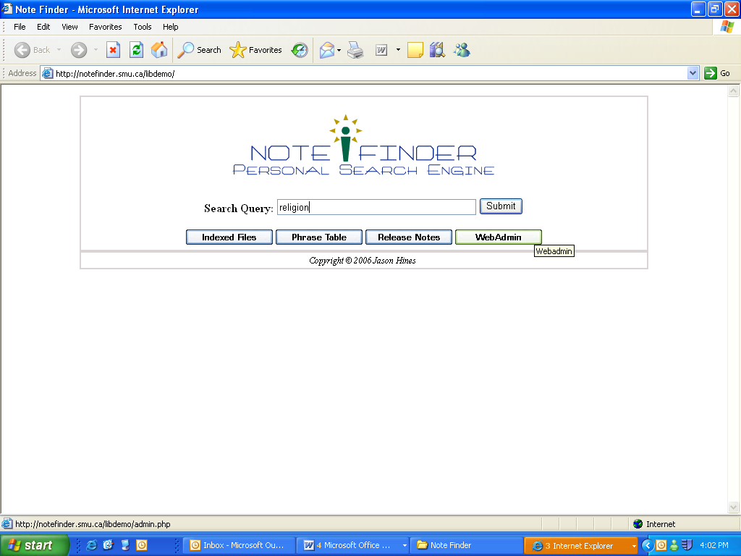

Important Notes

- Note Finder “notes” are not a substitute for attending class.
- Notes containing videos or other large files may take longer to download.
- Technical difficulties not withstanding, course notes are usually uploaded within 24-48 hours of the actual lecture. Liberated Learning notes may be in the form of text, audio or PowerPoint slides. This may differ depending upon professor preference.
- Thank you for testing out this system which is currently in the Beta stage of its development by the Saint Mary’s Computer Science department. We will be distributing a student feedback survey near the end of the semester and we look forward to receiving your comments at that time.

Links

Liberated Learning website (home page) http://www.liberatedlearning.com/

About Liberated Learning (for students) http://www.liberatedlearning.com/about/stakeholders.html

Note Finder – direct link http://www.liberatedlearning.com/note_finder.html

