

Course Transcripts: Quick Access Instructions
Note Finder | Note: must use Internet Explorer browser, unfortunately.  - www.liberatedlearning.com  - click "Note Finder" button at lower right  - click CSCI 2341 course link  - username: student  - password: 08notes  - Note: click files ending in "_frames.html" for text with audio playback  - (For more details on Liberated Learning and Note Finder, see below.)
IBM Hosted Transcription Service “INTONATA” | - https://antemural.watson.ibm.com/SLWeb/  - username: csci2341  - password: csci2341  - IBM has warned us that the system may be taken offline temporarily without notice, so access is never guaranteed!

If you cannot find the transcript you are looking for or are experiencing problems with either system, contact heather.martin@smu.ca.

Liberated Learning Concept
The Liberated Learning concept has the potential to revolutionize the way students and professors interact in a university environment.
The Liberated Learning concept is founded on two interrelated applications:
- using speech recognition technology to automatically transcribe spoken language and display it as readable text, and
- using speech recognition to produce accessible, multimedia notes
Liberated Learning technology was created to provide equal access to lecture information for ALL students. Students with mobility, hearing and visual impairments often have difficulty taking notes. Many other students in the classroom find it difficult to comprehend concepts as well as take notes effectively. This technology levels the playing field for all students and provides an additional support in the classroom.

Instructors may choose to display text during class and provide multimedia notes after class; others may choose to provide multimedia notes only.

Course transcripts are available on two platforms this year:
- Note Finder (developed by SMU CS students!)
- IBM’s Hosted Transcription Service (which lets you edit/correct transcripts wiki-style).

1. Liberated Learning’s Note Finder 
Note Finder is a note indexing and phrase table system used in conjunction with Liberated Learning's speech recognition generated Notes. This supplementary study tool has the unique ability to index uploaded course notes and allow students to search for specific words that are of key interest, via such tools as the Search Query, Phrase Table and Indexed Files.
To access Note Finder,

- Go to www.liberatedlearning.com
- Select the icon "Note Finder - online notes for students" at the right
- Scroll down and read “How to Use Note Finder”
- Select the link, ”CSCI 2341.1 Data Structures and Algorithms I”
- User name: student
- Password: 08notes
- The default page lists available recordings to date.
- To play back text and/or audio for a particular date, select the “[filename]_frames.html” file or “[filename].mp3” file. See image below.
- To search all transcripts simultaneously, enter a search string in the “Search Query” box.
- To view a list of the most frequently occurring words in the transcripts (i.e. possible course keywords), click “Phrase Table”.
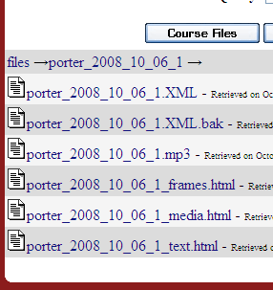
The “_frames.html” file plays back your text and audio simultaneously.

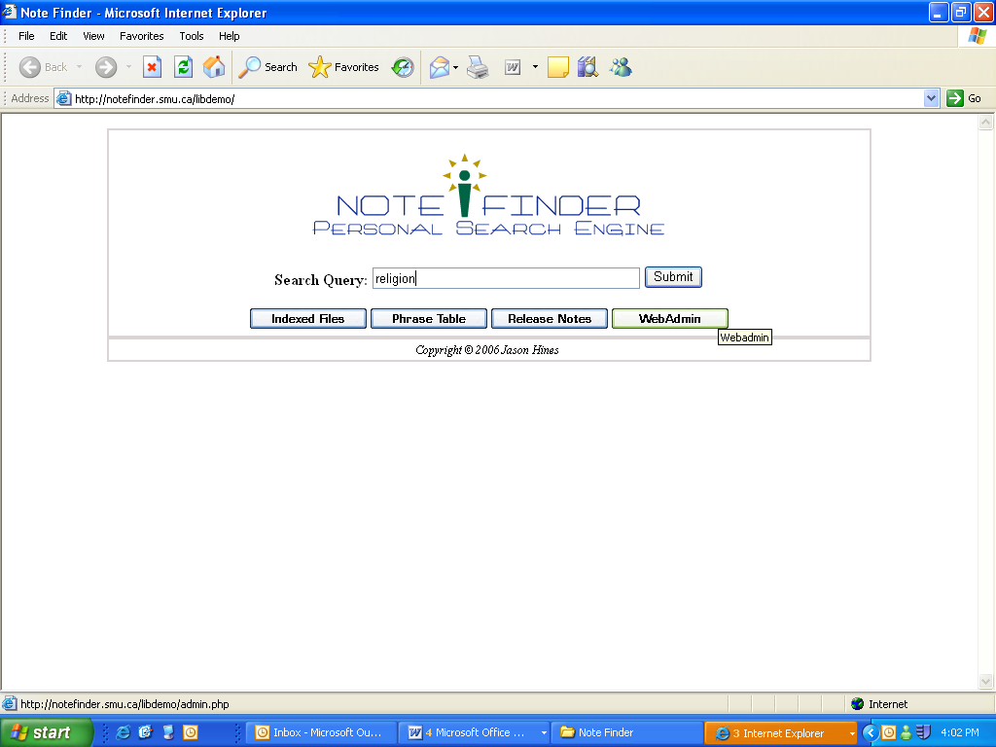

Important Notes

- Note Finder “notes” are not a substitute for attending class.
- Notes containing videos or other large files may take longer to download.
- Technical difficulties not withstanding, course notes are usually uploaded within 24-48 hours of the actual lecture. Liberated Learning notes may be in the form of text, audio or PowerPoint slides. This may differ depending upon professor preference.
- Thank you for testing out this system which is currently in the Beta stage of its development by the Saint Mary’s Computer Science department. We will be distributing a student feedback survey near the end of the semester and we look forward to receiving your comments at that time.

Links

Liberated Learning website (home page) http://www.liberatedlearning.com/

About Liberated Learning (for students) http://www.liberatedlearning.com/about/stakeholders.html

Note Finder – direct link http://www.liberatedlearning.com/note_finder.html

2. IBM’s Hosted Transcription Service 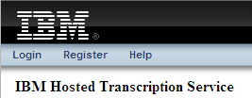

- Direct link: https://antemural.watson.ibm.com/SLWeb/
- Editable access (wiki-style):
  - username: csci2341
  - password: csci2341

